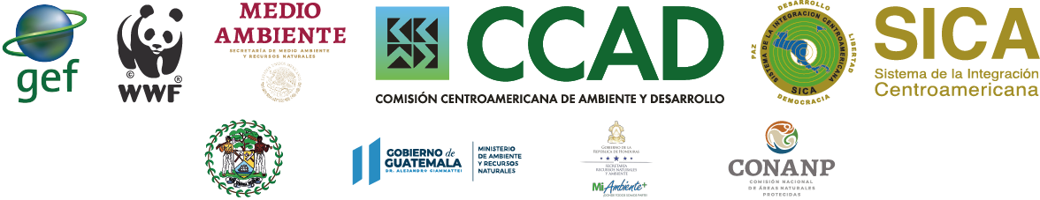
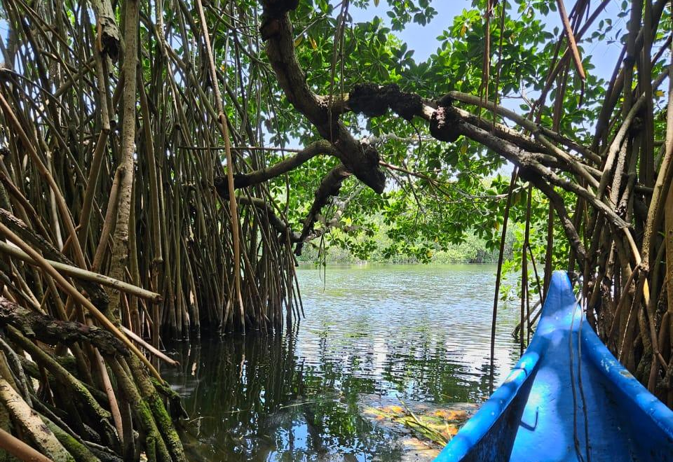
TERMINAL EVALUATION
“Integrated Ridge to Reef Management of the
Mesoamerican Reef Ecoregion (MAR2R)”
GEF ID 5765
FINAL REPORT
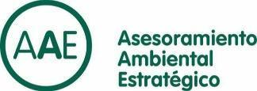
November 2023

Table of Contents

Project Data iv
Evaluation Team Members & Affiliations v
Statement of independence/conflict of interest vi
Locator Map vi
Acknowledgments viii
ii. Executive Summary ix
Brief Project Description ix
Overview of Evaluation Ratings xi
Summary of findings xviii
Conclusion & Recommendations xx
iii. Acronyms xxii
1. Introduction to Evaluation 1
1.1 Purpose of the Evaluation 1
1.2 Limitations of the Evaluation 2
1.3 Scope & Methodology 2
1.4 Structure of the TE Report 5
2. Project Description and Development Context 5
2.1 Problems the Project Sought to Address 5
2.2 Baseline Actions and Gaps to be Addressed by the Project 6
2.3 Summary of the Theory of Change 8
2.4 Expected Results 8
2.5 Stakeholders Analysis 9
2.6 Geographic Coordinates of project sites 11
3. Findings 11
3.1 Project Design/Formulation 11
3.1.1 Assessment of Relevance and Theory of Change 11
3.1.2 Use of Lessons from Similar Projects 16
3.1.3 GEF Additionality 17
3.1.4 WWF and CCAD comparative advantage 18
3.1.5 Replication approach/Linkages between the project and other interventions within the sector 20
3.1.6 Governance and management arrangements 21
3.1.7 Country Ownership 23
3.1.8 Analysis of M&E Design (*) 23
3.2 Project Implementation & Execution 23
3.2.1 Assessment of Project Outcomes, effectiveness, and potential for impact 23
3.2.2 Progress to Impact 39
3.2.3 WWF GEF Implementation (*), CCAD and partner execution (), coordination y and operational management 41
3.2.4 Risk Management 42
3.2.5 Financial Management 43
3.2.6. Operational Management: Effectiveness & Efficiency 43
3.2.7 M&E Design & Implementation /Adaptive Management & Capacity 46
3.3 Assessment of Risks to the Sustainability of Project Outcomes 47
3.3.1 Financial Risks: Potential Identified Risks 47
3.3.2 Sociopolitical Risks: Potential Identified Risks 48
3.3.3 Institutional Framework & Governance Risks: Potential Identified Risks 49
3.3.4 Environmental Risks: Potential Identified Risks 50
3.3.5 Overall Likelihood of Sustainability 51
3.3.6 Sustainability Exit Strategy 52
3.4 Gender Equality and Mainstreaming 54
3.5 Stakeholder Engagement 54
3.6 Safeguards Review 57
3.7 Finance and Co-finance review 60
4. Conclusions, Recommendations & Lessons Learned 63
5. ANNEXES 67
Annex 5.1: TOR of Terminal Evaluation (without annexes) 68
Annex. 5.2: Field visit itinerary (including photographs) 73
Annex 5.3: Geo-referenced maps 75
Annex 5.4: List of persons interviewed 79
Annex 5.5: List of documents reviewed 81
Annex 5.6: Evaluation Questions/ Matrix 82
Annex 5.7: Questionnaire used 83
Annex 5.8: Summary of survey results 84
Annex 5.9: GEF Tracking Tool 95
Annex 5.10: Ratings Criteria 96

Acknowledgments
Asesoramiento Ambiental Estratégico (AAE) and the evaluation team express our sincere gratitude and appreciation to all the parties involved and key collaborators of the Project who supported this evaluation. We would like to extend special recognition to the members of WWF-US and Mesoamerica, as well as CCAD-MAR2R and to the Institutional Focal Points of each country as members of the Steering Committee, and to the partners involved in the project's implementation, as well as regional alliances and platforms. for their generous support and patience throughout the evaluation process. We also want to thank the local teams and the governments of Belize, Guatemala, Honduras, and Mexico for your collaboration, logistics, information, and support during our fieldwork. We greatly value your hospitality, contributions, and efforts, without which this evaluation would not be possible.

Project Data

Project Title: | Integrated Ridge to Reef Management of the Mesoamerican Reef Ecoregion (MAR2R)
GEF Project ID: | 5765
WWF-US Project ID: | G003
Countries: | Belize, Guatemala, Honduras, Mexico
Project Duration: | 65 months
Project Type: | Full Size
GEF Trust Fund: | GEFTF
GEF Focal Area: | International Waters
GEF Focal Area Objectives: | IW-1, IW-2, IW-3
Implementing Agency(s) | WWF
Project Executing Organization: | Central American Commission on Environment and Development (CCAD)
Executing Project Partners: | Ministries of Natural Resources in Belize, Guatemala, Honduras and Mexico
TOTAL PROJECT BUDGET | PRODOC (US$) | Executed at TE (US$)
GEF Project Cost: | $9,018,349 | $ 8,719, 762
GEF Agency Fee: | $811,651 | $811,651
Total GEF STAR: | $9,830,000 | $9,531,413
Project Co-financing: | $51,277,908 | $53,952,224
Total Project Cost: | $61,107,908 | $63,483,637

RELEVANT DATES
CEO Endorsement/Approval | 04/04/2017
Agency Approval Date | 10/27/2017
Implementation Start | 11/01/2018
Midterm Evaluation | December 2021
Terminal Evaluation | June 2023
Project Completion Date (proposed or actual) | 06/30/2023
Table 1: WWF and GEF Project Summary Table

Evaluation Team Members & Affiliations
To execute the evaluation, Asesoramiento Ambiental Estratégico (AAE) has provided a qualified evaluation team led by an experienced international GEF Evaluation Expert supported by an evaluation coordinator and data analyst and a quality assurance asset as presented in Table 1.
Composition of Evaluation Team
Guido Fernandez de Velasco;  Quality Assurance, | Mr. Velasco is a Co-founder and Director of Asesoramiento Ambiental Estratégico (AAE), an international consultant specializing in Environmental Management, Results-Based Management, and Strategic Planning. He has extensive experience in project formulation and evaluation, particularly in Asia and Latin America. Guido has coordinated diverse technical teams, managed projects for various entities including the UN System, private sector, and Civil Society, and conducted quality control for AAE's projects. He has conducted numerous GEF terminal and mid-term evaluations across Latin America, Africa, and Asia-Pacific. He is the contract representative providing support to the evaluators and quality assurance of all products. Guido resides in Barcelona.
Robert W. Crowley  Evaluation Project Leader, Senior GEF Evaluation Expert | Mr. Crowley is a GEF project design and monitoring specialist with eight years of dedicated Monitoring and Evaluation (M&E) experience, including seven completed GEF Mid-term and Terminal evaluations since 2020. These include similar projects such as the Terminal Evaluation for GEF 9180 Reducing Deforestation. As a former GEF International Waters (IW) Project Director, he understands GEF requirements for implementation, execution, planning, and reporting, offering a balanced perspective. Mr. Crowley has designed around 40 results-based GEF-funded initiatives in various sectors across 24 countries. His expertise also extends to large regional programs, such as the GEF-8 Ecosystem Restoration Integrated Program, and climate-resilient infrastructure projects. He has provided strategy and planning services for water security, watershed management, and mining in Guyana and the Dominican Republic. He resides in the Dominican Republic.
Ms. Sara Marchena –Coordinator & Data Analyst | Ms. Marchena excels in logistical management, having served in various roles, including as Assistant to the Consul General of the United States and handling special projects for Fortune 500 companies like Coca-Cola, Barrick, Orange, Johnson & Johnson, UTC Overseas, among others. As the manager of RWC Technologies in the Dominican Republic, she has contributed to the implementation of 7 GEF evaluations since 2020, overseeing research, data management, and assessment of financing and co-financing. Sara collaborates with large evaluation teams, providing essential evidence, data, and support for economic assessments in multiple countries and for four GEF Implementing agencies. She plays a crucial role in financial interviews and indicator validation, with proficiency in both Spanish and English. Sara drafted background sections, project descriptions, evaluation methodologies, and sections on sustainability and cross-cutting aspects, as well as providing graphics and formatting for presentations and documents.
Table 2: Evaluation Team Roster

Statement of independence/conflict of interest
In accordance with GEF Policy for conducting evaluations of GEF-financed activities, AAE certifies that it is independent of GEF, WWF-US, and CCAD with no prior involvement in the design or implementation of the MAR2R project. AAE does not have business relationships, possess any affiliations with, nor is involved in any capacity with any organization or entity holding financial or non-financial interests pertaining to the subject matter or materials presented herein. AAE certifies that there is no conflict of interest. AAE endorses WWF and GEF policy for ethical and responsible practices, standards and safeguards for evaluations and the application of investigations with diverse stakeholders. AAE is solely responsible for all actions, methods and procedures executed during this evaluation.

Locator Map
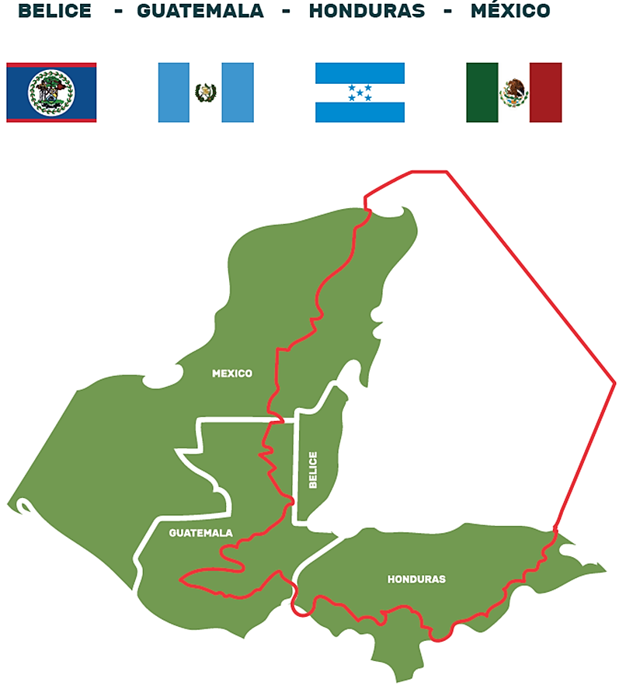
Map 1: Geographic scope of the MAR2R Project and Region

ii. Executive Summary

Brief Project Description
- The Mesoamerican Reef Ecoregion (MAR) shared by Belize, Guatemala, Honduras, and Mexico includes the world’s largest transboundary barrier reef, spanning more than 1,000 km of coast and covering an area of 464,263 km2 of ocean, coasts, and watersheds draining into the Caribbean. It is a biodiversity hotspot; a rich ecoregion ranging from cloud and tropical forests, large rivers, karstic hydrogeological systems, fertile lowlands, coastal wetlands, lagoons, mangrove forests, seagrass beds, and the most diverse coral reefs in the Western Atlantic.
- The MAR sustains equally diverse livelihoods contributing to the national and local economies through agricultural commodities, aquaculture, commercial and world class sport fishing, and an expanding tourism sector, sustaining more than 12 million people.
- The Integrated Ridge to Reef Management of the Mesoamerican Reef Ecoregion (MAR2R) Project MAR2R project was developed to support regional collaboration for integrated ridge to reef management of the MAR ecoregion by demonstrating its advantages and improving regional, national, and local capacities for integrated management and governance of its freshwater, coastal, and marine resources. It does so through (i) a strengthened resource governance and regional collaboration for integrated ridge to reef management; (ii) an integrated ridge to reef management of watersheds and freshwater resources; (iii) an integrated ridge to reef management of coastal and marine resources, and (iv) project monitoring and evaluation, and knowledge sharing.
- The project’s outcomes include regional and national instruments and capacity building to create the enabling environment; participative demonstration projects to showcase integrated ridge to reef management; and a consolidated regional vision and actions for an integrated ridge to reef management of MAR ecoregion through a Transboundary Diagnostic Assessment (TDA) and Strategic Action Program (SAP) to GEF International Waters (IW) standards.
- The GEF Implementing Agency (IA) was the World Wildlife Fund U.S. GEF Agency (WWF-U.S.) with WWF Mesoamerica sharing managerial and supervisory roles. The Executing Agency (EA) is the Central American Commission on Environment and Development (CCAD), the regional authority for environmental issues within the Central American Integration System (SICA) with the co-execution by the Ministries of Natural Resources of Belize, Guatemala, Honduras, and Mexico and with the support of various implementing partners, such as NGOs, academia, private sector partners and contractors.
- The implemented project produced a science-driven analysis of transboundary problems, a negotiated Strategic Action Plan responding to threats, drivers and outlining opportunities, important policies, and proposals; and knowledge and lessons learned from in situ demonstrations.
- This project was executed over a period of 65 months, from February 1, 2018, to June 30, 2023, for a total cost of US$63,483,637 with a total GEF investment of US$9,840,000 U.S. with $9,018,349 U.S. distributed as follows: a total execution of $8,719,761 U.S. (97%) to June 2023, $811,651 U.S. (8%) in agency fees, and co-financing of $53,952,224 U.S. primarily from CCAD, the Ministries of Environment, and other government institutions from the four participating countries and associated partners.

Overview of Evaluation Ratings

A. Assessment of Project Outcomes | Rating | Justification
Were Project outcomes Relevant when compared to focal area/operational program strategies, WWF strategies, country priorities, and mandates of the Agencies? Was the design appropriate for delivering the expected outcomes? | Highly Satisfactory | The MAR2R Project demonstrates strong coherence and relevance with International Waters concerns and aligns well with GEF-5 Focal Areas IW-1, IW-2, and IW-3. It fosters multi-state cooperation, addresses critical water-related issues, considers climate change, promotes sustainable transboundary water management, and emphasizes an ecosystem-based approach. The project effectively addresses transboundary pollution, contributes to sustainable water management, reduces conflicts, improves groundwater, promotes responsible industry and commerce, rebuilds fisheries, supports coastal management, and promotes cooperation, aligning with regional and national policies. Survey results show strong agreement on the project's relevance to conservation and sustainable use of shared resources and alignment with national priorities, policies, and goals for environmental conservation.  The project aligns with the national priorities and policies of Guatemala, Mexico, Honduras, and Belize, supporting environmental, biodiversity, water resource, and rural development goals. At the regional level, it's consistent with the Tulum and Tulum+8 Declarations.  The project design aids in policymaking, operationalizing existing policies, and aligns with agency mandates at both national and regional levels. The design follows the GEF IW methodology in producing a Transboundary Diagnostic Analysis and a negotiated Strategic Action Plan.  The design is therefore relevant to established priorities and in delivering the expected outcomes.
How do you assess the Effectiveness of Project outcomes? Were the actual outcomes commensurate with the expected outcomes? If assessment of outcome achievements is not feasible, output achievement can be used as a proxy. | Highly Satisfactory | The indicators and means of verification were adjusted to adapt to external circumstances, stemming from the pandemic and weather events which allowed the project to achieve 98% of the planned products. This has led to the successful completion of 97% of the objectives defined in the Results Framework. In fact, 98% of intended Outputs were realized contributing to 97% of targets. Evaluators awarded HS as the Outcomes have been realized. For that reason, and based on further justification described herein, the Project Effective.
How do you assess Project Efficiency? Was the Project cost- effective? How does the Project cost/time versus output/outcomes equation compares to that of a similar Project? | Satisfactory | The overall efficiency of the project is approximately 96%. This percentage indicates the degree to which project objectives were met in relation to the budget allocation. Despite challenges and delays faced by the project, the project demonstrated an ability to recover and accelerate its budget execution towards the end with an overall budget execution of 97%, 98% achievement of expected outputs, and 97% outcomes. This means that it effectively utilized its allocated budget to achieve its objectives.
Using the above criteria, please provide an overall rating for the achievement of the Project outcomes. This assessment should analyze both the achievement and shortcomings of these results as stated in the Project document | Satisfactory | Given the HS ranking for Relevance and the HS ranking for effectiveness, the overall score is influenced by a low level of effectiveness and efficiency early in the project cycle. In response to challenges, e.g., Pandemic and climate shocks, adaptations by all parties produced efficiency in budget allocation and implementation, and effectiveness in project execution and in the attainment of expected outcomes. Taking into consideration all factors across the entire project cycle, an overall rating of "Satisfactory" is appropriate.
B. Assessment of Risks to Sustainability of Project Outcomes
Please describe these risks below, considering likelihood and magnitude:
Financial Risks | Magnitude | Impact to Sustainability
Economic Changes and Market Shifts: Potential economic changes or shifts in commodities markets for shrimp, lobster, coffee, sugar and palm oil can pose a risk to the project's revenue generation. These uncertainties could affect land use and cover. | Medium to High | High. If sustainable agriculture or fishing becomes economically unviable due to market shifts, there's a risk that practices might revert to more harmful, unsustainable methods.
Resource Limitations: Limited financial resources, manpower, and technological infrastructure can hinder the execution of the project's Strategic Plan. This is most evident in the availability of capital for credit to finance improved technology or retrofit old technology, such as wastewater treatment plants. | Medium | Medium. Without proper resources, the environmental achievements can degrade over time. For instance, a restored wetland could be threatened if there aren't resources for its continued management. This can render the project outcomes unsustainable in the long run. The private sector focus of the project’s demonstrations will mitigate that effect if scaled. Other projects are under development. Transformational scaling-out should be a focus in all new aligned projects to reduce this risk.
Global economic performance can affect the availability of capital for green investments. Changes in global economics should form part of the assumptions of the documents. | Medium | Medium to High. An economic downturn can force stakeholders e.g., local communities to prioritize immediate economic gains over long-term environmental sustainability. This limitation may also lead to operational challenges and impact the overall sustainability of the SAP if SICA member states cannot provide consistent levels of support.
Financial Sustainability Assessment: Likely (L)
The strategies outlined in the SAP, such as diversifying funding sources, aligning with national priorities, and optimizing resource usage, demonstrate a comprehensive approach to mitigate these risks and ensure the long-term success of the project.
Socio-Political Risks | Magnitude | Impact to Sustainability
Diminishing Community Support: Community support for the project may decline over time due to changes in community priorities, leadership, or economic conditions. This can pose challenges in maintaining local engagement and participation. | Medium to High | High. Projects like MAR2R often rely on local engagement for long-term success. If the community stops valuing or actively supporting the project outcomes, there's a risk that conservation efforts could lapse or be actively reversed.
Potential Conflicts and Alienation: Any conflicts or changes that alienate the local community over time or that force communities to choose between economics and environment. It may be difficult to increase willingness to pay since conflicts may disrupt community cohesion and support. | Medium | High. Conflicts can create divisions and reduce collective community efforts. Alienated community members might choose between economics over environment.
Gender-Based Disparities: Gender-based disparities are identified as a potential concern that may require ongoing efforts to address. Achieving gender equality and inclusivity may be a slow and continuous process. | Medium | Medium to High. Gender inclusivity is crucial for holistic community engagement. Neglecting gender inclusivity can mean missing out on diverse perspectives and solutions that could benefit the project.
Socio-Political Sustainability Assessment: Moderately Likely (ML)
The SAP includes measures to mitigate sociopolitical risks related to community dynamics, gender disparities, and inclusiveness. Regardless, there remains moderate risks associated with the potential for diminishing community support over time and the emergence of conflicts. The emphasis on community engagement, gender equality, and transparency should contribute to overall sociopolitical sustainability. Ongoing monitoring and adaptability will be essential to address and mitigate these risks effectively.
Institutional Framework and Governance Risks | Magnitude | Impact to Sustainability
National Elections and Political Instability: Rapid changes in leadership, political instability, and shifts in government priorities can disrupt the continuity of SAP implementation. These factors, including nationalism, could introduce risk to transboundary cooperation. | Medium to High | High. Political instability can result in a lack of focus on environmental and transboundary projects.  Political changes can lead to decreased funding, support, or even discontinuation of the SAP process. Transboundary cooperation is especially vulnerable as it requires consistent commitment from all involved nations. A nationalist agenda by any nation can impede collaboration.
Consistency in Policy Implementation: Consistency in the SAP success relies on the capacity of governments to place quality leadership within CCAD and implement policies aligned with the SAP. Inconsistencies in policy implementation can hinder progress and sustainability. Changes in administration can influence the SAP's direction and priorities. | Medium | Medium to High. Inconsistent policy implementation can disrupt SAP progress and make its outcomes vulnerable. Regular changes in direction can also confuse stakeholders, leading to decreased engagement or misaligned actions.
Adaptability to Changing Circumstances: The SAP is vulnerable to changing circumstances, including technological advancements, economic shifts, and social changes. Failure to do so may lead to the project becoming outdated or less effective. | Medium | Medium. If the SAP isn't agile enough to adapt, it might miss opportunities or face challenges to which it is not equipped. An outdated or rigid SAP process can become less effective in achieving its goals. This may lead to missed opportunities or reduced effectiveness in face of new challenges or changes.
Institutional Framework and Governance Sustainability Assessment: Moderately Likely (ML)
The potential for rapid leadership changes, shifts in government priorities and an unequal capacity for executing SAP actions introduces moderate risks to sustainability. The CCAD should remain vigilant, adaptable, and politically engaged to navigate these challenges successfully and maintain its institutional and governance sustainability.
Environmental Risks | Magnitude | Impact to Sustainability
Changes in Environmental Conditions and Regulations: The project acknowledges the importance of complying with environmentally sustainable standards and has incorporated various regional strategies and initiatives to address environmental challenges. However, it recognizes that changes in environmental conditions and regulations could pose moderate risks to sustainability. These changes may require adjustments to the SAP strategies and practices to remain compliant. Conversely, this could be an opportunity to share good practice in policy. | Medium to High | Medium. Environmental conditions can change due to various factors like climate change, while regulations might evolve as new knowledge emerges. If the project doesn't adapt to changing conditions or regulations, its outcomes may not remain sustainable or compliant. However, with adaptability, it can also seize opportunities to share and adopt best practices.
National Policy Shifts: A policy shift, especially incentives to productive sectors at the national level in one of the member countries can have significant implications for environmental sustainability by introducing uncertainty and potential challenges in aligning the project with new national policies and priorities. | Medium | Medium to High. National policies can change depending on political landscapes or economic pressures. This could challenge alignment with the project's sustainability goals.  If new policies conflict with the project's objectives, it could endanger the sustainability or reverse the effects of the achieved outcomes. Realignment may require additional resources.
Resource Diversion and Priority Shifting Events: Events, such as pandemics or large climatic events that divert resources and shift priorities are potential risks to environmental sustainability and can disrupt the project's ability to allocate resources and maintain its focus on environmentally sustainable practices. | Medium | High. Unexpected events like pandemics or climatic disasters can divert resources and attention from the project's goals. These events can stall ongoing efforts and strain resources, making it challenging to maintain and promote sustainable practices.
There are no strategies in place for a collapse scenario. There are technologies under development, such as 3D printing of coral in Mexico, that could be used to repopulate coral reefs in the event of a catastrophic event. These types of contingency plans can include identifying genetic material of sea grass species, mangroves, fishes, etc. A fish mortality event in Belize’s New River provides an example of the difficulties that arise when events occur without contingency plans. The SAP does not address catastrophic scenarios. | Medium to High | High. The lack of preparedness for catastrophic events, like a significant coral die-off, presents risks to the project's sustainability. Without contingency plans, sudden events can cause irreversible damage, threatening the sustainability of the achieved outcomes.
Environmental Sustainability Assessment: Moderately Likely (ML)
Despite the SAP’s regional environmental strategies and initiatives, the potential risks associated with changes in environmental conditions, regulations, policy shifts, and resource diversion are considered moderate. The probability of climatic or environmental shocks is moderate to high. It is essential for the SAP implementation to remain adaptable and responsive to these potential challenges to ensure the overall sustainability of its environmental outcomes
Overall Rating of Sustainability of Project Outcomes | Justification
Moderately Likely (ML) | The project emphasizes proactive actions, strategic foresight, and has identified moderate risks across several dimensions like financial, sociopolitical, environmental, and governance. The strategic plan is comprehensive, addressing these risks with a focus on long-term positive outcomes. Essential to the project's approach is the use of sustainability indicators for monitoring and evaluation, covering various domains such as institutional strength, community engagement, and environmental responsibility. These indicators help in continuous assessment and resource allocation, reflecting the project's dedication to sustained impact and success.
The Risk Assessment for the Overall Sustainability of the Project demonstrates a robust approach to ensuring the project's long-term viability and positive outcomes
C. Assessment of Monitoring and Evaluation (M&E) Systems | Remarks
M&E Design – Was the M&E plan at the CEO endorsement practical and sufficient? Did the M&E plan include baseline data? Did it: specify clear targets and appropriate SMART indicators to track environmental, gender, and socioeconomic results; a proper methodological approach; specify practical organization and logistics of M&E activities including schedule and responsibilities for data collection; and budget adequate funds for M&E activities? | The Monitoring and Evaluation (M&E) Design for the project is rated highly satisfactory, effectively enabling the tracking of key data and indicator targets throughout the project. Central to this is the Results Framework, a successful tool for monitoring and assessing results. The M&E system benefits from having baseline data for most indicators, setting a strong base for gauging performance. While the indicators used are suitable and clear, there's potential for enhancement via SMART analysis. Resources for M&E are ample, with dedicated staff and a budget constituting 14% of the project's total budget.
M&E implementation – Did the M&E system operate as per the M&E plan? Where necessary, was the M&E plan revised in a timely manner? Was information on specified indicators and relevant GEF focal area indicators gathered in a systematic manner? Were appropriate methodological approaches used to analyze data? Were resources for M&E sufficient? How was the information from the M&E system used during Project implementation? Did it facilitate transparency, sharing and adaptive management? |  | The M&E system's implementation is deemed satisfactory. Initial communication issues between the Executing and Implementing Agencies, which arose from high expectations based on WWF's prior project experience, were resolved using adaptive management. This process was crucial in getting the project on-track, emphasizing its role as an exemplary model of adaptive management. Key factors in the project's success include stakeholder engagement, collaboration with CCAD, strengthening capacity, and the essential contribution of ISNCs for improved governance. Within this adaptive framework, the executing and implementing agencies collaboratively modified indicators impacted by the pandemic. This collaboration resulted in redefining several key outcomes and outputs and more realistic targets, approved by the steering committee. The project's M&E system proved its worth through regular report submissions, aiding the overall management and enhancing decision-making processes.
Overall Rating of M&E During Implementation |  | Highly Satisfactory
The M&E tracking system is considered adequate. The quality of the information and reporting provided in implementation meets expectations and facilitates decision-making and evaluations. It has demonstrated reliability through the consistent submission of reports and the delivery of tangible benefits to the project's overall management and decision-making processes. Overall, the project's approach to monitoring and evaluation has proven to be robust and highly effective in supporting its objectives and outcomes.
D. Implementation and Execution Rating | Rating |  | Justification
Please rate the WWF GEF Agency on the Project implementation. | S |  | The implementing agency was instrumental in the Project’s adaptive management, asserting the oversight role's effectiveness. The project experienced initial communication hurdles between the Implementing and Executing Agencies. Proactiveness and collaboration from both parties eventually solved these issues. Strategic staffing adjustments were made by WWF, CCAD, and the PMU, leading to enhanced coordination and communication. WWF addressed technical administrative concerns, which were adopted by the PMU. Pandemic-induced limitations curtailed oversight visits. Yet, as challenges arose, timely Technical Assistance was extended, successfully refining CCAD's financial, Monitoring and Evaluation, administration and safeguard systems to meet GEF fiduciary standards.
Please rate the Executing Agency on Project execution. | S |  | CCAD possesses the authority and capacity to gather MAR's national policymakers and regulatory bodies, making it apt for an IW initiative's executing agency. The MAR2R enhanced CCAD's position in the region, equipping it with the enhanced skills and systems to handle intricate projects alongside regional and national allies. CCAD's transformation was further enhanced by a leadership change that introduced a proactive approach. Stakeholders reported smooth and effective communication with the PMU. However, national grantees flagged concerns about bureaucratic hurdles and delayed financial procedures. It is noted that CCADs systems require further development, Capacity building should be integrated into all future projects to support continued strengthening of CCADs project management, financial and quality assurance systems. An overall rating of Satisfactory reflects CCADs positive trajectory and growth as a development agency. .
Overall quality of implementation and execution | S |  | The agencies' ability to adapt, collaborate, and achieve desired outcomes, even amid challenges, justifies this rating.
Table 3: Summary of Evaluation Ratings

Summary of Findings
Relevance and Coherence
The MAR2R Project demonstrates strong coherence and relevance with International Waters concerns and aligns well with GEF-5 Focal Areas IW-1, IW-2, and IW-3. It fosters multi-state cooperation, addresses critical water-related issues, considers climate change, promotes sustainable transboundary water management, and emphasizes an ecosystem-based approach. The project effectively addresses transboundary pollution, contributes to sustainable water management, reduces conflicts, improves groundwater, rebuilds fisheries, supports coastal management, and promotes cooperation, aligning with regional and national policies. Survey results show strong agreement on the project's relevance to conservation and sustainable use of shared resources and alignment with national priorities, policies, and goals for environmental conservation.
Effectiveness
The implementation of the project was Highly Satisfactory. Regional policy instruments developed (7); national policy instruments developed (4); All countries (4) in the MAR endorsed the Transboundary Diagnostic Analysis and the Strategic Action Program; number of visitors consulting the Regional Environmental Observatory (3,897); 3,695 Stakeholders trained in IWRM; Strengthened public-private mechanisms to increase (USD) in funding available for public private mechanisms in BZ, GT and HN ($579,479); Stakeholders engaged to reach Voluntary Standards in sugar and palm oil (4); and Number of tourism and tourism development sector actors adopting better management practices (BMP) to protect aquifers and freshwater critical habitats under project activities (36). The results of the project exceeded expectations.
Efficiency
The execution of the project was satisfactory. 98% of the outputs were produced on 97% of the budget. Regardless of COVID, the PMU maintained a flow of project activities. In response to slow performance, the principal partners took corrective action that increased the delivery and the efficiency of the delivery of the annual work plans. In terms of the time-to-delivery, there was no delegation of authority to the PMU to approve basic amounts of expenditures. SICA administrative approval procedures were in force and required SICA sign-off which created drags in delivery.
Results/ Impact
The Project was Highly Successful in producing the Results to Impact per GEF IW Core indicators by increasing the number of regional policy instruments that promote ridge to reef management of the MAR ecoregion approved due to project activities (7); increase in the area (ha) of watersheds under IWRM project activities (3,402,101 ha.); and the area of coastal and marine ecosystems under ICMM (323,600 ha.). An endorsed Transboundary Diagnostic Analysis and Strategic Action Program.
Sustainability
Sustainability is “Moderately Likely.” Financial risks for future SAP implementation are related to commodity prices, difficulty in de-risking small and mid-sized producers, and credit availability. Socio-political risks are in distrust by stakeholders, difficulty in willingness to pay for environmental services. Institutional risks in frequent changes in leadership, nationalism, capacity to act on improved policies, and perverse incentives, and low capacity to adapt to changing circumstances. Environmental risks associated with climate change and no plans in place for ecosystem restoration following a catastrophic collapse. Short term financial sustainability is reliant primarily on grantsmanship, which is an active and ongoing process. WWF collaborated in development of a Concept Note for a MAR2R phase II project with CCAD, who has mandated the PMU to develop additional projects to extend the Ridge to Reef concept to all SICA nations.
Adaptive Management
The project was highly successful in adaptive management. All parties (WWF, CCAD, and the PMU) realized personnel changes, adjusted the Results Framework, and increased the effectiveness of the M&E and management functions improved delivery following a slow start and from the effects of COVID and post-COVID related interruptions in the value chain.
Equality and Gender Mainstreaming
CCAD had no prior established Equality and Gender mechanisms or safeguards. The project used the approved WWF-GEF Environment and Social Management Framework. Equality and Gender were effectively mainstreamed. The time needed to complete all safeguards requirements given the capacity of local organizations was underestimated contributing to delays in execution. The sub-executing agencies for those projects had histories of mainstreaming gender and equality. Gender and Equality were mainstreamed into the budget and reporting process. However, approximately 70% of respondents indicated that men and women had equal access to project benefits.
Table 4: Summary of Findings

Conclusion & Recommendations

Effectiveness
Recommendations: Create a Monitoring and Evaluation section in the REO that tracks a scorecard on SAP progress, such as the Chesapeake Bay Scorecard or other similar instrument that rallies public action. Use this as a basis for formulating new projects and setting targets for new projects and in fortifying CCAD’s role in MAR2R. Systematize the SAP indicators. | Responsible Entity  CCAD
Efficiency
Finding 2: The project was implemented efficiently but with time lags.
Recommendations Future processes can be streamlined through the establishment of CCAD Standard Operating Procedures for all aspects of project management (financial, M&E, safeguards, gender, etc.) to GEF & international standards. This could be done through a GEF capacity development project or in tandem with a MAR2R Phase II initiative. Take advantage of the GEF Policies and guidance and training materials available through GEF STAP referenced in the recommendations of this report. Once established, a framework for the delegation of authority for the routine financial management of projects from SICA to CCAD can be expanded, hence streamlining the process. SICA can retain oversight and annual auditing, etc. in fulfillment of their fiduciary responsibility and as a safeguard. At the onset of each new project, develop a project manual that defines for all stakeholders (IAs and EAs) the Standard Operating Procedures, per SICA, CCAD, and donor specifications, project data and indicators in-force. | Responsible Entity  CCAD
Finding 3: Results to Impact
Recommendations: Work towards a transformational scaling of Global Environmental Benefits by expanding the Theory of Change to include step changes that scale out (replication, financing), scale deep (advocacy for change, policy), and Scale-up (policies enabling private sector, green infrastructure and eliminate perverse incentives). All new projects for SAP implementation would fit within a common expanded and directional TOC. | Responsible Entity:  CCAD, National governments, bilateral and multi-lateral institutions.
Finding 4: Sustainability
Recommendations: Develop a MAR2R Fase II project that makes operational the Strategic Action Program (SAP). Update the NDCs of each nation to include strategic projects under the SAP. Create a public-private financing roundtable for SAP implementation to scale global environmental benefits and to cofinancing SAP aligned projects. Increase communications on the benefits of MAR2R and hazards of poor wastewater. Seek alternatives to lack of financing institutions to support businesses to install water treatment and reuse systems. Develop concept notes for all the projects alluded to in the SAP. Consider a capacity building project for CCAD and state and local governments to support SAP implementation. More than mitigation plans, create restoration plans to respond to catastrophic collapses. | Responsible Entity:  CCAD, National Focal Points, support from INGOs
Adaptive Capacity
Finding 5: The Adaptive Management of the project was “highly effective”
Recommendations: A project board meeting (Ministers, CCAD, and IA-agency) should be held yearly to provide feedback to the IAs and EAs and to provide conflict resolution if needed. The PMU participation of the PMU in executive committees should be of a ‘secretary role’ with a voice and no vote. This will enable better feedback to improve the project on a yearly basis and avoid the possibility of any member being both “judge and jury.” High and mid-level steering structures and their functions can be institutionalized within CCAD for all projects. | Responsible Entity  CCAD
Equality and Mainstreaming
Finding 6: Gender and Equality were effectively mainstreamed into the project. Systematize within CCAD
Recommendations: For SAP implementation, the process can be further mainstreamed by developing policy and guidance for stakeholder engagement, gender, indigenous persons and local communities (including FPIC), In those cases that are requested by the communities themselves, exploring and researching, but above all respecting the unique governance forms of the people adhering to ancestral/traditional knowledge and with a local impact) and a grievance mechanism. These policies and guidance notes can be applied to all projects executed by CCAD and increase their capacity to execute projects. These can be widely disseminated through the REO and evaluated yearly. Combine process and gender sensitive indicators to capture the quality of mainstreaming in addition to earmarking project budgets. | Responsible Entity  CCAD
Table 5: Recommendations

Acronyms

AIPAH | Industrial Association of Palm Oil Producers of Honduras
APAH | Sugar Producers Association of Honduras
BONSUCRO | Better Sugar Cane Initiative
CCAD | Central American Commission on Environment and Development
CLME+ | Caribbean Large Marine Ecosystem
CONAGUA | National Water Commission - Mexico
CONANP | National Commission on Natural Protected Areas - Mexico
CZMAI | Coastal Zone Management Authority and Institute - Belize
DIGEPESCA | Fisheries General Directorate – Honduras
ERAM | Framework Regional Environmental Strategy 2015-2020 (Estrategia Regional Ambiental Marco 2015-2020 in Spanish)
ERCA | Blue Growth Regional Strategy (Estrategia Regional de Crecimiento Azul in Spanish)
ESMF | Environmental and Social Management Framework
FIP | Fishery Improvement Project
FP | Focal Point
FUNDAECO | Foundation for Ecodevelopment and Conservation
GEF | Global Environment Facility
HRI | Healthy Reefs for Healthy People Initiative
ICMM | Integrated Coastal Marine Management
IDB | Inter-American Development Bank
ISNC | Intersectoral National Committee
ICZM | Integrated Coastal Zone Management
IWRM | Integrated Water Resource Management
M&E | Monitoring and Evaluation
MAR | Mesoamerican Reef
MAR2R | Integrated Ridge to Reef Management of the Mesoamerican Reef Project
MARN | Ministry of the Environment and Natural Resources - Guatemala
MARTI | Mesoamerican Reef Tourism Initiative
Mi Ambiente | Secretaría de Energía, Recursos Naturales, Ambiente y Minas - Honduras
MSC | Marine Stewardship Council
MX | United States of Mexico
NDC | Nationally Determined Contribution
NOM 001 | Norma Oficial Mexicana sobre descargas de aguas residuales
OSPESCA | Organización del Sector Pesquero y Acuícola del Istmo Centroamericano
REO | Regional Environmental Observatory
SAP | Strategic Action Plan
PIR | Progress Implementation Report
PMU | Project Management Unit
PPR | Project Progress Report
PREA | Protocolo Regional de Economía Azul
PRODOC | Project Document
RSPO | Roundtable on Sustainable Palm Oil
R2R | Ridge to Reef
SCTLD | Stony Coral Tissue Lost Disease
SICA | Sistema de Integración Centroamericana
SITCA | Secretaría de Integración de Turismo en Centroamérica
SEMARNAT | Secretaría de Medio Ambiente y Recursos Naturales (México)
SUSTENTUR | Sustainable and Social Tourism
TDA | Transboundary Diagnosis Analysis
TOR | Terms of Reference
TOC | Theory of Change

Introduction to Evaluation

- The Terminal Evaluation process was defined in an Inception Report submitted to WWF in response to comments from the consulted IA and EA partners on July 26th, 2023. That process is summarized in the following sections.
- The Terminal Evaluation (TE) is an independent, technical, and financial evaluation of the Project’s performance against expectations. In adherence to GEF requirements, WWF the GEF IA, contracted Asesoramiento Ambiental Estratégico (AAE), an independent consulting firm, to assess the Project’s relevance, effectiveness, and efficiency, and to gauge achievement of the outcomes, impacts (actual and potential) and their sustainability per a contracted Terms-of-Reference (TOR) (Annex 5.1)
- The evaluation promotes accountability, transparency and facilitates the synthesis of lessons. The feedback provided allows the GEF Independent Evaluation Office (IEO) to identify recurring issues across the GEF portfolio; and contribute to GEF IEO databases for aggregation, analysis and informing future program and project design.
- The objective of the evaluation is realized through the following TE Report that determines whether the project achieved its objectives through the attainment of the expected outcomes and assesses the likelihood of realizing the long-term impacts. It draws lessons aimed to improve the sustainability of the Project’s benefits. The TE is guided by the WWF-GEF Agency evaluation criteria and guidance and within GEF and agency ethical standards.

1.1 Purpose of the Evaluation
- All projects financed by the GEF are required to complete a TE to provide a comprehensive and systematic account of the performance of a completed project by evaluating its design, implementation, and achievement of objectives. The TE provides GEF Agencies and project partners with a comprehensive and systematic account of the project’s performance by assessing its design, implementation, progress towards objectives, attention to cross-cutting themes and the likelihood of long-term impacts.
- The objectives of this evaluation are: (i) to examine the scope, magnitude, and sustainability of the project's impacts; (ii) to identify concerns and best practices; (iii) to assess progress towards the expected results; and (iv) to draw lessons learned that support the sustainability of the project’s benefits and assist in the improvement of future projects. The evaluation is framed within the analysis of seven (7) core criteria of relevance, coherence, effectiveness, efficiency, results/Impact, sustainability, and adaptability.
- The product is a final report that assesses whether the Project achieved its purpose of contributing to the conservation and sustainable use of shared freshwater, coastal, and marine resources in the transboundary MAR ecoregion through the implementation of the watershed-to-reef approach, thereby ensuring sustainable economic benefits and livelihoods for the countries and their communities, based on the level of attainment of the project's objective and results goals. Specific objectives, criteria, and required ratings (Rankings) are detailed in the Terms of Reference (ToR) for the current consultancy (Annex 5.1), which is the prevailing source in the event of any discrepancies.

1.2 Limitations of the Evaluation
- “Evaluability” is the extent to which a program can be reliably evaluated, i.e., maintaining consistency between data, information, and evaluation judgements so that these judgements can be relied upon. Evaluability also refers to the quality of the results framework, documents and/or effects map (coherence and alignment between effect, outcome, output, indicator) and the monitoring system in place, to enable an effective evaluation. Based on the information provided, the project was deemed “evaluable” with sufficient conditions to support the evaluation process. The evaluation was implemented as planned with no setbacks. The IAs, EAs and executing partners were cooperative, responsive and forthcoming in responding to evaluators’ requests.

1.3 Scope & Methodology
- The scope of the TE is defined by temporal, geographic and programmatic aspects of the Project as specified in the TOR and as defined in the approved Evaluation Methodology presented in Annex 5.6.
- The temporal dimension covers the Project from CEO endorsement in April 2017 to June 2023.
- The geographical dimension of the evaluation is “regional” with consultation focused on the localized activities within the Mesoamerican region and both regional and national-level policy and fiduciary aspects of interest to the governments of Mexico, Honduras, Belize, and Guatemala. Maps in Annex 5.3 indicate the original geographic dimension of the project and the expanded dimension of the TE.
- The thematic or programmatic dimension covers the following: (a) the project´s foundation as described in its justification, strategy, and design; (b) the Project´s progress towards expected results and impacts; (c) Project implementation and adaptive management; and (d) lessons learned, conclusions and recommendations. Thematically, the evaluation is framed within the objectives and concepts for the GEF International Waters Focal Area Strategic Objectives 1, 2, and 3. The TE assessed project performance against indicators established in the project’s modified Results Frameworks. The evaluation methodology, key questions and criteria were developed through a participative process and agreed during an inception workshop held on June 14, 2023, and presented in an Inception Workshop Report approved on July 26, 2023.
Methodology
- The GEF Evaluation Criteria are lenses through which the information gleaned from information collection and other activities was processed. These are: (i) relevance, (ii) effectiveness, (iii) efficiency; (iv) the ranking of overall Progress to Impact (v) Project Implementation and Adaptive Management; (vi) cross- cutting aspects: (vii) sustainability; and (viii) conclusions, recommendations and lessons learned. See Annex 5.10 for a description of TE criteria and ratings scales. For each, key evaluation questions were developed and are presented in the TE Matrix (Annex 5.6).
- The data collection and analysis methodology combined qualitative (interviews and focus group meetings) and quantitative methods (data collection, processing, analysis), which allowed evaluators to draw conclusions relative to the Project’s achievement of the outputs and the relative strengths, weaknesses, and opportunities. The methodology is summarized as follows:
- Desk Review of project and sector information from internal and external sources (Annex 5.5.). The information collected was analyzed for the quality and relevance of the information provided, gaps, coherence, and correlation between documents, etc. This was the primary source of information for gauging effectiveness in the completion of outputs and attainment of targets per indicators. Quarterly financial reports were analyzed to inform the efficiency analysis. There were no gaps in the information base presented.
- Focus Group Discussions (FGDs) were utilized to reduce the number of interviews, to inform the Evaluation Mission, to indicate the need for follow-on interviews and to foment dialogue on future project actions and recommendations. Both virtual and face-to-face Focus Group discussions were implemented.
- Key Informant Interviews (KIIs): A Semi-structured Interview Guide (Annex 5.7) facilitated consistency between interviews. The questions were derived from the TE Matrix and applied according to the expertise of each interviewee. Both virtual and face-to-face interviews were implemented.
- Mission/Field visits: Fieldwork options were evaluated and discussed with WWF-GEF and the CCAD Project Management Unit (PMU) during inception. Site visits shortened the evaluation timeline and enhanced efficiency. The mission took place from Tuesday, August 15th, to Saturday, August 26th. Site visits to Cancun, Akumal and Chetumal Mexico; Belmopan and Orange Walk Belize; and San Pedro Sula, Honduras that enabled face-to-face interactions with project authorities, government representatives, communities, and beneficiaries of demonstration projects within the target area. All interviews with Guatemalan authorities and partners were virtual. The detailed itinerary is shown in Annex 5.2.
- Triangulation: Information from the desk survey was triangulated through KIIs. An online questionnaire was posted to provide context on findings and to gauge satisfaction. Additional information was also requested and exchanged via email.
- An invitation to respond to an online survey with structured questions common to all groups was sent to project stakeholders and beneficiaries to gauge overall satisfaction and qualify results obtained through interviews. The invitation was sent via email and circulated to participants interviewed for dissemination. A total of 53 responses were received from an estimated 65 requests for a response rate of 82%. The survey results are not used as primary data, but rather to support the triangulation of evaluation findings. See Annex 5.8 for survey results.
- Presentation of Findings: A feedback loop was established between AAE, WWF, CCAD and key stakeholders to validate the preliminary findings. A webinar presenting preliminary findings was implemented on 18 September 2023. Comments were received for a week following the presentation and are incorporated into this report.
- A draft TE Report was submitted on 28 September 2023. Following a comment phase, a final report was submitted in response to comments and approved on 01 December 2023.
- The results per key evaluation criteria were scored using a “traffic light system,” a color code ranging from Red (Not Achieved) to Yellow (Partially Achieved or above 70%) to Green (Achieved) using the stated Mid-term targets and End-of-Project (EOP) targets as benchmarks. The ranking is complemented by a numerical rating associated with GEF evaluation categories ranging from “Highly Unsatisfactory” (HU) to “Highly Satisfactory” (HS). The ranking system and scales are described in Annex 5.10.
- The following evaluation categories received rankings:
- Relevance/Coherence of the Project Strategy focused on the strategic formulation and design of the project, its coherence with the situational analysis and the problems raised; the degree of participation of the beneficiary population in the construction of the project, considering its link with the priority areas of the GEF, IAs and international priorities.
- Effectiveness: An analysis of progress towards achieving results at the Outcome-level as defined in the indicators within GEF-approved project Results Framework. A second layer of analysis tested progress against the stated outputs thereby testing the quality of the indicators. Inconsistencies between the two activities enabled evaluators to identify problems with design, the indicators or problems in execution.
- Efficiency is the ability of the project in executing the programmed activities within the times frames and budget established. Evaluators analyzed the administrative/financial actions, the application of the work planning approach and adaptations based on monitoring of results.
- Project Implementation and Adaptive Management.
- Monitoring and Evaluation: a composite of design and effectiveness of the M&E implementation process.
- Sustainability was analyzed from four perspectives: financial risks, socio-economic feasibility, institutional and governance risks, and environmental risks. Evaluators examined the cross-cutting tools provided to enhance Sustainability including safeguards e.g., Stakeholder Engagement, Gender Action Planning and the presence of a functional Grievance Mechanism of the project.
- Based on the TE results, the Report provides Conclusions, Recommendations and Lessons Learned.

1.4 Structure of the TE Report
- The TE Report follows the structure indicated in the TOR. The document is divided into five sections: (1) the introduction, (2) the project description and background context, (3) the findings, (4) the conclusions, recommendations, and lessons learned, and (5) the mentioned annexes.

Project Description and Development Context

- The project was implemented over a 65-month period from February 2018 to June 2023. Following an unsuccessful Mid-term Review (MTR), a successful process was executed in the 42nd month of implementation (70%) with 13 months remaining (30%) until the project's completion. This terminal evaluation covers the entire implementation period (65 months) up to June 30, 2023.

2.1 Problems the Project Sought to Address
- The Mesoamerican Reef Ecoregion (MAR) shared by Belize, Guatemala, Honduras, and Mexico includes the world’s largest transboundary barrier reef, spanning more than 1,000 km of coast and covering an area of 464,263 km2 of ocean, coasts, and watersheds draining into the Caribbean. It is a biodiversity hotspot; a rich ecoregion ranging from cloud and tropical forests, large rivers, karstic hydrogeological systems, fertile lowlands, coastal wetlands, lagoons, mangrove forests, seagrass beds, and the most diverse coral reefs in the Western Atlantic. The MAR sustains equally diverse livelihoods contributing to the national economies to communities through agricultural commodities, aquaculture, commercial and world class sport fishing, and an expanding tourism sector, sustaining more than 12 million people.
- The approved Project Document details the anthropogenic pressures affecting the region and its ecosystem services. To summarize, these are land use change; inappropriate agricultural practices; unregulated and expanding development, incomplete and inadequate policy and management regimes and inadequate financing. These result in unmonitored sediment loading from non-point sources, nutrient loading of aquatic systems from point sources, overextractions, that result in negative feedback loops that lead to decreasing environmental quality, lower economic opportunity and back to decreasing environmental quality. In management terms, the chain of interrelated upstream and downstream causes and effects is unnoticed by stakeholders living and operating in relative isolation to each other. This is also true across the MAR geography and governments. At the interstate level, the MAR was also managed in silos with insufficient collaboration between authorities at national and regional levels. Despite strong political support from member countries, weak capacity and inadequate financial resources limited regional transboundary integrated water and soil management. When these factors are combined with the known effects of climate change, such as sea level, higher ambient air and water temperatures, and changes in storm patterns and intensity lead to consequential effects, such as increased magnitude of sea surge, algae and sargassum blooms leading to eutrophication, proliferation of coral diseases and decline.
- Collectively, these lead to interconnected impacts from “ridge to reef” with consequences for freshwater, coastal and near-shore marine ecosystems compromising their structural and functional integrity that reduces resiliency to the effects of storms, coastal erosion, and reduced economic resilience in shipping, aquaculture, real estate, tourism, commercial and sport fishing, and reduced municipal and central government tax bases that effect flows of municipal and central government goods and services to upstream populations.

2.2 Baseline Actions and Gaps to be Addressed by the Project
- Since 1997, the four MAR countries have developed baseline efforts to address transboundary issues. The MAR region is declared as a priority conservation area through the Tulum and Tulum +8 Declaration commissioning the Central American Commission on Environment and Development (CCAD) to lead their joint efforts. There was also previous experience in negotiating and managing a GEF International Waters process through the GEF CLME and transboundary waters agreements in place between Mexico and Guatemala and Belize. In addition, important NGO actions supported approaches to the sustainable management and conservation of the MAR’s natural resources and established the foundation for a ridge to reef regional approach, such as in the following selected examples.
- The baseline establishes the “Ridge-to-Reef concept and the key barriers that constrict an effective response to the problems mentioned in the previous section. The intergovernmental policy response was defined in the updated Regional Action Plan for the MAR (2007) which recognized the need for an integrated watershed, coastal, and marine management, or a ridge-to-reef approach. The document articulates a strategic direction through 11 sub-strategies for management of principal economic activities and for principal ecosystems within the MAR. Although the plan was never implemented, it defines the MAR2R concept and identifies the key technical and policy issues to be resolved, helping to define the baseline situation.
- The concept of Integrated Water Resources Management (IWRM) including the need for integrated and transboundary management of watersheds and hydrological resources for water conservation was established in the CCAD Regional Framework Strategy on the Environment (ERAM).
- Baseline actions in watershed management planning were further established for several rivers and aquifers, such as for the Rio Hondo watershed, where a binational council (Mexico and Belize) was created to improve the quality of its water resources. In 2014, the watershed council developed strategies and action plans for the Chetumal Basin. However, the council has limited capacity for implementation and lacks regulatory capacities having only a consultative role with stakeholders. Guatemala has established the national authority for the sustainable management of the Motagua River basin and has provided guidance for the development of watershed management plans and has provided monitoring equipment for water quality in the Motagua watershed area. The baseline also includes extensive targeted policy actions at the national level, such as, in Mexico, Belize and Guatemala, exchange programs supported artisanal fishermen with improved organization capacities and techniques, the establishment of no-take zones, and improved market opportunities. In Belize, Guatemala, and the Bay Islands of Honduras, a ban on fishing parrotfish is in place. Regional fisheries efforts are also working towards establishing compatible regulations for finfish and conch through experience sharing and improved community organization, fishing gear, and establishment of no-take zones. Efforts have led to increased regulatory compliance and harmonization between Belize and Mexico, specifically for the conch fishery. The most relevant regional accomplishments to address overfishing come from a 2009 region-wide effort led by OSPESCA to halts lobster fishing from Belize to Panama during the lobster reproductive season, implementing a lobster ban.
- The baseline scenario also includes private sector actions relevant to the MAR2R concept. Among these are experiences between businesses and Non-Government Organizations in the development of water funds and financing of the actions related to Corporate and Social Responsibility (CSR) programs. For example, The Coca-Cola Company (TCCC) in 2006 partnered with WWF and Fundación Defensores de la Naturaleza to launch Guatemala’s Sierra de las Minas Water Fund in the Motagua-Polochic system. Defensores de la Naturaleza established the mechanism in collaboration with the Coca-Cola bottler and other business partners, as well as international donors active in the region.
- A second baseline private sector approach is the involvement of NGOs and producers to embrace Best Management Practices (BMPs) and Voluntary Standards. Baseline actions to connect producers to Roundtables on Sustainable Palm Oil, Sugar Cane, and Shrimp production to adhere to voluntary standards that increase environmental and social performance and market competitiveness. WWF has been continuously working with productive sectors since 2004. In fishing, WWF has supported a certification process to achieve Marine Stewardship Council (MSC) standards. Fisherfolk and businesses committing to this sustainable standard can maintain current markets or access specialized ones for their product. Likewise, the Aquaculture Stewardship Council (ASC) promotes better management practices for sustainable operations. In Belize, for example, the commercial scale adoption of these practices amongst shrimp farmers has resulted in significant reductions of effluents by up to 90% (when compared to 2004 levels), enabling the recovery of important coastal areas like the sea grass beds of Placencia Lagoon. These better management practices have also enabled producers to reach ASC certification. All private sector efforts listed, and others as described in the project’s documentation formed the basis for the MAR2R private sector engagement activities.
- Finally, the Project document provides an extensive baseline in technical restoration activities, such as coral reef management, mangrove management, Integrated Coastal and Marine Management (ICMM), fisheries management and lobster production. In addition, a list of transnational projects, whose scope and management influences how authorities manage transboundary resources or has direct linkages to the project are:
- The GIZ supported Regional Database on Forest Resources in Central America and the Dominican Republic to support forest monitoring in each SICA nation and establish the foundation for a regional forest information system that operates within the framework of the Regional Environmental Observatory (REO). Another important GIZ investment in the region includes the “Enhancing the Adaptive Capacity of Rural Economies and Natural Resources to Climate Change” project with project activities in eight Caribbean countries, including Belize and promoting a ridge to reef approach to conservation.
- The regional project Conservation and Sustainable Use of the Selva Maya, implemented by GIZ on behalf of the German Federal Ministry of Economic Cooperation and Development and in collaboration with the CCAD, seeks to preserve the Selva Maya by promoting the sustainable use of its natural resources in Belize, Guatemala, and Mexico.
- The CLME+ project “Catalyzing Implementation of the Strategic Action Program for the Sustainable Management of Shared Living Marine Resources in the Caribbean and North Brazil Shelf Large Marine Ecosystems” is a GEF IW project supporting integrated regional governance and promoting ecosystem-based management/ecosystem approach to fisheries to secure provision of goods and services from the region’s living marine resources. The project’s contributions to regional governance, IW methodologies, and enhanced understanding of the region’s marine resources supported MAR2R efforts significantly.
- The baseline scenario was not sufficient to address the problems presented earlier due to persistent gaps, such as:
- Disconnection between efforts implemented in the watershed and those in the coastal and marine zone and between technical sectors. Low levels of integration lead to decision-making in silos.
- No instrumentation for regional collaboration. Watershed management plans are managed from individual national perspectives.
- Low cohesiveness of policy and capacity for regulation and application, especially in multi-stakeholder and multi-sectoral approaches.
- No policies to create sustainable financing of improved initiatives. Innovative financing is on a small scale.

2.3 Summary of the Theory of Change
- The Theory of Change for the MAR2R Project proposes that if the CCAD exercises effective leadership and facilitates decision-making, allowing the governments of the four countries in the MAR to adopt a comprehensive approach from the ridge to the reef for the governance and management of the shared transboundary MAR ecoregion, and if, in turn, national governments actively engage civil society, the private sector, and local communities in this process, then it will be possible to strengthen the capacity of MAR countries to preserve or enhance the ecological integrity of watersheds and coastal and marine ecosystems in the MAR region.

2.4 Expected Results
- The purpose of the Project is to contribute to the conservation and sustainable use of shared freshwater, coastal, and marine resources in the transboundary MAR ecoregion through the implementation of a ridge-to-reef approach, thus ensuring sustainable economic benefits and livelihoods for the countries and their communities. Its objective is to support regional collaboration for the integrated management of the ridge-to-reef of the transboundary MAR ecoregion by demonstrating its advantages and enhancing regional, national, and local capacities for the governance and integrated management of their freshwater, coastal, and marine resources.
- The Project's strategy is based on the coordinated regional vision that aligns with the Tulum+8 Regional Action Plan for the MAR and the Regional Environmental Framework Strategy of CCAD. The objective was sought through the following means:
- Enhancing regional capabilities and fostering collaboration among the four MAR countries via CCAD. This involves creating a conducive, synchronized policy and regulatory framework. This includes the introduction of regional cooperative demonstration initiatives, along with the essential tools and instruments required for monitoring and assessment (M&E) to inform decision-making.
- Building up the capacity at regional, national, and local levels to facilitate comprehensive ridge-to-reef management within the MAR region.
- Mobilizing a diverse array of stakeholders, including governmental bodies, local communities, and private sector entities, to actively participate in the implementation of sustainable management practices aimed at mitigating threats to the MAR.
- Specifically, the project sought to achieve the objective through four components: (i) a strengthened resource governance and regional collaboration for integrated ridge to reef management; (ii) an integrated ridge to reef management of watersheds and freshwater resources; (iii) an integrated ridge to reef management of coastal and marine resources, and (iv) project monitoring and evaluation, and knowledge sharing. To make these operational, 11 outcomes were detailed as presented in Table 6.

Components | Outcomes | Budget
Components | Outcomes | Grant | Co-financing
Component 1:  Strengthen resource governance and regional collaboration for integrated ridge to reef management in the MAR | Outcome 1.1: The countries have the enabling conditions for MAR R2R management.  Outcome 1.2: MAR national R2R policy (IWRM and ICM) frameworks are strengthened.  Outcome 1.3: MAR has a TDA and an SAP that will guide the ecoregional R2R management.  Outcome 1.4: MAR strategic planning, policy making, management and monitoring supported with updated reliable information accessed via Regional Environmental Observatory (REO). | $ 858,890 | $ 8,420,685
Component 2:  Integrated ridge to reef management of watersheds and freshwater resources | Outcome 2.1: IWRM in priority watersheds increased.  Outcome 2.2: Public-private mechanisms for integrated watershed management are consolidated and supported by stakeholders.  Outcome 2.3: Stakeholders engaged in IWRM in priority watersheds. | $ 4,294,452 | $ 24,176,566
Component 3:  Integrated ridge to reef management of coastal and marine resources | Outcome 3.1: ICMM strengthened through capacity building and strategic planning.  Outcome 3.2: Stakeholders engaged in ICMM in coastal marine prioritized areas | $ 2,576,671 | $ 9,653,332
Component 4:  Project monitoring and evaluation, and knowledge sharing | Outcome 4.1: The Project's monitoring and evaluation system employs participatory methods throughout Project lifetime.  Outcome 4.2: Advantages of the ridge-to-reef approach shared with local and international audiences, including the GEF IW: LEARN community. | $ 858,890 | $ 7,357,325
Subtotal |  | $ 8,588,903 | $ 49,787,908
Project Management Cost (PMC) |  | $ 429,446 | $ 1,490,000
Total Project Cost |  | $ 9,018,349 | $ 51,277,908
Table No. 6 Overview of the project components budgets

2.5 Stakeholders Analysis
- The MAR2R project stems from previous initiatives focused on conservation of the MAR in collaboration with programs and projects supported by international partners, such as GEF, Healthy Reefs for Healthy People Initiative (HRI), MAR Fund, WWF, and others. These initiatives are described in the Project Documentation for CEO approval and have laid the foundation for the ridge to reef approach. The project identified, involved, and benefitted a broad range of stakeholder’s groups in the MAR illustrated as follows:
- International:
- Implementing Partners: GEF, WWF-US, WWF-MAR, with its extensive experience in ridge-to-reef conservation, will provide technical knowledge and collaborate closely with CCAD and other project partners, leveraging its relationships across various sectors for effective project execution in the MAR.
- International NGOs: MAR Fund, HRI, Wetlands International (?)
- International companies: Demo companies with international capitalization and management
- Regional:
- Central American Commission on Environment and Development (CCAD): CCAD, as the environmental division of the Central American Integration Secretariat (SICA), leads regional efforts for MAR conservation and management. CCAD also hosts the Regional Environmental Observatory (REO) and will execute the project.
- Central American Fisheries and Aquaculture Organization (OSPESCA): OSPESCA supports regional fisheries and will closely coordinate with the project, particularly in fisheries-related activities.
- Ministries of Environment in Belize, Guatemala, Honduras, and Mexico: These ministries oversee project progress and regional political will, collaborating to protect, conserve, and sustainably manage natural resources.
- National:
- National focal points: Liaisons named by each participating country's environmental authorities, working to ensure political commitment and forming the MAR Technical Working Group.
- Relevant government agencies: Various agencies in the four countries will engage in the project, focusing on effective scaling of ridge-to-reef efforts, integrated watershed and coastal-marine management, and demonstrative projects. This includes municipal governments.
- Local communities: Engaging local communities living and working in MAR watersheds, coastal and marine areas, including farmer associations, indigenous committees, women's groups, and fishers' associations, is essential for project success.
- Private Sector: Multiple private-sector actors in the MAR, including those in agriculture, aquaculture, fisheries, and tourism, will collaborate with the project to implement sustainable practices.
- NGOs: Executing partnerships: Amigos de Sian Ka'an, FUNDAECO, Fundacion Defensores de la Naturaleza, HRI, MAR Fund, MARTI, Roatan Marine Park, etc.
- Multisectoral groups: These groups, composed of public and private stakeholders, academia, community organizations, and civil society representatives, will collaboratively address key challenges in the ecoregion.

2.6 Geographic Coordinates of project sites
- The Project has an intervention area through government institutions covering 564,263 km2 of oceans, coasts, and hydrographic basins in four countries (Belize, Guatemala, Honduras, and Mexico) known as the Mesoamerican Reef Ecoregion (MAR). This area encompasses the coastline of the Mexican state of Quintana Roo, Belize, and the national coastlines of Guatemala, the central and eastern coasts, and the Bay Islands of Honduras. The region is home to 2 to 12 million people and is considered a key hotspot for biodiversity. It is one of the richest ecoregions with the most diverse coral reefs in the Western Atlantic and hydrographic basins that host a variety of forest ecosystems, from cloud forests to broadleaf jungles, and mangroves in coastal lowlands. Geographic coordinates are provided in Table 7. See also maps in Annex 5.3.

Location Name | Latitude | Longitude | Geo Name ID
Mexico | 21.1742 | 86.8464 | Cancun
Belize | 17.2500 | 88.7500 | Belize
Guatemala | 15.7278 | 88.5944 | San Pedro Sula
Honduras | 15.5042 | 88.0250 | Puerto Barrios

Table 7: Geographic Coordinates

Findings

3.1 Project Design/Formulation

3.1.1 Assessment of Relevance and Theory of Change
- This section evaluates the relevance of the project’s design to established priorities, to the stated set of problems, and the coherence of the project’s design and architecture to the Theory of Change.
- Evaluators conclude that the project design is highly relevant to national priorities and plans and in-line with institutional priorities of participating nations. It follows closely the GEF IW methodology for International Waters and supports key regional and national policy directions.
- The project shows strong coherence and relevance with the concerns of International Waters, as well as alignment with the GEF-5 Focal Areas IW-1, IW-2, and IW-3. Below is an analysis of how the project addresses these concerns and aligns with the GEF-5 Focal Areas:
- The MAR2R Project addresses the concern of transboundary pollution by focusing on transboundary management in the MAR region and developing a Transboundary Diagnostic Analysis (TDA) and a Strategic Action Plan (SAP) that address water quality issues and health risks related to water pollution. These are the core attributes of any GEF IW project. The SAP also addresses the land-based drivers of threats to the near shore environment. It also provides important inputs to the coastal zone management gaps defined. Actions to preserve mangroves, and address issues to coral reef bleaching will by default contribute to rebuilding a portion of the marine fisheries that feed and reproduce in the near shore environment. The project contributes to sustainable water management and the reduction of conflicts related to water scarcity and flooding by promoting integrated watershed management practices and increasing capacity for water management. Eventually, it will have a small positive impact on the quality and quantity of groundwater because of improved management. Part of this management involved the participatory development of three regional protocols and the updating and design of public policy associated with the project's objectives. This highlights the importance and impact of regional work based on national and local initiatives. All of this aligns with the core indicators of the GEF IW projects. The project aligns with the conservation of marine resources and livelihood protection by rebuilding marine fisheries and promoting sustainable coastal management. The combined focus on IWRM and integrated coastal management (ICMM) contributes to addressing habitat loss and invasive species issues.
- The SAP demonstrates a strong alignment with International Waters Strategic Objective 2 (IW SO-2), which aims to catalyze multi-state cooperation to rebuild marine fisheries and reduce pollution of coasts and Large Marine Ecosystems while considering climatic variability and change. The SAP achieves this alignment through its comprehensive approach to addressing the land-based drivers of threats to the near shore environment. By identifying and targeting these drivers, it effectively contributes to reducing pollution in coastal areas and Large Marine Ecosystems, which is a key component of IW SO-2. Furthermore, the SAP plays a pivotal role in filling the gaps in coastal zone management, ensuring that actions to preserve vital ecosystems such as mangroves and mitigate issues like coral reef bleaching are integrated into its strategy. These actions, by default, lead to the restoration of critical marine fisheries habitats situated in the near shore environment. Therefore, the SAP not only aligns with IW SO-2 but also actively contributes to its objectives by promoting multi-state cooperation and addressing the pressing challenges of marine ecosystem preservation and restoration in the face of climatic variability and change.
- The following list illustrates the relationships between the Project Outcomes and the GEF IW Strategic Objectives (SO).
- Project Outcomes aligned with IW SO-1: Catalyze multi-state cooperation to balance conflicting water uses in transboundary surface and groundwater basins while considering climatic variability and change.
- (Outcome) 1.1: Establishment of enabling conditions for transboundary MAR R2R management aligns with IW-1's cooperation principle.
- 1.3. Process and dialogue for the TDA and SAP.
- 1.4: Support via reliable information from the Regional Environmental Observatory (REO) empowers decision-makers for MAR strategic planning, policymaking, and monitoring in line with IW-1 principles.
- 2.1: Augmentation of integrated watershed management in priority areas relates to sustainable water management and addresses IW-1 concerns.
- 2.2: Strengthened public-private mechanisms for integrated watershed management embraces the collaborative spirit advocated by IW-1.
- Project Outcomes aligned with IW SO-2: Catalyze multi-state cooperation to rebuild marine fisheries and reduce pollution of coasts and Large Marine Ecosystems while considering climatic variability and change.
- 1.2: Strengthened MAR National R2R Policy Frameworks: Strengthening of MAR national R2R policy frameworks (IWRM and ICMM) correspond to goals of IW-2 for rebuilding marine fisheries and pollution reduction.
- 2.3: Stakeholder Engagement in IWRM: Stakeholder engagement in Integrated Water Resources Management (IWRM) reflects participatory approach of IW-1, IW-2, and IW-3.
- Project Outcomes aligned with IW SO-3: Support foundational capacity building, portfolio learning, and targeted research needs for joint, ecosystem- based management of transboundary water systems.
- 1.3: TDA and SAP for Ecoregional Management: the creation of a Transboundary Diagnostic Analysis (TDA) and a Strategic Action Plan (SAP) embraces ecosystem-based management principles of IW-3.
- 3.1: Strengthened ICMM -Capacity Building: ICMM strengthened via capacity building and strategic planning demonstrates commitment to capacity building and knowledge exchange, aligning with IW-3
- 3.2: Stakeholder Engagement in ICMM: Engagement of stakeholders in Integrated Coastal Management and Monitoring (ICMM) reflects participatory principles of IW-1, IW-2, and IW-3.
86% of the respondents to a TE Survey indicated that the project is highly aligned with their country's environmental conservation plans and objectives.
90% indicated that the project is relevant for the conservation and sustainable use of the shared freshwater, coastal, and marine resources of the MAR transboundary ecoregion.
- The project design is relevant to regional and national priorities and provides important information supporting improved policy action at the national and regional levels. In fact, all government authorities, local and national, affirmed that the policy instruments produced made operational existing policies or informed new or improved policymaking. At the regional level, it aligns with the commitments of the Tulum and Tulum+8 Declarations. The SAP makes operational the sector plans within CCAD's ERAM and OSPESCA's regional fisheries policy and the regional blue economy strategy led by OSPESCA, as well as the Sustainable Tourism Policy of SITCA, among others. The SAP endorsement by the parties is testament to the alignment to national interests. Policy instruments produced by the project (Discussed in Section 3.2.) also provided instruments supporting national coastal and marine policies, climate mitigation strategies, and have supported national-level policymaking. In that regard, the project design has been both relevant and catalytic. At the national level, the project aligns with national policies related to the protection of areas, environmental improvement, biodiversity, water resources, and rural development in Guatemala, Mexico, Honduras, and Belize.

GUATEMALA

Consistent with Protection
Areas Strategy (199and Enhancement of Environment Policy (2007).
Aligned with Guatemalan Protected 9) for water and watershed protection.
Supports National Biodiversity Policy (2012) for ecosystem restoration.
In line with Coastal Marine Areas Policy for conservation and climate action.
Aligns with National Water Resources, Wetlands, and Climate Change Policies.
Aligned with Rural Development Policy, emphasizing watershed management.
2021 National Determined Contribution Guatemala

MEXICO

Consistent with National Biodiversity Strategy and Ecological Balance and Environmental Protection State Law.
Aligned with Quintana Roo State Forestry Law for sustainable development.
In line with Quintana Roo Plan 2011–2016 and Green Quintana Roo strategy, recognizing the significance of the MAR.
2022 Updated National Determined Contribution.

HONDURAS

Aligns with National Biodiversity Strategy and Action Plan (1998) for rational territory use.
Consistent with Forestry Strategy for integrated watershed management and ecosystem services mechanisms.
Aligned with National Policy on Water Resources for Integrated Water Resources Management.
Complies with General Water Law (2009) and General Environmental Law for water resource protection.
In line with Country Vision 2010–2038 and National Plan 2010–2022 for resource management and protected areas.
Updated 2021 National Determined Contribution Honduras

BELICE

Aligns with Horizon 2030, emphasizing sustainable environment and natural resource management.
Aligned with Belize's National Biodiversity Strategy and Action Plan (NBSAP) for comprehensive resource use.
Supports National Protected Areas System Plan (NPASP) for enhanced protected area management.
Compliant with sector-specific policies and legislation, including Water Resources Management Act, National Lands Act, and Coastal Zone Management Act.
2021 Belize’s Updated Nationally Determined Contribution

Figure 1. Illustrated Project Alignment by Country

Coherence
- Evaluators reviewed the coherence of the project design and architecture with the stated problem, justification, barriers and theory of change. Evaluators determined that the design and architecture of the project is coherent with regards to the internal logic of the project. The problem analysis was sufficiently rigorous and was informed by lessons from a continuum of relevant projects. This process was strengthened by the project’s TDA that validated the national and transnational problems, intermediate and root causes and processes. A solid foundation has been established for the Theory of Change and validated the relevance of the project's architecture.

75% of those surveyed considered the project's objectives and outcomes to be realistic and concrete.
90% of the respondents affirm that the project is directly related to the conservation and sustainable use of shared freshwater, coastal, and marine resources in the transboundary MAR ecoregion.

- Although the relationship between the project objective and expected outcomes is coherent and logical, the proposed outcomes appear to be overly ambitious. It is normal in the GEF IW process to execute a full-sized project for a participative TDA process for the purpose of preparing the capacity of the partners to work and communicate using unified concepts and vocabulary. In essence, it is a capacity building process that forges transboundary relationships and commitment. Often a follow-on project is rendered for SAP development and approval and subsequent projects for SAP implementation. This project is dense with the TDA and SAP rolled into one outcome and 10 other outcomes that are traditional to SAP implementation. The downside to this design is twofold: (i) a small staff was overloaded and (b) it takes longer to achieve the activities with more going on. This increases the risk of failure in the event of a climatic event or pandemic. Hence, the process was therefore consultant driven that can have some repercussions mentioned in section 3.2. Also noteworthy was the absence of a capacity building outcome for CCAD and partners to prepare them to operate in the IW framework. Without a dedicated outcome and indicators to that effect, WWF has not received credit it deserves for facilitating a consistent capacity building process in preparing the CCAD to execute a GEF initiative and manage a process once the project is completed. This is the only shortcoming identified in the project design. In doing so, WWF assumed a risk in investing in CCAD who, at the time, did not have a demonstrated delivery capacity for a complex transboundary project. That bet paid-off in a strengthened regional entity with the capacity for the management of complicated projects. On the positive side, the parties endorsed the TDA and SAP documents increasing their buy-in into the IW process, the CCAD is prepared for future initiatives, and important demonstration activities have already been undertaken that will reduce the timeframe to next steps.
- The indicators used are status indicators and are considered SMART and as redesigned, provide adequate benchmarks for the progress of this project. However, process indicators are lacking and could have enriched the understanding of the qualitative aspects of the project. These would measure the degree to which participants feel they have benefitted from the project, levels of participation, inclusiveness, adoption of concepts or technology, etc. These can be easily measured through Knowledge, Attitude and Practice (KAP) surveys, periodic questionnaires with sliding scales, polls, among others. This concept can reveal important information on understanding and addressing attitudes that support unproductive practices. Process indicators are also essential for understanding cultural or gender-based perceptions about local practices. CCAD is urged to consider incorporating process indicators for selected outcomes some qualitative indicators into the SAP and in future projects.
- No assumptions were presented. Well-developed assumptions might have alerted designers to the issue of capacity building for CCAD.

76% of respondents to the TE Survey consider that political tension between some of the countries affected collaboration.

The Theory of Change
- The Theory of Change (ToC) framework is validated for this project. It aligns with standardized frameworks for Integrated Water Resources Management (IWRM) projects. However, it must be adjusted to sustainably achieve the desired impacts, which will not be realized with only effective leadership by CCAD. The complete scenario would need to address policy coherence, sustainable financing, and targeted capacities in each of the core technical areas outlined in the SAP and with private sector engagement per the results of the demonstration projects. The TOC was effective for this project and for moving forward towards an SAP. However, it needs to be further revised by CCAD to outline the future of the MAR region to guide SAP implementation and the development of other future initiatives around which all future projects can contribute. That process should incorporate step-changes and a transformational process and scaling out of effects, such as the results from demonstration projects to higher levels, scaling-up of effects through policies that create incentives or eliminate perverse incentives, and scaling-deep of changes in attitudes and reversing inappropriate production practices. Evaluators recommend that CCAD consult the GEF-STAP guidance on Transformation, Policy Coherence, and other new resources. More comprehensive and detailed information of the transformational process is provided in Section 3.2, Progress towards Impact.

3.1.2 Use of Lessons from Similar Projects
- During formulation, the MAR2R project correctly recognized the importance of coordinating closely with other GEF-financed projects and other sector-related initiatives. Lessons from other projects such as the GEF/UNDP Honduras MPA project, GEF/IDB/UNEP Caribbean Regional Fund for Wastewater Management (CReW), GEF/WB Management and Protection of Key Biodiversity Areas project in Belize, and the GEF/UNDP Guatemala Coastal-marine project were considered in areas related to leverage resources and enhance regional governance. The mentioned projects, in addition to many other national efforts, established an effective platform to develop the TDA and SAP. Because of investments, such as CLME+, the SICA, CCAD, and ministries had prior experience in the development of Transboundary Diagnostic Analysis and negotiation of Strategic Action Programs. The mentioned projects have all contributed to increasing the cooperation between Central American Nations and forging productive relationships between homologous authorities in each country.
- These also provided key lessons that were considered in this project. For example, the mentioned CLME+ project demonstrated the process and elevated the thematic discussion on marine threats and barriers. The Motagua Watershed Project demonstrated that transboundary projects cannot be managed as separate national-level management plans. Multilateral commitment to results is necessary. The GEF-funded Caribbean Regional Fund for Wastewater Management (CReW) project demonstrated key threats to the MAR ecoregion related to wastewater management and informed the capacity building component of this project. The Ridge-to-Reef concept was informed by the UNEP/UNDP/FAO Ridge to Reef Program for the Pacific Islands was relevant to the MAR2R project. Both projects seek opportunities to exchange experiences and lessons learned, offering cross-fertilization and systematization benefits for the broader GEF global community. These and lessons from many others were transmitted through the IWLEARN platform. Numerous project-level and national governmental representatives interviewed cited the importance of IWLEARN as a source of information. There is now a Massive Online Course on Transboundary Freshwater Security available through the SDG Academy that can be promoted by WWF and CCAD. Follow-on Projects could cover the small certification costs for key authorities and stakeholders as part of a capacity building process.

3.1.3 GEF Additionality
- Evaluators assessed GEF additionality based on a simplified framework outlined in GEF/ME/C.55/inf.01 - An Evaluative Approach to Assessing GEF’s Additionality of 2018. This framework identifies six key factors:
- Environmental: GEF provides a range of interventions to achieve Global Environmental Benefits (GEBs), such as improving Areas Beyond National Jurisdiction, enhancing water security in freshwater ecosystems, and reducing pollution. The MAR2R project, supported by GEF, has indeed generated GEBs that wouldn't have occurred without GEF's involvement. For instance, it has impacted 3,402,101 hectares of watersheds through Integrated Water Resources Management (IWRM) activities and 323,600 hectares of coastal and marine ecosystems through Integrated Coastal Management and Marine Protected Areas (ICMM) activities. To achieve broader environmental impact, the project's Pathway to Impact emphasizes the need for effective implementation of the Strategic Action Plan (SAP), aiming for catalytic effects leading to wider adoption and behavioral change. The GEF investment has already catalyzed parallel investments in, for example, the sugar cane industry as described further below.
- Legal and Regulatory: GEF contributes to transformative changes in sustainable environmental legal and regulatory frameworks. The MAR2R project has successfully led to legal and regulatory reforms that wouldn't have happened without the project. This includes the approval of seven regional policy instruments promoting ridge-to-reef management in the MAR ecoregion, the development of four national policy instruments, and the endorsement of a Strategic Action Plan (SAP) for ecoregional ridge-to-reef management by four countries. The SAP's creation, funded by GEF, exemplifies additionality, as it is expected to guide actions beyond the project's completion, aligning with GEF's goal of fostering global environmental benefits.
- Institutional and Governance: GEF supports existing institutions to transition into efficient and sustainable environmental roles. As a result of the project, institutions have been strengthened, facilitating a conducive environment for measuring and achieving environmental impact. This includes enhancing the governance and leadership of institutions like CCAD and Ministries and engaging various stakeholders to mitigate threats in the region, addressing cross-sectoral environmental issues involving agriculture, tourism, and fisheries, and strengthening the relationship between CCAD and Mexico.
- Financial: GEF provides additional funding to transform projects with local benefits into ones with global environmental benefits. GEF's involvement has attracted more financing from both private and public sources. This includes direct investments in the field, involving local communities and actors, and leveraging additional funds.
- Socio-Economic: GEF contributes to improving livelihoods and social benefits through its activities. Several of the demonstration projects in small scale coffee and cacao processing, ecotourism, and monitoring have created important sources of income that would not have happened without these investments. Building resilience in the Shrimp, Palm oil, and sugar industries also leads to protect employment and resilience in enhanced living standards for population groups affected by environmental conditions. GEF's contribution involves establishing a wide network of partners, enabling engagement with community, social, private, governmental, and regional organizations.
- Innovation: GEF offers sustainable technologies and knowledge to overcome existing barriers for viable projects. This has led to the rapid adoption of new technologies, such as water treatment innovations in coffee and sugar cane sectors, quality control in cacao and coffee production, and experimentation in coral reef reestablishment, dialogues for innovative solutions to fish kill in Belize and Saragassum blooms across the MAR. Innovation is also stimulated through building regional, national, and local capacities for integrated ridge-to-reef management in the MAR region and involving and engaging the productive sector.
- The TE concludes that GEF has produced important additionality over the baseline situation that has and will continue to produce associated incremental benefits.

3.1.4 WWF and CCAD comparative advantage
- The comparative advantage of World Wildlife Fund, Inc. (WWF) as the GEF project agency for the MAR2R project is rooted in several key strengths and extensive experience:

- Decades of Field Implementation: WWF brings over 50 years of hands-on experience in implementing conservation programs worldwide. This extensive field experience is a significant advantage, as it demonstrates a track record of successful conservation efforts across diverse ecosystems.
- Global Network and Membership Base: WWF operates in 80 offices across approximately 100 countries and boasts a membership base of over 5 million individuals worldwide. This extensive network and support base provide resources, knowledge, and reach on a global scale, enhancing the project's capacity to engage stakeholders and mobilize support.
- Global Initiatives and Programmatic Pillars: WWF's engagement in 1,300 conservation and environmental projects through its Global Initiatives and programmatic pillars, including Species Conservation, Forest Conservation, Climate Change and Energy, and Fresh Water, showcases a comprehensive approach to conservation challenges. These pillars align with the multidimensional needs of the MAR2R project.
- Social Inclusion and Sustainable Livelihoods: WWF's commitment to social inclusion and sustainable livelihoods addresses the human dimension of conservation, which is vital for long-term success. This holistic perspective ensures that conservation efforts consider the well-being of local communities.
- Long-Standing Presence in MAR: WWF has been actively working in the Mesoamerican Reef (MAR) ecoregion for over two decades. Its early involvement in ecoregional planning led to the development of the GEF-funded MAR ecoregion program. WWF's continued presence and strong working relationships with MAR countries and regional bodies, such as CCAD and OSPESCA, demonstrate its commitment to the region.
- Establishment of MAR Fund: WWF played a pivotal role in establishing the MAR Fund, which coordinates, finances, and implements multinational reef conservation strategies. This collaborative effort illustrates WWF's ability to catalyze partnerships and mobilize resources for conservation.
- Focus on Freshwater Conservation: WWF, in partnership with The Coca-Cola Company, prioritized the MAR ecoregion as a critical freshwater basin for conservation. This emphasis on protecting upper watersheds aligns with the MAR2R project's ridge-to-reef approach, which recognizes the interconnectedness of ecosystems.
- Holistic and Multidisciplinary Perspective: WWF's ability to approach conservation challenges from a holistic and multidisciplinary standpoint is invaluable. This perspective allows for a comprehensive understanding of complex environmental issues and the development of effective solutions.
- Credibility and Collaboration: WWF has built credibility and maintains productive dialogues with MAR countries. Its reputation as a key player in international policies and initiatives positions it well to drive positive change in the MAR ecoregion.
- WWF's comparative advantage lies in its extensive experience, global reach, multidimensional approach, and deep commitment to the MAR ecoregion's conservation. Since 2004, WWF has developed a consistent and close relationship with commodities producers. They have developed trust with productive sectors and that experience greatly informed the design of the project. These qualities made WWF a strong partner and project agency for the long-term success of the MAR2R project, ensuring the ecological health and well-being of the region.
- The comparative advantage of the Central American Commission on Environment and Development (CCAD) can be explained in the following ways:
- Regional Authority: CCAD serves as the regional authority for environmental issues within the Central American Integration System (SICA). This regional mandate positions CCAD as a key player in addressing environmental challenges in the Central American region.
- Political Leadership: CCAD's role as the executing agency is highlighted by its political leadership in the execution of environmental initiatives. The reference to the "Tulum Declaration" and its subsequent ratification by the leaders of Belize, Guatemala, Honduras, and Mexico underscores CCAD's ability to garner political commitment for conservation efforts. More recently, CCAD mandated expanding the Ridge-to-Reef process to all 8 member and associated states and with developing follow-on projects to extend the process.
- Involvement of National Governments: CCAD has demonstrated its capacity to involve national governments actively. This involvement is essential for the success of regional projects, as it ensures the commitment and collaboration of the countries in the region.
- Strengthening Government Capacities: CCAD's role includes strengthening the capacities of national governments. This capacity-building aspect is crucial for effective project implementation and governance.
- Facilitation of Collaboration: CCAD facilitates collaboration not only among national governments but also with different agencies within SICA, such as OPESCA and SITCA. This collaborative approach enhances the effectiveness of environmental initiatives.
- Strengthening Regional Cooperation: CCAD's activities contribute to the strengthening of regional cooperation in environmental conservation and sustainable development. The CCAD stands out for its extensive portfolio of regional projects that give life to the Regional Environmental Framework Strategy (ERAM). Several development partners, such as Germany (through GIZ and KFW), the European Union, JICA, GCF, and FAO, actively support this portfolio. For example, the CCAD demonstrates its commitment by participating in various regional projects, such as the "Capacity Development for Integrated Biodiversity Management and Conservation in the SICA Region" with resources from Japanese cooperation (JICA) and the Caribbean Large Marine Ecosystem (CLME+) Project. CCAD is positioned to maintain coherence across donor-driven activities. This collaborative approach aligns with the goals of regional initiatives.
- Support for Tulum Declaration: CCAD actively supports the implementation of the Tulum Declaration, emphasizing its commitment to the conservation and development of the Mesoamerican Barrier Reef System (MAR).
- In summary, CCAD's comparative advantage lies in its regional authority, political leadership, ability to involve national governments, capacity-building efforts, facilitation of collaboration, and engagement in regional projects. These strengths position CCAD as a key player in addressing environmental and conservation challenges in the Central American region and supporting the implementation of important initiatives like the Tulum Declaration.

3.1.5 Replication approach/Linkages between the project and other interventions within the sector
- The MAR2R Project demonstrates linkages with various regional and national entities, projects, and committees, indicating its role as a catalyst for integrated marine and coastal conservation efforts in the MAR ecoregion. It also showcases its potential to influence and inspire similar initiatives within the sector.
- Interaction with SICA Agencies: The MAR2R Project executed by CCAD through the Project Management Unit (PMU) involves direct and effective interaction with different agencies of the Central American Integration System (SICA), including OSPESCA (the Organization of the Fisheries and Aquaculture Sector of the Central American Isthmus) and SITCA (Secretaria de Integracion Turistica Centroamericana)). This interaction ensures alignment and collaboration with regional bodies that have a stake in marine and coastal conservation efforts. Recently, SICA’s Tourism structure has become engaged in the MAR2R dialogue, which is a critical linkage for sustainable development.
- Model for Designing Other Projects: The MAR2R Project is considered a model to follow when designing other projects and initiatives. It serves as an example of how to strengthen the regional vision and incorporate other countries that require a watershed approach for reef conservation. This suggests that the project's approach and success are being recognized and emulated within the sector.
- Expansion of Regional Projects: As mentioned, CCAD is now charged with expanding the concept to all member and associated states including the development of projects involving additional countries, such as Panama and the Dominican Republic, which are not part of the initial MAR2R Project but have an interest in watershed and reef conservation. This expansion reflects the project's influence and its potential to catalyze broader regional efforts.
- Interaction with Other Regional Projects: The MAR2R Project interacts with other regional projects, such as the "Development of Capacities in Management and Integral Conservation of Biodiversity in the SICA Region" (funded by the Japan International Cooperation Agency) and the "Caribbean Large Marine Ecosystem (CLME+)" GEF Project. These interactions demonstrate the project's connectivity with broader regional initiatives aimed at biodiversity conservation and marine resource management. Enhancing National Watershed Governance: The establishment of Intersectoral National Committees (ISNC) as part of the MAR2R Project contributes to enhancing national watershed governance. These committees include representatives from various sectors, including the private sector, academia, civil society organizations, and local governments. They facilitate dialogue, analysis, and prioritization of project activities, fostering collaboration and ensuring a comprehensive approach to watershed management.
- Technical Table for Coastal Marine Zone Protection: In Guatemala, the Technical Table for the Protection of the Coastal Marine Zone serves as an ISNC to inform, discuss, and analyze project priorities. This highlights the project's impact on enhancing governance structures and involving government departments and institutions in project-related discussions.

3.1.6 Governance and management arrangements
- The project was implemented by WWF-U.S’s GEF Agency with fiduciary responsibility. The project shared implementation responsibilities with WWF Mesoamerica who supported the project’s management, oversight, supervision and provided targeted technical support to the PMU. The WWF Mesoamerican Director and a Technical Specialist were assigned as Project Manager and Project Supervision Lead respectively. WWF at times engaged WWF Mexico for targeted support. CCAD was the executing partner. Progress reporting was carried out by CCAD’s Project Management Unit (PMU) to WWF. The project was executed in cooperation with the Ministries of Natural Resources of Belize, Guatemala, Honduras, and Mexico and with the support of NGOs, academia, and private sector partners.
- Project Management Unit (PMU): was established within CCAD to execute project activities, achieve expected results and accomplishments, and reach different levels of action. The PMU was responsible for the day-to-day implementation of project activities in accordance with practices, procedures, and regulations established by CCAD and the WWF GEF Agency. The PMU was located at the CCAD headquarters in El Salvador.
- Executive Secretariat of CCAD: The Executive Secretariat of CCAD was responsible for overseeing the work of the Project Manager and serving as a link between the PMU and the PSC.
- MAR Ministerial Council (CMC): The CMC, composed of the Ministers of Environment from the four MAR countries, was empowered by the Tulum Declaration and provided political oversight, coordination, and support to the project.
- MAR Technical Working Group (MTWG): The National Focal Points of the four countries comprised the MTWG. The Focal Points are the national liaisons designated by the Minister of Environment of each MAR country to CCAD. Collectively, they are known as the MTWG and provided support and advice to the project regarding ensuring successful regional and national coordination of project activities. The group was actively involved with MAR2R from its PIF (Project Identification Form) design. This group worked closely with the Project Manager, the PSC, and the Executive Secretary of CCAD. The MTWG served as the project's Steering Committee (PSC), along with the Executive Secretary of CCAD.
- National Focal Points: each of them served as the link between the PMU and the government environmental agencies in their respective countries, as well as with the ISNC, ensuring collaboration and coordination for the successful implementation of the project.
- National Intersectoral Committees (ISNC): The ISNCs are national-level groups with participants from the public and private sectors and civil society, acting as national liaisons for the project. The PMU and the MTWG coordinated with the ISNCs to advance and validate policy actions and national-level demonstration projects. In each country, the ISNC was formed based on pre-existing groups that were expanded to include representatives from the watershed to reef continuum. One such group is the Coastal Zone Advisory Council in Belize, composed of government representatives, the private sector, NGOs, and academia. Their role was to advise the Coastal Zone Management Authority and Institute (CZMAI) on technical matters related to coastal issues and facilitate coordination between agencies. In Guatemala, the ISNC was formed through the Caribbean Coast and Sea Working Group, the group leading the development of the Integrated Caribbean Marine and Coastal Management Program of Guatemala. and other stakeholders from the "watershed," such as the Ministry of Agriculture, the National Forestry Institute, and NGOs. The identification of suitable pre-existing multi-sectoral representation groups in Honduras and Mexico was finalized during the first three months of the project's inception phase.
- Partners and Other Implementation Mechanisms: Project implementation included the participation of the private sector, government, non-governmental organizations, organized community groups, and associations/cooperatives of women, fishermen, farmers, and others as partners.
- The design of the governance structure was correct for a GEF IW project. The levels and involvement were sufficient for the needs of the project and the participants were satisfied with its function. An analysis of the effectiveness of the implementation structure is included later in this report.

3.1.7 Country Ownership
- The four countries involved in the MAR2R project (Belize, Guatemala, Honduras, and Mexico) have taken ownership of the project and its outcomes. The project management unit (PMU) has actively sought the approval of national governments for defining project actions, ensuring that the project aligns with each country's priorities. This collaborative approach has allowed the countries to take ownership of the project results. Despite facing administrative changes and concerns during supervision, the PMU has worked diligently to engage with government representatives and strengthen their capacities. The involvement of governments in the development and validation of action plans, integrated water resources management (IWRM) plans, and the integrated coastal management and marine (ICMM) strategic plan demonstrates their commitment to the project. This ownership and active participation by the countries are essential for the effective implementation of the project's actions and the achievement of regional priorities. Without the acceptance and involvement of governments, even technically sound proposals may not be successful, highlighting the importance of their engagement in ensuring the project's success.
- All government representatives from all countries interviewed stated that they felt the project was responsive to their needs, addressed their issues, and felt that they had a role in the decision-making process.

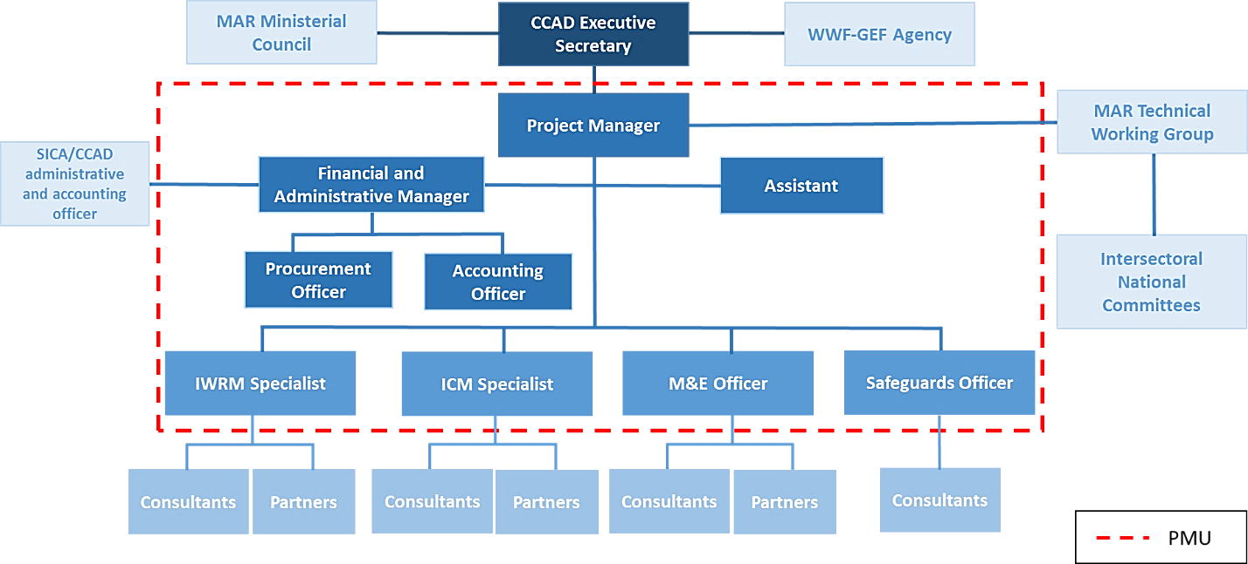
Figure 2. Organizational Chart

3.1.8 Analysis of M&E Design (*)
- The analysis of the M&E Design is treated together with the effectiveness ranking of the M&E System in the next section of the document.

3.2 Project Implementation & Execution

3.2.1 Assessment of Project Outcomes, effectiveness, and potential for impact
- This section presents the progress of the project towards expected results using the “traffic light” ranking. At TE, there is generally “Green” ranking for completion of targets per the indicators presented in the Results Framework. A “Red” ranking indicates failure to reach the targets. At TE, a “yellow” ranking indicates that the outcome was partially achieved above the 70% threshold and contributes to the attainment of the project objective. The End-of-Project ranking is placed side-by-side with the MTR ratings to enable a comparison of progress in a relatively short period of time. At MTR, a “Yellow” ranking indicated that the target was “in progress with a likelihood of completion by EOP.” Evaluators analyzed the performance of the Project’s implementation from inception in November 2018 to June 2023. The following results show the indicator’s targets achieved up to the MTR (December 2021) and the achievements by the TE (June 2023).
- Start to MTR: after 36 months implementation, the project achieved 56% of the expected results.
- From MTR to End of Project: The project achieved the remaining 41% of its targets during the 29 months after the MTR.
- At TE, the project achieved 97% of the expected results.
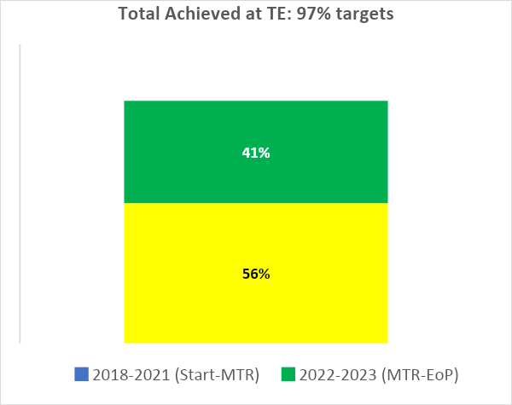
Figure 3. Progress towards Results

- Only one output within one Outcome was not fully realized for factors beyond the reach of the project. In fact, 98% of intended Outputs were realized, contributing to 97% of targets realized as measured by the established indicators in the Results Framework. For that reason, Evaluators rank the project as “Highly Satisfactory.”

Project Execution by Component | TE | MTR
Component 1: | 100% | 60%
Component 2: | 100% | 70%
Component 3: | 94% | 33%
Component 4: | 90% | 63%
Table No. 8: Overall Rating of Effectiveness in Delivery by Component

- The following provides a Component-by-Component analysis of Progress towards results:
Component 1: Strengthen resource governance and regional collaboration for integrated ridge to reef management in the MAR.
- The effectiveness rating for this component is “Highly Satisfactory” (HS).
- Outcome 1 provides the basis for the IW methodology and the enabling environment sought by the project. As Table 8 illustrates, the results of this outcome were impressive and demonstrate the importance of the CCAD structure and involvement of national, state and local governments in delivering policy outcomes. The project overdelivered the number of policies, regulations, and guidelines sought. The centerpiece of the project is Outcome 1.3, which delivers both the TDA and SAP. As mentioned in the Project Description section, generally whole projects are dedicated to each of those documents, which are indeed projects in themselves. Here, they are rolled into a single outcome. The SAP is the mutually endorsed policy guidance for the mid-term development of the ridge-to-reef in the MAR. The outcome is complemented by further “enabling policy instruments at the regional level and at the national level aimed at both Integrated Water Resource Management (IWRM) and Integrated Coastal and Marine Management.

Component 1
Outcomes | Indicators |  | Metrics | EoP Target |  | Baseline | Achieved at MTR | Achieved at TE | TE Rating
Outcome 1.1. The countries have the enabling conditions for MAR R2R management | Number of regional policy instruments developed |  | # regional policy instruments | 2 |  | 0 | 3 | 7 | 100%  HS
Outcome 1.2. MAR national R2R policy (IWRM and ICMM) frameworks are strengthened [linking Components 2 and 3]. | Number of national policy instruments developed |  | # nat. policy instruments | 2 |  | 0 | 1 | 4 | 100%  HS
Outcome 1.3. The MAR has a Transboundary Diagnostic Analysis (TDA) and a Strategic Action Plan (SAP) that will guide the ecoregional ridge to reef management. | Number of countries in the MAR endorsing TDA and SAP |  | # countries | 4 |  | 0 | 0 | 4 | 100%  HS
Outcome 1.4. MAR strategic planning, policy making, management and monitoring supported with updated reliable information accessed via REO | Number of unique visitors consulting REO (Regional Environmental Observatory) in one full year |  | # visitors | 100 |  | 0 | 3,465 | 3,897 | 100%  HS
Component Rating: Highly Satisfactory (100%)
Achieved |  | Partially Achieved |  |  | Not Achieved
Table 9: Component 1 Progress Towards Results
- To understand these, Table 6 indicates the types of Instruments sought. Like at the outcome level, all the outputs sought were achieved with the project producing much more than the intended targets.
OUTPUTS | EoP Target | Achieved at TE
1.1.1. A least two regional protocols, standards and other instruments for ridge to reef (R2R) approach developed in the MAR (IWRM and ICMM) (BZ GT HN MX). | 2 | 7 | 100%
1.1.2. At least one regional demonstration project for regional collaboration is implemented in the MAR (BZ GT HN MX). | 1 | 1 | 100%
1.2.1. At least two national policy instruments that support ridge to reef approach in the MAR developed (BZ GT HN MX). | 2 | 7 | 100%
1.3.1. One Transboundary Diagnostic Analysis (TDA) developed for the MAR and approved by Ministers of Environment (BZ GT HN MX). | 1 | 1 | 100%
1.3.2. One Strategic Action Plan (SAP) for the MAR developed based on TDA and submitted for approval by Ministers of Environment (BZ GT HN MX). | 1 | 1 | 100%
1.4.1. Four national processes for the collection, systematization, analysis and sharing of MAR information harmonized and improved (BZ GT HN MX). | 4 | 5 | 100%
1.4.2. CCAD's REO is acting as the information hub with increased updated, accessible and user-friendly MAR data (BZ GT HN MX). | 1 | 1 | 100%
Table 10: Component 1: Products Attained
- The key policies produced by the Project are summarized as follows:
- Regional Policies:
- Regional Protocol for Blue Economy with a Ridge-to-Reef Approach
- Guidelines for the Regional Protocol for Blue Economy with a Ridge-to-Reef Approach
- Social and Sustainable Tourism Vision MAR
- Regional Protocol for Harmonization of Wastewater Discharge Standards with a Ridge-to-Reef Approach
- CCAD Restoration Policy Brief with a Ridge-to-Reef Approach
- Memorandum of Understanding SEMARNAT-CCAD
- Mangrove Restoration Manual
- Regional Strategy for the Management, Conservation, Restoration, and Monitoring of Mangroves in the Mesoamerican Reef 2020-2025
- CCAD Restoration and Ridge-to-Reef Approach Declaration
- General Agreement CCAD-SITCA-SUSTENTUR
- Strategic Action Plan for the Integrated Management of the Ridge-to-Reef Ecoregion of the Mesoamerican Reef

- National Policies:
- Comprehensive Water Resources Management Policy of Honduras
- National Policy for Comprehensive Water Resources Management, Strategy, and Action Plan (Belize)
- Special Regulation for Water Recharge Reserve Zones (Honduras)
- NOM-001-SEMARNAT-2021, which establishes permissible limits of contaminants in wastewater discharges into nationally owned receiving bodies (Mexico)
- Wetlands Policy
- National Biodiversity Policy
- Quintana Roo Coastal Policies
- As discussed, the list of policies and instruments achieved is relevant to the priorities and commitments of the four countries within the MAR. All government sources interviewed indicated that the policies filled important gaps in their normative and regulatory frameworks and are therefore helping to create a more coherent policy environment. In addition, many of the policies and tools created are catalytic. For example, evaluators verified that guidance for the management of Coral Reef ecosystems within Quintana Roo’s Coastal Policies is informing decision-making in Pacific states. Another example is the role of the Guidelines for the Regional Protocol for Blue Economy with a Ridge-to-Reef in informing Belize’s new ministerial administration for a Blue Economy. These examples provided additional benefits that resulted from a multi-stakeholder approach. In the previous example, Belize’s Department of Environment developed an active working relationship with the Marine and Coastal Zone authorities, critical to the ridge-to-reef concept. The close cooperation between governments, NGOs and businesses was the product of the strong relationships and close contact between the PMU and the national governments and local counterparts and the ability of the CCAD to convene dialogue. Of critical importance to the sustainability of the MAR SAP is the inclusion of the Mexico into the process. The relationship between CCAD, the Mexican federal and state authorities is a significant step.
- Finally, the existing Regional Environmental Observatory was equipped to manage information as a hub for distribution of information in support of the MAR development process. The next logical step will be to support the evolution of the REO into a decision-making support system.
- With the inter-ministerial declaration supporting the expansion of the MAR2R concept across all CCAD nations, evaluators concluded that the project was successful in inculcating MAR2R into an enabling policy environment, in filling key policy gaps, and providing catalytic tools and policy definitions that will enable SAP implementation in both regional and national levels.
- One notable weakness in the SAP process is the absence of an agreed Central American Water Commission or Authority. Within the SAP, water issues and conflicts are simply relegated to CCAD without establishing the principles or rules for dialogue on transboundary water issues. Many of the elements of principles, e.g. right to timely consultation, free and full informed consent, etc. are present in the baseline transboundary projects. These can be incorporated into a common structure for the monitoring and dialogue on transboundary watercourses. An example can be taken from the operational nature of UNECE to the European Community. Regardless, the role of CCAD in reaching this point and negotiating TDA and SAP approval is well established.

Component 2: Integrated ridge to reef management of watersheds and freshwater resources
- The effectiveness rating for this component is “Highly Satisfactory.”
- Component 2 provides the IW process with two important aspects. First, it provides for demonstration experiences that produced important information and lessons for several commodity and commercial sectors that have been identified as enablers of important problems contributing to the environmental risks in the MAR. Second, given that the global levels of investment from grants are chronically low in producing global environmental benefits, creating opportunities for private sector engagement is strategically important for the GEF agenda into the future. Component 2 responds to the IWRM perspective. Component 3 responds to the ICMM aspects. Both components are successful in both areas. The following presentation periodically addresses the results for Component 3, which has similar outputs but oriented to the marine and coastal environment. Findings unique to component 3 are discussed in that section. Table 11 presents the Outcome-by-Outcome results of Component 2.
- Table 8 demonstrates the production of outputs, all leading to the success of the component.

Outcomes | Indicators |  | Metrics | EoP Target |  | Baseline | Achieved at MTR | Achieved at TE | TE Rating
Outcome 2.1 Integrated watershed management in priority watersheds increased | Number of stakeholders trained in IWRM through project activities |  | # men | 350 |  | 0 | 473 | 2,424 | 100%
 |  |  | # women | 350 |  | 0 | 230 | 1,271 | 100%
Outcome 2.2. Public-private mechanisms for integrated watershed management are strengthened and supported by stakeholders. | Increase (USD) in funding available for public private mechanisms in BZ, GT and HN |  | USD increased | 175,000 |  | 50,000 | 161,825 | 579,479 | 100%
Outcome 2.3. Stakeholders engaged in IWRM in priority watersheds | Percentage of sugar and oil palm producers in project area on track to reach or maintain Voluntary Standards, per their own management/action plans |  | Percentage of sugar mills that are on the route to achieve Bonsucro certification | 100% |  | 2 | 0 | 2 | 100%
 |  |  | Percentage of sugar mills that maintain Bonsucro certification** | 100% |  | 2 | 0% | 2 | 100%
 |  |  | Percentage of producers who are on the route to achieve RSPO certification. | 100% |  | 4 | 4 | 4 | 100%
 |  |  | Percentage of producers maintaining RSPO certification* | 100% |  | 8 | 8 | 8 | 100%
 |  |  | Percentage of producers with action plans *** | 100% |  | 12 | 12 | 12 | 100%
 | Number of tourism and tourism development sector actors adopting better management practices (BMP) to protect aquifers and freshwater critical habitats under project activities |  | # Stakeholders | 32 |  | 0 | 32 | 36 | 100%
 |  |  | (Tourism sector)
Component Rating: Highly Satisfactory (100%)
Achieved |  | Partially Achieved |  |  | Not Achieved
Table 11: Component 2 Progress Towards Results

OUTPUTS | EoP Target | Achieved at TE
2.1.1. At least five demonstration projects implemented to increase area of priority MAR watersheds under IWRM (BZ GT HN MX). | 5 | 5 | 100%
2.1.2. At least two water reserves established within MAR watersheds offer regional experience in the use of this instrument for water conservation (GT HN) [Linked to Outputs 1.2.1 and 2.1.1] | 2 | 2 | 100%
2.1.3. At least 350 stakeholders with increased capacities to implement IWRM management plans (BZ GT HN MEX) | 350 | 3695 | 100%
2.2.1. One public-private mechanism (Water Fund) for integrated watershed management is strengthened (GT). | 1 | 1 | 100%
2.2.2. Two new public-private mechanisms for integrated watershed management are designed and created (BZ HN). | 2 | 2 | 100%
2.3.1. At least 14 cases of voluntary standards in commodity agriculture implemented as demonstration projects of private sector engagement on watershed management (BONSUCRO and RSPO) (GT HN). | 14 | 14 | 100%
2.3.2. At least 32 tourism and tourism development sector actors adopting better management practices to protect aquifers and freshwater critical habitats (BZ GT HN MX). | 32 | 32 | 100%
2.3.3. At least 20 local communities implementing IWRM activities (linked to Output 2.1.1) (BZ GT HN MX). | 24 | 24 | 100%
2.3.4. At least 350 local stakeholders with increased capacities to implement BMPs and IWRM activities (BZ GT HN MX) | 350 | 350 | 100%
Table 12: Component 2: Products
- Component 2 was extremely productive, as illustrated by the following:

- Over 2.5 million hectares have been integrated into integrated watershed management plans.
- Five demonstrative projects implemented across five watersheds, showcasing the importance of community participation in integrated water resource management.
- Creation and strengthening of three public-private mechanisms, driving investments towards improved water governance and management.
- 400 individuals trained from the public and private sectors in the MAR. This training empowers them to design, implement, and monitor actions related to Integrated Water Resource Management (IWRM).
- Through partnership with SUSTENTUR, the project crafted the "Guidelines for Sustainable and Social Tourism for the Mesoamerican Reef Eco-Region." This document serves as a blueprint for responsible tourism practices.
- The training program, "Integrated Management of Cenotes, Caves, and Springs," addresses critical areas within the tourism sector, including nature-based tourism, integrated management systems, aquifer preservation, and COVID-19 health protocols. This initiative is based on the best practices outlined in various manuals and protocols, ensuring that tourism activities align with sustainability goals.
- Significant steps were taken to professionalize wastewater treatment plant operators and decision-makers involved in water management in the Riviera Maya.
- Training sessions have systematically reached thousands of participants, with a total of 3,695 individuals benefiting from the knowledge and tools provided.
- The demonstration areas in both Components 2 and 3 targeted the private sector. Key to the success of these was the selection of participants. Evaluators were able to visit the sites of eco-tourism, chocolate processing, and coffee management and processing sites that benefitted from training, technical assistance, and improved equipment and interact with the beneficiaries.
- Several of the demonstrations tested pre-processing and conversion, such as coffee processing and toasting, chocolate confection, or hospitality businesses. These types of businesses profited greatly from experiential training, e.g., trips to visit similar entrepreneurs, in-site technical assistance by NGO facilitators, and basic processing equipment, quality control, and sanitation of waste and byproducts. In all cases, beneficiaries reported increases in real income, increased benefits extended to families in the form of more resilient income and reported new opportunities or additional derivative products created in their businesses because of the training and technical assistance. All beneficiaries selected had experience in their businesses and had the dream of making them grow. They all demonstrated entrepreneurial abilities, keen focus on their financials, and all were experimenting to increase efficiency or add value through derivative products or new markets. Most of those are family businesses with several generations of family members participating and benefiting. The NGOs selected as facilitators were also well qualified and experienced with strong social outreach facilities and a deep understanding of their clients. Although limited in number, the PMU also established strong relationships with the beneficiaries through frequent oversight visits and in face-to-face encounters. This leads to the conclusion that two important functions of demonstration projects: trust building and accompaniment were effective.
- The process of working through qualified NGOs proved to be effective, despite different skill and capacity levels among the NGOs in administrative and financial management, on one hand, and technical skills, on the other. Bureaucracy on the part of SICA & CCAD was cited as a point of consternation but did not constrict the demonstration projects. A different type of relationship took place in Belize, where the Department of Environment works in tandem with a quasi-governmental agency, PACT. PACT proved efficient in purchasing but was hindered by a slow approval process within the Department of Environment whose CEO is the only signatory, leading to delays. On the operational side, once approved, resources flowed, and objectives were completed. The project worked with local actors to provide basic training in reforestation science and rehabilitation of degraded areas. The hands-on demonstration gave community stakeholders the opportunity to support the problems in their section of the watershed. The project has a strong youth focus and integrated schools in this endeavor.
- An important contribution of the project are the lessons learned from engaging the private sector in conservation efforts in line with the productive reality of the local stakeholders. The project has produced synthesis documents that describes the actions and lessons learned . These are informative but fall short on defining next steps. As demonstrations, each should be analyzed for the potential to scale-out the practices, scale deep the training and education, or scale-up the policy or regulatory environment. In the case of negative experiences recommendations for redesign or rejection of the practices should be documented.
- The selection of the demonstration projects was carried out adequately, with an effective identification of all participating individuals and institutions involved. Furthermore, abundant entrepreneurial skills are observed among the participants. The strategic focus on the private sector has proven effective in addressing drivers and encouraging watershed management acceptance. An outstanding achievement is that all demonstrations have generated income for the parties’ and families involved. Active efforts have been made to strengthen the necessary capacities for achieving significant impact, such as wastewater treatment training for operators. Evaluators identified gaps in the process, which are discussed together with the private sector issues below in component 3.
- The project invested in sustainable financing, such as the water fund, the importance of this initiative is recognized. While water funds are considered a good idea based on previous experiences, and the institution involved, Fundacion Defesores de la Naturaleza has long-term experience, significant additional support is required to grow these funds to levels able to scale conservation and restoration actions. However, in all jurisdictions visited, water services are either free or garner very low prices. These funds will not be sustainable until the value of water is internalized by diverse user’s groups. Investments in local producers have equally positive results as described, which is a good step towards realizing the value of water. However, significant levels of credit will be necessary to expand results and hence scale global environmental benefits Additionally, visits and business-to-business (B2B) exchanges have yielded positive results. In summary, appropriate choices have been made in the selection of demonstrations, and all parties involved were correctly identified and selected demonstrating supporting by entrepreneurial skills. The orientation towards the private sector has contributed to the success of watershed management, generating income for families. Capacity strengthening has been prioritized, and the importance of supporting sustainable financing, such as the water fund, for future developments is emphasized.
- The following figure illustrates the diversity of stakeholders participating in the activities:

MÉXICO | BELICE | GUATEMALA | HONDURAS | REGIONAL
Red de Turismo Comunitario de Quintana Roo | Sarteneja Alliance for Conservation and Development (SACD) | Asociación de Exportadores de Guatemala (AGEXPORT) | Asociación Pro Comunidades Turísticas de Honduras LARECOTURH | Secretaría de Integración Turística Centroamericana (SITCA)
Secretaría de Turismo de Quintana Roo | Asociación de la Industria de Turismo de Belice (BTIA) | Ministerio de Ambiente y Recursos Naturales | Instituto Hondureño de Turismo (IHT) | Ministerio del Ambiente y los Recursos Naturales (MARENA)
Asociación de Hoteles de la Riviera Maya | Caye Caulker Belize Tourism Industry Association (CCBTIA) | Fundación para el Ecodesarrollo y la Conservación (FUNDAECO) | Cámara de Turismo de la Ceiba | Ministerio de Turismo de la República Dominicana
Asociación de Hoteles de Holbox | Department of the Enviroment | Instituto Guatemalteco de Turismo | Choose Honduras | Camara Nacional de Ecoturismo (CANAECO)
CONANP | Orange Walk Counsil | Mundo Maya | Zolitur | Ministerio de Turismo del Salvador
Amigos de Sian Ka'an |  | WWF Guatemala / Mesoamerica | Telamar Resort | Autoridad de Turismo de Panamá
Hotel Iberostar |  | Asociación Ak Tenamit | Fundación Merendon | Instituto Costarricense de Turismo
Siijil Noh Ha |  | K'uk Tours | Roatán Marine Park | Instituto Nicaragüense de Turismo
DMO Cozumel |  | Central de Reservas Caribe Maya |  | Instituto Nicaragüense de Turismo
 |  |  |  | Caribe Circular/GIZ
 |  |  |  | Marfund/Fondo SAM
 |  |  |  | Healthy Reefs For Healthy People
 |  |  |  | Coral Reef Alliance
 |  |  |  | Sureste Sostenible/ Liderazgo Sam
Figure 4: Stakeholder Involvement by country

- Of the Public Private Mechanisms, San Pedro Sula Alliance for Water Security (public-private dialogue platform in the Chamelecón river basin) is perhaps the gold standard for stakeholder participation and involvement. The Alliance, which is still in its formal incorporation process integrates private sector, NGOs, and academia with the municipal government and representatives from central government agencies with leadership from the private sector. The Ridge-to-Reef actions are articulated in a watershed action plan which has been made operational through the Municipalities planning and budget process that places watershed development into the municipal planning process. In addition, the NGO support adds to the initiative. All interested parties are therefore moving in the same general direction. Although it is a relatively new process but consolidated from grassroots efforts by partners such as the Fundacion Meredon and many others with over 30 years of development experience in the zone. CCAD should monitor the development and progress of this group to determine the performance of their nascent fund and collaborative management experience.
Component 3: Integrated ridge to reef management of coastal and marine resources
- Component 3 is ranked “Highly Satisfactory.”
- Within Component 3, Outcome 3.2 missed the mark on certifications within the shrimp industry for circumstances related to COVID-19 and difficulties in international commerce and value chain issues, beyond the control of all parties. Regardless, the results obtained provided the data, observations and lessons expected from the certification process and will greatly support future actions, which are discussed below. In effect, the Project reduced the targets midstream. However, the value of the demonstration are the lessons derived from the producers that withdrew from the certification process. For that reason, the outcome indicators do not tell the whole story.
- This component, like component 2, produced policy outcomes, capacities, and private sector engagement in the ICMM space. This component also supported a multi-stakeholder dialogue and strengthens CCADs position to support the ICMM aspects of the MAR2R concept. Among the milestones achieved are:
- Support for Marine Spatial Planning
- Promoting Sustainable Tourism
- Strengthening Mangrove and Coral Management
- Engaging Indigenous Communities
- Supporting Best Practices and Certifications
- Tables 13 and 14 present the progress towards results and the achievement of outputs respectively.

Outcomes | Indicators |  | Metrics | EoP Target |  | Baseline | Achieved at MTR | Achieved at TE | TE Rating
Outcome 3.1. ICMM strengthened through capacity building and strategic planning | Number of stakeholders trained in ICMM through project activities |  | # men | 350 |  | 0 | 75 | 587 | 100%
 |  |  | # women | 350 |  | 0 | 113 | 599 | 100%
Outcome 3.2. Stakeholders engaged in ICMM in coastal marine prioritized areas | Percentage of farms and fisheries in project area on track to reach Voluntary Standards, per their own management/action plans.  (Marine Stewardship Council –MSC- and Aquaculture Stewardship Council -ASC) |  | Shrimp farms in ASC auditing process | 100% |  | 8 | 0 | 100% | 100%
 |  |  | Fisheries MSC FIPs under implementation (with Action Plan evaluation and follow up) | 50% |  | 2 | 0 | 50% | 100%
 | Number of tourism and tourism development sector actors, and communities implementing better management practices (BMP) to protect coastal and marine habitats under project activities. |  | Number of tourism sector actors | 32 |  | 0 | 24 | 32 | 100%
 |  |  | Number of communities | 24 |  | 8 | 16 | 24 | 100%
Component 3 Rating: Satisfactory (94%)
Achieved |  | Partially Achieved |  |  | Not Achieved
Table 13: Component 3 Progress Towards Impact
- The project integrated Mexico into a productive role in transboundary coordination of the Meso-American Reef and facilitated a productive regional dialogue among participating countries. This created an important platform for SICA and CCAD enabling access to Mexico’s experience, science and technology, especially in coral reef establishment. This dialogue helped identify regional needs and opportunities for integrated ridge-to-reef TDA and SAP. Notably, the project played a crucial role in initiating a regional dialogue on the blue economy, ultimately leading to the creation of the SICA Regional Blue Growth Strategy under the leadership of OSPESCA and with similar benefits to each participating nation. Among the benefits, the following are highlighted:
- In Mexico, a coastal management policy for the State of Quintana Roo, extremely important for the MAR was developed and adopted, promoting environmentally balanced social and economic development with an integrated coastal zone management approach.
- In Guatemala, the project supported the development of an integrated planning exercise for the Caribbean coast by linking the Integrated Management Plan for the Caribbean Coastal Roundtable and the National Action Plan to reduce climate vulnerability, resulting in a strategic instrument (PGIMC-Caribe) for coastal-marine issues and sustainable development strategies, embedded within an exercise of marine spatial planning and to address the effects of climate change, a Climate Vulnerability Action Plan was developed for the Guatemalan Caribbean.
- In Belize, a participatory process updated the Belize Integrated Coastal Zone Management Plan, serving as a cutting-edge marine spatial planning tool in the region to preserve marine biodiversity while enabling sustainable economic use and informed their plans to develop a blue economy structure.
- In Honduras, two policies were developed at the national level - the National Biodiversity Policy and the Wetlands and Coastal-Marine Space Policy - to contribute to the conservation and sustainable use of shared freshwater, coastal, and marine resources, aligning with the integrated ridge-to-reef approach.
OUTPUTS | EoP Target | Achieved at TE
3.1.1. At least one policy instrument prepared to strengthen ICMM planning (HN MX). | 1 | 3 | 100%
3.1.2. The Coastal Zoning and Management Authority and Institute (CZMAI) in Belize is supported with capacity building and streamlined frameworks to implement the Belize Integrated Coastal Zone Management Plan (BZ). | 1 | 1 | 100%
3.1.3. Implementation of the Caribbean Coastal Marine Strategy in Guatemala supported (GT). | 1 | 1 | 100%
3.1.4. At least 350 stakeholders with increased capacities representing national and local government agencies, municipalities and other stakeholders on ICMM (BZ GT HN MX). | 350 | 1186 | 100%
3.2.1. At least 13 cases of voluntary standards in fisheries and aquaculture implemented as demonstration projects of private sector engagement on coastal and marine management (MSC and ASC) (BZ GT HN MX). | 8 | 8 | 100%
3.2.2. At least 32 tourism sector stakeholders implement BMPs related to coastal and marine habitats. (BZ GT HN MX) [linked to activities of Outcome 2.3.2]. | 32 | 32 | 100%
3.2.3. At least 24 local communities and stakeholders participating in the implementation of mangrove and coral restoration activities (BZ GT HN MX). | 24 | 28 | 100%
3.2.4. At least 350 stakeholders with increased capacities on FIPs, ASC, coastal and marine habitat BMPs, and mangrove and coral restoration (BZ GT HN MX). | 350 | 350 | 100%
Table 14: Component 3 Products
- The project successfully engaged a full range of stakeholders in ICMM through specific cases, including aquaculture and fisheries, coastal zone tourism, and indigenous communities linked to mangrove and coral management, such as the following:
- In aquaculture and fisheries, the project focused on promoting best practices through voluntary standards. As a result, all 8 audited shrimp farms developed plans to advance in the voluntary certification process. The project worked with the Belize Shrimp Growers Association to build capacity and generate the data needed for MSC and ASC certifications. Two farms achieved certification, and others have action plans or internal monitoring plans in place. Of the two, one will no longer remain certified due to the high transfer costs. The other 8 who did not achieve certification underscore the tight margins and the vulnerability of the shrimp farms to value chain issues and world prices. During and following COVID, inflationary pressures drove many to close. The willingness of the producers to reduce their risks through improved practices, such as complete water recycling, enables growers to avoid sea-borne diseases, not release germplasm from farms into the ocean, and most importantly, produce larger amounts of shrimp in smaller areas (see par. 128). The technology and sanitary practices are expensive and Belize does not have an industrial bank to catalyze the transition. Therefore, only the largest producer was able to maintain the certification process. This underscores the need for synchronized innovation, market, and credit. Future initiatives could work with producers, such as Royal Mayan to match with environmental capital accelerators to scale the demonstrated technologies. The individual management plans produced by the project are a good initial step and could benefit the producers that are left in business. The solution, however, may not necessarily be individual. A collective solution could be studied that would sufficiently de-risk to enable access to larger amounts of capital needed to fund the levels of technology warranted for local environmental conditions and to capture economies in production.
- The project also supported the Honduran lobster Fisheries Improvement Project (FIP) Honduras through the development of a participatory action plan involving state institutions and local partners. Regarding the spiny lobster in Honduras, the project assessed the progress in the Fisheries Improvement Project (FIP) and updated the FIP work plan. Sectorial meetings were held to complement the revised information and support responsible fishing, including ethical codes and action plans for spiny lobster certification. Although less technified, the Lobster industry requires champions to match research, development, credit, and understand the market conditions for the fishermen and conditions under which they can sustainably finance their endeavors and their own wellbeing.
- In the tourism sector, 56 sector actors and communities, including 32 private sector companies and 24 community-based enterprises, implemented better management practices to protect coastal and marine habitats under project activities.
- Regarding spiny lobster in Honduras, the project conducted a review to assess progress in the Fishery Improvement Project (FIP) and updated the FIP work plan. Sectoral meetings were held to complement the information reviewed, and support was provided for responsible fisheries, including codes of ethics and action plans for spiny lobster certification.
- Related to Component 2, a multi-step process was undertaken to involve the tourism sector in implementing best practices. First, a Vision for Sustainable and Social Tourism was developed and endorsed by stakeholders from the tourism and environmental sectors in the region. An agreement signed by SUSTENTUR, CCAD, and SITCA in 2021 further supported the promotion of sustainable tourism in the area. Second, a Diploma course for training professionals in sustainable and social tourism was created and conducted in two iterations. These courses, led by SUSTENTUR and coordinated by ISTO, provided multidisciplinary training to position sustainable and social tourism in the region. Simultaneously, guidelines for best practices in environmental management within the tourism sector were designed. These guidelines led to capacity assessments in 56 companies, facilitating the implementation of best practices. These improvements were carried out in both private and community-based companies.
- Additionally, the Alliance for Sustainable and Social Tourism in the MAR (SST-MAR Alliance) was established in alignment with the 2030 Vision for tourism in the region. This alliance fosters collaboration and innovation in sustainable and social tourism, facilitating the exchange of knowledge, experiences, and policies to support responsible tourism and contribute to the conservation of the Mesoamerican Reef Ecoregion.
- To engage local communities in Integrated Coastal and Marine Management (ICMM), several important and catalytic activities related to mangrove and coral restoration were conducted:
- Regional Strategy for mangrove conservation and restoration: A regional strategy for the conservation and restoration of mangroves in the Mesoamerican Reef (MAR) was developed through coordination among various regional actors. This strategy was shared with all countries in the region and involved participants from the Mesoamerican Mangrove and Seagrass Network, which comprises over 40 institutions and 75 individuals.
- Exchange of experiences for mangrove restoration: To support the regional mangrove strategy, the MAR2R Project, UNEP-Cartagena Convention, and MAR Fund collaborated to create the "Manual for the Ecological Restoration of Mangroves in the MAR and the Wider Caribbean." The manual served as the foundation for implementing the regional strategy and was launched in December 2021. It facilitated knowledge sharing, including participation in the Regional Mangrove Congress in Mexico in 2022. Additionally, a high-resolution map of the mangrove ecosystems in the Mesoamerican Reef Ecoregion was created.
- Field actions: The project conducted on-ground activities with communities to promote mangrove and coral reef restoration. In Guatemala, support was provided for the management plan of the Barra Sarstún community's tropical floodable forest, and entry into the PROBOSQUE incentive program was approved. Restoration efforts in San Juan community involved planting 6,000 red mangrove propagules. In Belize, activities included identifying deforested riparian zones, stakeholder engagement, seed collection, and nursery planting. Two hectares in the Orange Walk Town area were replanted for restoration, and a nursery was established and maintained in Chunox Village to provide seedlings for riparian forest restoration.
- For coral reef restoration:
- In Cozumel, Mexico, under the guidance of the Cozumel Community Foundation (FCC), a training program was conducted, involving at least twenty-four individuals who were taught reef restoration techniques and monitoring practices in Puerto Morelos, Quintana Roo. Additionally, coral fragments were gathered for repopulation, and a coral nursery was established.
- Akumal, Mexico, saw the evaluation and mapping of donor reefs and restoration nurseries. Ten campaigns were executed to maintain these nurseries, and support was extended for the establishment of seven additional nurseries.
- In Roatan, Honduras, several capacity-building initiatives took place, focusing on coral reef management and restoration, aimed at enhancing expertise and skills in this field.
- The promotion of voluntary standards in Shrimp (component 3), sugar cane and palm oil (component 2) by the project provides a window to understanding the nature of working with the private sector for SAP implementation and provides an understanding of opportunities for development in the future. The Project revealed 3 important lessons:
- All the business owners interviewed welcomed the opportunity to be associated with CCAD and WWF. There was a value in environmentally sound business development. All business owners indicated this was to improve their brand and to reduce risks. This indicates that there is an openness that can contribute to productive partnerships for SAP implementation. Likewise, government regulators interviewed placed high value on their experience with the private sector. Some indicated that they were motivated by the innovations in the business sector and provided new and empathic perspectives in their work as regulators.
- Working with the producers’ associations as an entry point rather than individual businesses created trust and enabled a better understanding of the sector and its possibilities and facilitates dissemination of information and options for working with small producers.
- WWF has a long-term relationship with the selected sectors and has built relationships with them since 2004. Additional findings are:
- All the sectors mentioned have a dichotomy between large and small producers. It is easier to promote certification with the large producers who tend to be more resilient. The small producers are not generally unified, have very slim margins and are difficult to finance. Financing this mixed group to adopt improved wastewater and clean technologies and practices will require de-risking.
- Credit is a limiting factor to scaling improved technologies.
- The transfer costs of certification are a deal-breaker for small and mid-size producers. All large-scale processors interviewed felt the costs could be offset by sales. Small and mid-sized shrimp producers were not able to absorb the costs of certification following the removal of the COVID lockdown. They are however following the protocols and hope to re-certify when conditions change.
- Examples of the technological aspects supported by the project were the following:
- Small scale wastewater decanting: In small-scale tourism sites around Mayan water pools, the project financed small scale water treatment facilities. These were accessible with low-scale decanting systems that were working well. These were promoted by the Amigos de Sian Kam as part of the integrated demonstration. Most importantly, the owners of the establishments spoke correctly and well of the systems and the environmental benefits.
- Coffee processing in San Pedro Sula: promoted by the Fundación Meredon, small scale producers installed improved de-pulping machines that enabled them to de-pulp their beans on approximately 80% less water. A water treatment system decants the wastewater and the coffee cherries are decomposed using worm culture. The worm castings are applied to the coffee stands that are visibly in excellent condition in comparison to adjacent stands. The beneficiaries also spoke with dedication about the environmental aspects and financial benefits.
- Shrimp producers in Belize have installed water recirculation pumps to filter and reuse their wastewater and avoid release to the sea. A state-of-the-art recirculation system was installed by the Royal Mayan Shrimp. The recirculation system along with management improvements has allowed Royal Mayan to achieve the same production on 20% of the acreage with no release of water into the ocean. This eliminates the risk of releasing exotic species into the ecosystem and opens the possibility of increasing production without expanding beyond the original footprint of the operation. Unfortunately, following storms, COVID, and volatile prices, mid to small producers cannot secure credit to overhaul their technologies. Belize does not have a development bank which creates the opportunity for green impact investing.
- Training for Wastewater operators: Training was provided to wastewater system operators because they are in the position to make decisions that directly influence the quality of wastewater. Each operator manages thousands of cubic meters daily that affect the environment, local populations, and visiting tourists. The training program is highly regarded by technicians and participants contacted and should be considered for broadscale application.

Component 4: Project monitoring and evaluation, and knowledge sharing
- Like the other systems, component 4 was also considered to be “Highly Satisfactory”. This component provides the project’s monitoring and evaluation system to inform decision-making and the communications, knowledge management and learning of the project.
Component 4
Outcomes | Indicators | Metrics | EoP Target | Baseline | Achieved at MTR | Achieved at TE | TE Rating
Outcome 4.1. The project's monitoring and evaluation system employs participatory methods throughout project lifetime. | Number of MAR2R progress reports completed (including midterm and final evaluations and GEF IW Tracking Tool) | # progress reports | 10 | 0 | 2 | 9 | 90%
 |  | MTR | 1 | 0 | 1 | 1 | 90%
 |  | TE | 1 | 0 | 0 | 1 | 90%
 |  | GEF Tracking tool | 1 | 1 | 1 | 1 | 90%
Outcome 4.2. Advantages of the ridge to reef approach shared with local and international audiences, including the GEF IWLEARN community | Number of communication and knowledge management products disseminated | Webpage | 1 | 0 | 1 | 1 | 100%
 |  | Social media | 2 | 0 | 2 | 2 | 100%
 |  | Publications | 10 | 0 | 6 | 58 | 100%
 |  | Videos/animations | 4 | 0 | 13 | 28 | 100%
 |  | Webinars hosted | 4 | 0 | 16 | 23 | 100%
 |  | Attendance list to workshops | 36 | 0 | 20 | 158 | 100%
 |  | Int’l. workshops | 2 | 0 | 3 | 5 | 100%
Table 15: Component 4: Progress Towards Results

OUTPUT |  | EoP Target |  | Achieved at TE
4.1.1. Project monitoring system provides systematic information on project progress to reach the specified outputs and outcomes |  | 1 |  | 1 | 100%
4.1.2. Midterm and final evaluations developed and shared in a timely manner |  | 2 |  | 2 | 100%
4.1.3. GEF IW Tracking Tool completed reports on project progress. |  | 2 |  | 2 | 100%
4.2.1. At least three project results from demonstration projects and other activities disseminated in neighboring countries for replication and upscaling. |  | 3 |  | 4 | 100%
4.2.2. Participation in at least 36 national workshops and two international conferences, including the International Waters Conference, to share approaches and lessons learned from MAR2R project. |  | 36 |  | 36 | 100%
4.2.3. At least 21 knowledge products (website, social media accounts, publications including IW: LEARN experience notes, videos/animations, etc.) on lessons learned and project best practices developed and disseminated nationally, regionally, and to the international IW community. |  | 21 |  | 21 | 100%
Achieved | Partially Achieved |  | Not Achieved
Table 16: Component 4: Products
The monitoring and evaluation system is evaluated later in this document.

- The monitoring and evaluation (M&E) system demonstrated its effectiveness once institutional changes were implemented. This system was successful in identifying issues and pinpointing underperformance, enabling appropriate corrective measures to be taken. The M&E system is evaluated later in this report.
- The planned knowledge exchanges played a critical role in the project's success; for example, a face-to-face event held in Roatán facilitated valuable connections and was highly regarded among the involved stakeholders. Furthermore, the generated knowledge products were of high quality. However, there is a need to enhance the REO to include the multiple dimensions of the SAP Monitoring and Evaluation Framework (KML) and ensure the linkages and sustainability of the Observatory for ongoing and effective project activity monitoring.

3.2.2 Progress to Impact
- The TE evaluator analyzed the GEF-5 IW tracking tool completed at the end of the project on July 25th, 2023 (Annex 5.9). The project made progress in relation to the project goal to contribute to the conservation and sustainable use of shared freshwater, coastal and marine resources of the transboundary MAR ecoregion by implementing the ridge to reef approach and hence securing sustainable economic benefits and livelihoods for the countries and their communities.

Project Objective | Indicators | Metrics | EoP Target | Baseline | Achieved at MTR | Achieved at TE | TE Rating
Objective:  Support regional collaboration for the integrated ridge to reef management of the transboundary MAR ecoregion by demonstrating its advantages and improving regional, national and local capacities for the integrated management and governance of its freshwater, coastal and marine resources | O.1 Number of regional policy instruments that promote ridge to reef management of the MAR ecoregion approved due to project activities | # policies | 2 | 0 | 3 | 7 | 100%
 | O. 2 Area (ha) of watersheds under IWRM project activities | # ha | 2,651,669 | 0 | 1,336,652 | 3,402,101 | 100%
 | O.3 Area (ha) of coastal and marine ecosystems under ICMM project activities | # ha | 157,800 | 0 | 323,600 | 323,600 | 100%
OBJECTIVE HIGHLY SATISFACTORY ACHIEVED
Table 16 Progress Towards Impact.
- Given that tangible impacts were realized and that other projects are now capitalizing on this effort, the Impacts are considered Highly Satisfactory (HS).
- To ensure that project's results to contribute to the conservation and sustainable use of shared freshwater, coastal and marine resources of the transboundary MAR ecoregion reach the expected global environmental benefits as envisioned by the GEF which may take years to become evident after the project's completion, evaluators used the Review of Outcomes to Impacts (ROtI) method developed by the GEF Evaluation Office to develop an Outcomes-Impacts Theory of Change.
- The Theory of Change (ToC) framework is validated for this project, as stated in Section 3.1 above. It aligns with standardized frameworks for Integrated Water Resources Management (IWRM) projects. However, it must be adjusted to sustainably achieve the desired impacts, which will not be realized with only effective leadership by CCAD. The complete scenario would need to address policy coherence, sustainable financing, and targeted capacities in each of the core technical areas outlined in the SAP and with private sector engagement per the results of the demonstration projects. The TOC was effective for this project and for moving forward towards an SAP. However, it needs to be further revised by CCAD to outline the future of the MAR region to guide SAP implementation and the development of other future initiatives around which all future projects can contribute. That process should incorporate step-changes and a transformational process and scaling out of effects, such as the results from demonstration projects to higher levels, Scaling-up of effects through policies that create incentives or eliminate perverse incentives, and Scaling-deep of changes in attitudes and reversing inappropriate production practices. Evaluators recommend that CCAD consult the GEF-STAP guidance on Transformation, Policy Coherence, and other new resources. That process could involve segmenting Impact Drivers, Intermediate States and Impact-level GEBs as illustrated for example in figure 5. The transformational process for is broadly illustrated graphically in figure 6.
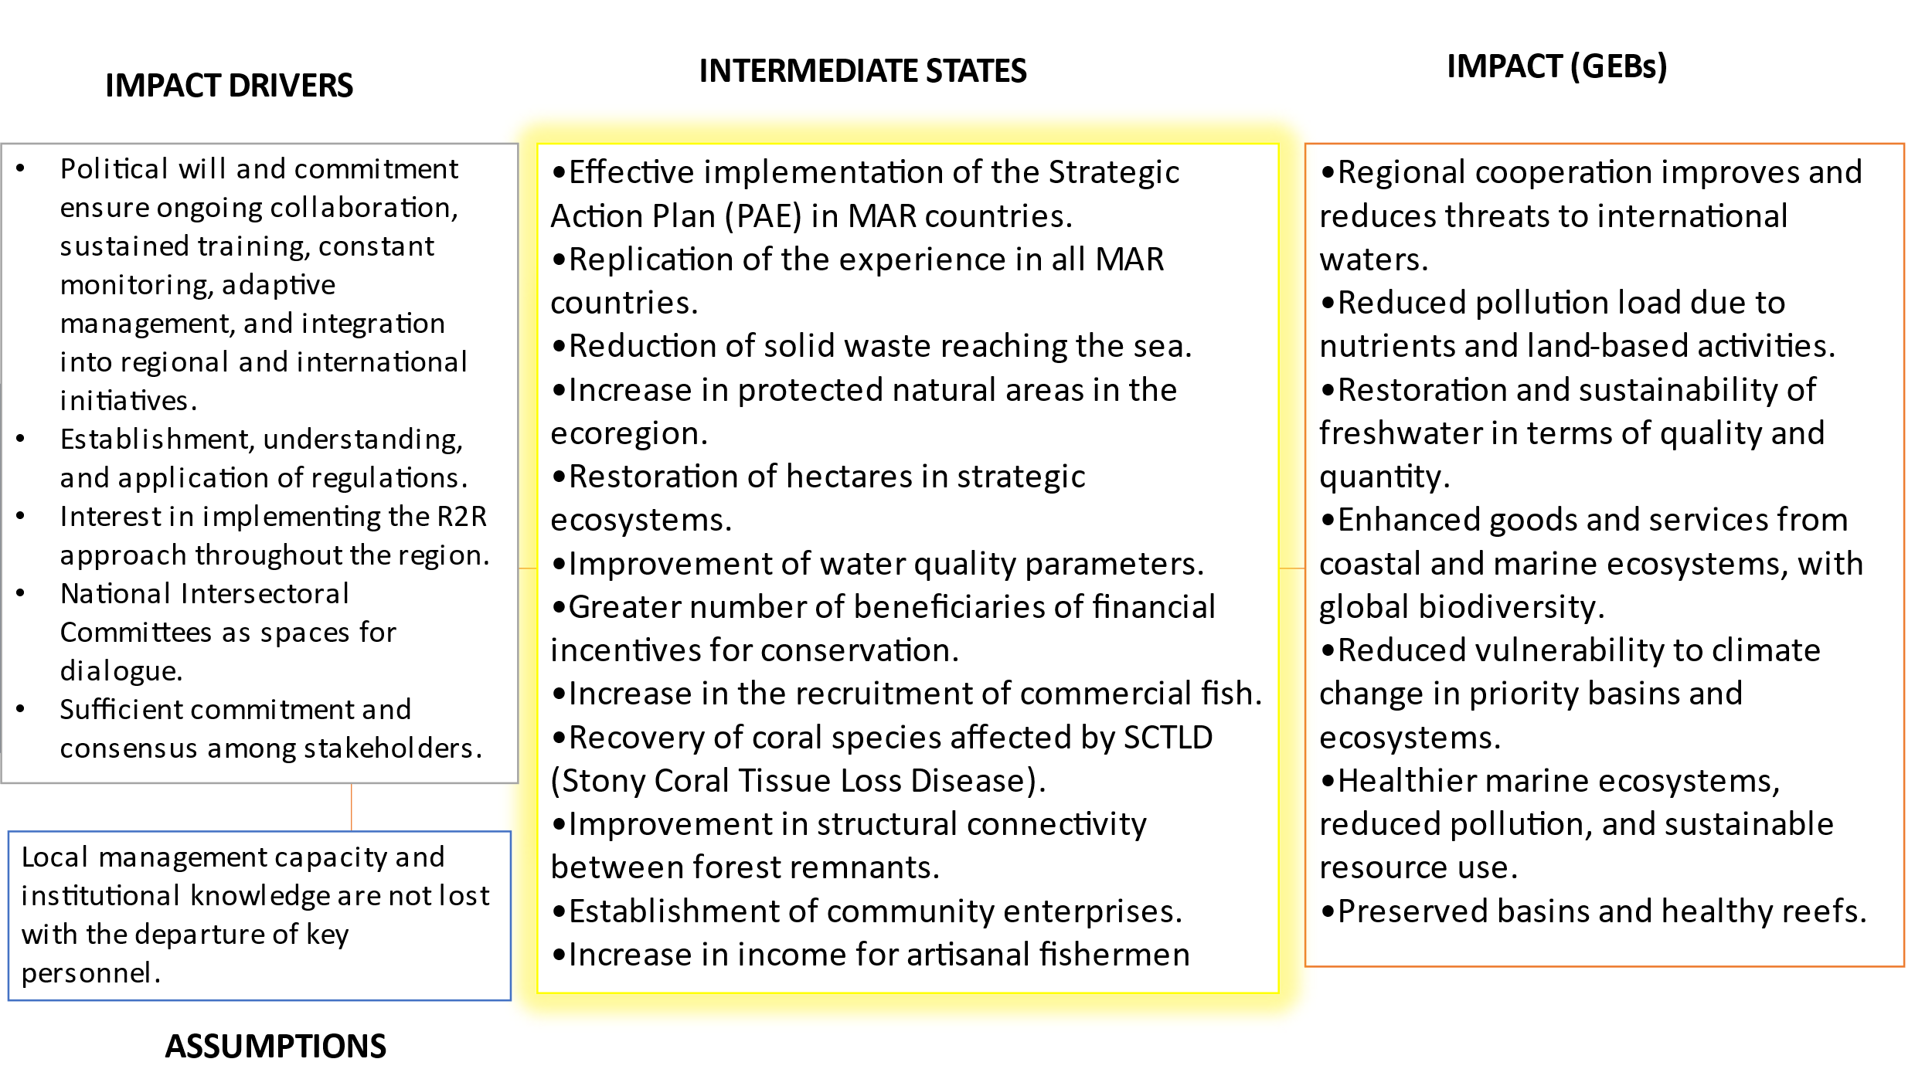
Figure 5: Illustrated relationship between Impact, Intermediate States and GEBs

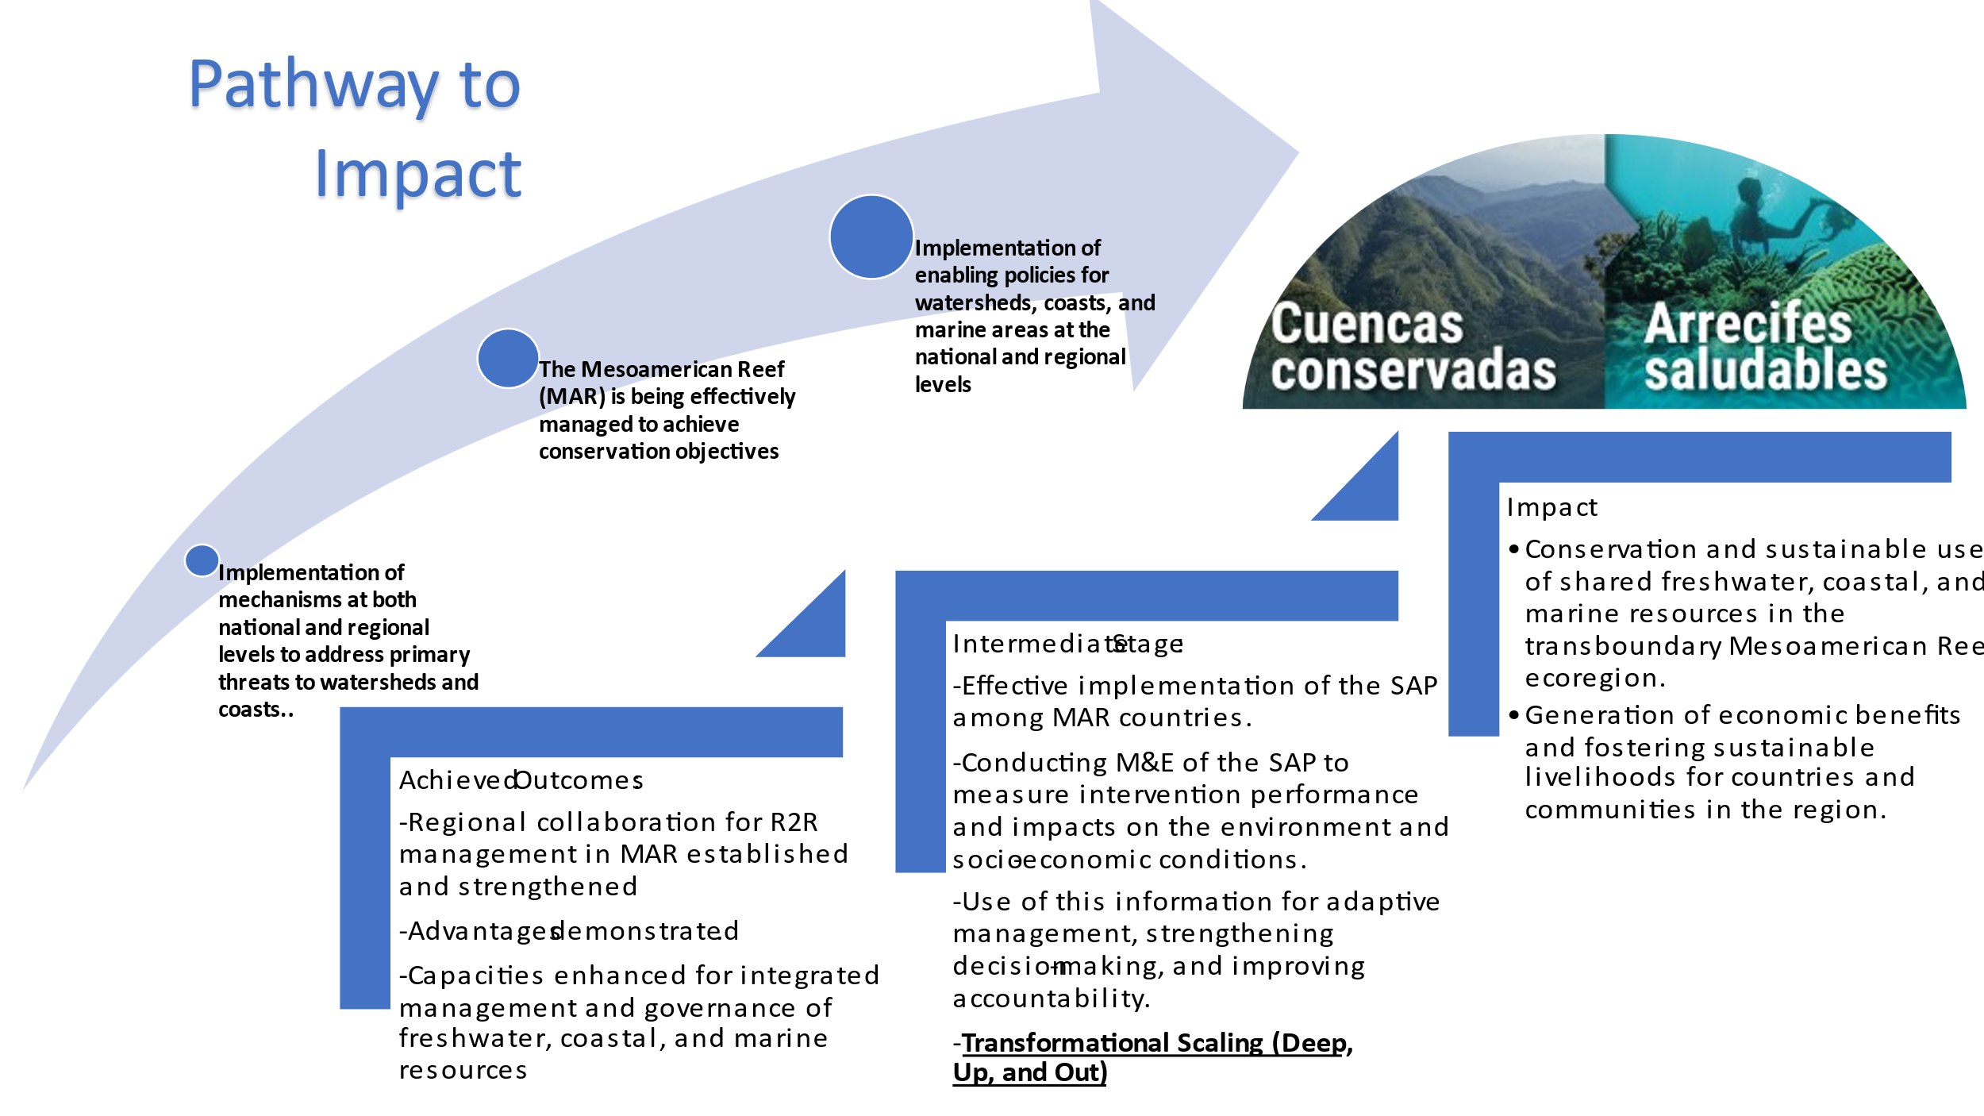
Figure 6: An Illustrated Transformational Pathway for MAR2R

3.2.3 WWF GEF Implementation (*), CCAD and partner execution (), coordination y and operational management
- Project Implementation and management was evaluated through parameters associated with the managerial functions required for successful project execution ranging from the recruiting of quality staff and contractors to sound financial management. The management effectiveness is reviewed from the perspective of the IA, EA and executing partners within the established governance structure.
- Table No. 12 below summarizes the rankings by management category. The overall ranking for Project Implementation, Adaptive Management and Governance is ranked as Satisfactory (S).

Project Implementation, Execution, and Management Assessment | Rating
Quality of Implementing Partner Execution | S
Quality of Implementing Agency Oversight | S
Institutional Arrangements | HS
Risk Management | S
Financial Management | HS
Table No. 16 Ranking of Project Implementation, Execution and Governance
- Implementing Agency Oversight: Direct oversight was provided by WWF GEF Agency and WWF Mesoamerica. The project faced initial communication challenges between the Implementing and Executing Agencies. Project delays, discussed below, strained the relationship between the IAs and EA. This process was complicated by personnel issues and a failed Mid-term Review process that required a new procedure, and the effects of COVID that limited oversight visits. WWF responded with key personnel changes in Mesoamerica, successfully relaunched an effective MTR, and worked with high-level partners to extend and realign the project, as described in paragraph 142. As discussed, there was no technical assistance or capacity building outcome within the Project’s design to prepare CCAD for leadership in the IW space and to build the technical and administrative systems needed to manage complex transboundary projects. Therefore, that effort and results are not captured by the Project’s indicators in the Results Framework. Unfortunately oversight visits were limited due to pandemic related restrictions. Technical Assistance in administrative and financial aspects was provided as needed and was successful in improving CCADs systems in compliance with GEF fiduciary standards. The implementing agency was a catalyst for effective and adaptive management and the oversight role was successful.
- Executing Agency: CCAD has the mandate and means to convene national policymakers and regulatory authorities from the MAR, two important qualities in an executing agency for an IW initiative. The MAR2R project was important and effective in supporting CCAD in developing the systems to manage sub-grants and experience to successfully execute complex transboundary projects with regional and national partners, strengthening their position as protagonists in that space. CCAD was further strengthened through their executive renewal process which brought new leadership that embraced a dynamic and productive process. The project reported that the inclusion of PMU within CCAD's Executive Secretariat also improved internal communication. All authorities interviewed felt that the communication with the PMU was fluid and productive. The PMU actively engaged stakeholders at all levels, built effective relationships with co-executing partners and contractors and established clear communication channels, and excelled in continuous monitoring and adaptability once personnel changes were made. A long hiring process significantly delayed project execution. KIIs from both within and outside of CCAD, including national level grantees indicated bureaucracy and slowness in turning around disbursements and reimbursements. Under the present structure, procurement responsibility is driven to the SICA/CCAD administrative and accounting officer rather than the Financial and Administrative Manager for the project. Regardless, the PMU and CCAD successfully navigated the complex process of producing the TDA and high-level governmental negotiations necessary to obtain an endorsed SAP. Mid-stream personnel changes in the EA M&E/oversight function were also effective in enabling the PMU to overcome the start-up delays and significant COVID-induced delays to deliver the Project’s outputs. Evaluators recommend that SICA capitalize on the experience and continue to improve their delivery process through project-level systems that provide agility at the project-level while maintaining SICA’s oversight and audit authority.
- Project Steering and Guidance: The MAR Technical Working Group functions as the traditional Project Steering Committee and is charged with approving the annual work plans. Unfortunately, it does not appear that the issues causing problems that contributed to early low performance were addressed by the PSC until the Project reached a critical stage. At that point, the PSC, CCAD, and WWF took concrete steps to recover momentum and set the project on a trajectory towards success. All partners made effective changes in personnel, approved project realignment and achieved GEF authorization for an extension. The steps taken were effective in setting the Project on course for success. Key informant interviews and comments received in response to this draft document underscore a difference in expectations between the IA and EAs. EAs appear to have expected a capacity building process early on. However, the CEO endorsement package, endorsed by all parties, did not include a capacity building process or indicators to that effect. This could be a weakness in the design and coordination phase of the project or in the inception phase. The misalignment of expectations could have also contributed to the slow delivery of the project. Regardless, that process was effectively reversed once all parties came together and took decisive action. Operationally, focal point members changed according to changes in political administration. Their participation was important in tracking and follow-up on activities within their jurisdictions and provided support. They are knowledgeable and engaged. National Intersectoral Committees (ISNCs) were successfully integrated, promoting improved governance in national watersheds with participation from diverse sectors. Given the range of factors that influenced project delivery, the project outcomes were secured through an adaptive process.

79% of participants in the evaluation survey are satisfied with the project and most of the interviewees agree that the project's governance improved over time.

3.2.4 Risk Management
- The PMU was responsible for identifying, reporting, and responding to risks as well as identifying new risks. To do so, the PMU reported risks to WWF-GEF on a semestral basis through the Project Progress Reports (PPRs), section on “Project Risk Identification and Risk Mitigation Plans”. A total of 8 risks were identified in the PRODOC and tracked by the project. These were reduced to 2 by 2023:
- As mentioned earlier, WWF assumed considerable risk with regards to an untested CCAD unit without sufficient systems to smoothly execute the project. This factor and the process of bringing CCAD up to readiness caused delays as witnessed in the subcontracting for demonstration projects. This risk should have been internalized in the design of the project and the number of outputs reduced to accommodate that growth. With assistance, personal changes, and commitment, those risks reduced overtime as project execution increased and eventually delivered on all outputs. This aspect is discussed further under Implementation Progress, par. 153.
- For each demonstration project, a basic analysis of social and environmental risks was conducted, and a grievance resolution system was put in place. Overall, the implemented activities carry low risk and were environmentally and community friendly.
- Coral reef restoration efforts included training in reef restoration techniques, coral fragment collection, and nursery setup in Mexico. These activities involved diving in shallow waters, which in general does not represent an additional risk to human health, only the low risk intrinsic to near shore diving.
- Interviewees indicated that the PMU did discuss risks and presented proposals for responding to risks, as part of the M&E process and adaptive management.

 | Year 1 | Year 2 | Year 3 | Year 4 | Year 5
Risk Ratings | S | S | S | M | L
Table 17: MAR2R Summary Risk Rating
- The risk rating was low at the end of the project given a likelihood for project results to be sustainable. The MAR2R exit plan should support sustaining project results and mitigating any risks. The foundation of the exit plan lies in the formulation and endorsement of the TDA and the SAP, which identifies critical environmental issues, offers solutions, and establishes a framework for targeted efforts.

68% of participants in the evaluation survey agreed that the Project recorded, stored, and appropriately tracked information, including risk monitoring, with key partners and internal teams.

- Evaluators consider that the risks were correctly assessed, addressed, and reported.

3.2.5 Financial Management
- The PMU submitted to the evaluators the quarterly and annual financial reports. These were complete and enabled the analysis presented above. The Key Informants interviewed were satisfied with the financial management of the project´s resources as was the IA. The EAs felt that the tools provided by WWF-GEF were complete and provided an effective assessment of the management of the project´s financial resources.
- The overall financial management of the project´s $ 9,018,349 U.S. budget is considered sound and compliant with GEF and international standards.

3.2.6. Operational Management: Effectiveness & Efficiency
- Operational management in the context of an International Waters project is a critical discipline centered on the strategic orchestration, planning, and oversight of the daily activities required to advance the project's overarching goals and objectives efficiently and effectively. This encompasses the management of processes, allocation of resources, and coordination of activities essential for executing and delivering the project's initiatives in the complex environment of international waters.
- The operational management of the project was deemed satisfactory, as it demonstrated effective planning, resource allocation, and process management throughout its execution. Several key pieces of evidence support this assessment. The project demonstrated commendable adaptability and resilience in response to external challenges, including disruptions caused by the COVID-19 pandemic, staffing changes, and hurricane-related setbacks during the initial 2 1/2 years. While the project faced delays in meeting some milestones and deadlines due to these factors, its ability to adjust and continue progress reflects its capacity to navigate unexpected hurdles and maintain flexibility in project management. Additionally, budgetary control was maintained within acceptable limits, with no significant cost overruns, validating prudent financial management. Moreover, performance metric demonstrated that, despite challenges, the project exceeded its targets and achieved all its planned outputs and outcomes. In summary, a combination of financial prudence, stakeholder satisfaction, and adaptability provides compelling evidence of the project's satisfactory operational management.
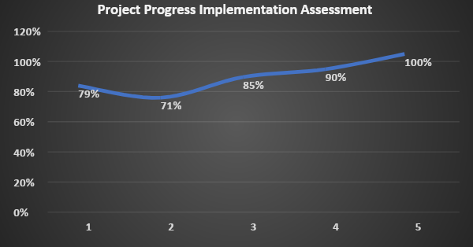
Figure 7: The percent implementation of the annual work plans
- Implementation progress (IP) is based on progress against the annual work plan. The formulation of Annual Operating Plans (AOPs) involved a learning curve for WWF (implementing agency) and CCAD (executing agency), necessitating adjustments and technical support. By year 2, the Project Management Unit (PMU) had learned from year 1, making AOP formulation and follow-up easier. COVID-19 impacted field activities, requiring the use of digital platforms for virtual support. Year 3 AOP aimed to compensate for delays due to COVID-19 and extreme weather events, incorporating indicator changes in the Results Framework in issues related to the certification of shrimp farmers, oil palm producers and sugar cane producers. AOP 5 focused on closing activities, sharing lessons, and reaching a broader audience. Enabling conditions were created to strengthen planning, execution capacity, and knowledge exchange among partners.
- Budget execution by component reveals the narrative of adaptive management, as illustrated in Figure 7:
- The period from February 2021 to June 2021 marked a phase of necessary adjustments, setting the stage for significant growth starting in June 2021 2022 and continuing thereafter.
- The spike observed in year 5 also serves as an indicator that numerous products came online very late in the process. This generally indicates insufficient time to put information and materials into practice, which is an additional side-effect of the late project inception process and of the Pandemic. This observation aligns with the chart provided earlier, which illustrates that all the project products were achieved in the last year of the project. Given this timeline, it is evident that policies, regulations, and plans finalized toward the end of the project would naturally require post-project closure implementation and monitoring. CCAD should de conscious of the need to continue to promote the products, especially the knowledge products on an ongoing basis and incorporate these elements into future projects. These circumstances present opportunities for further exploration and development under the MAR2R Phase II initiative.

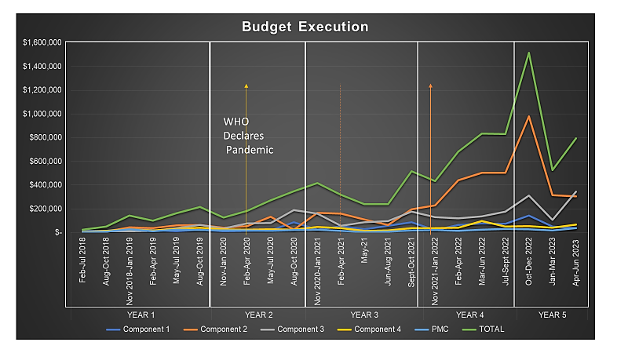
Figure 8. Budget Execution
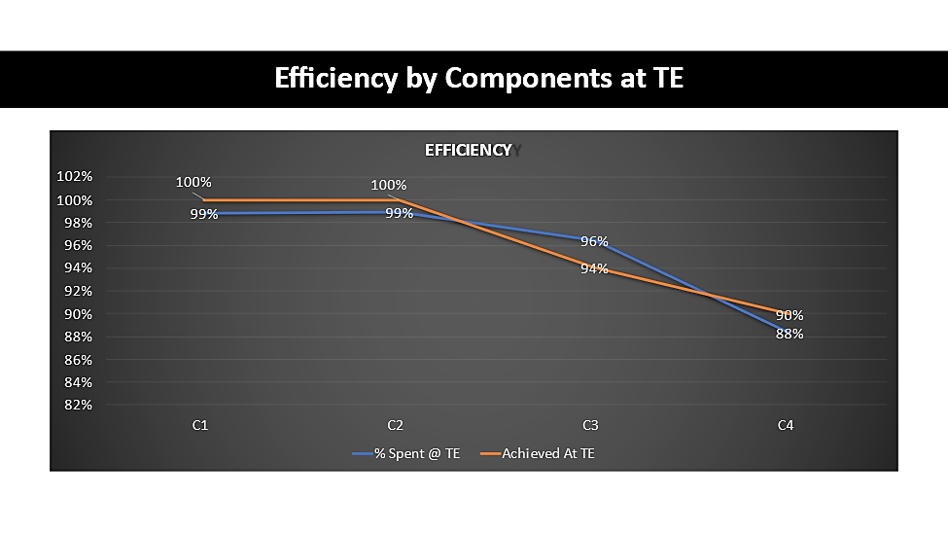
Figure 9 Efficiency by Component

- To assess the overall efficiency of the project, evaluators employ a weighted average approach that considers both the achievement of project targets and the allocation of budget spent to meet the target.
- Therefore, the overall efficiency of the project is approximately 96%, indicating the degree to which project objectives were met in relation to the budget allocation, rating “Satisfactory” at the End of the Project.
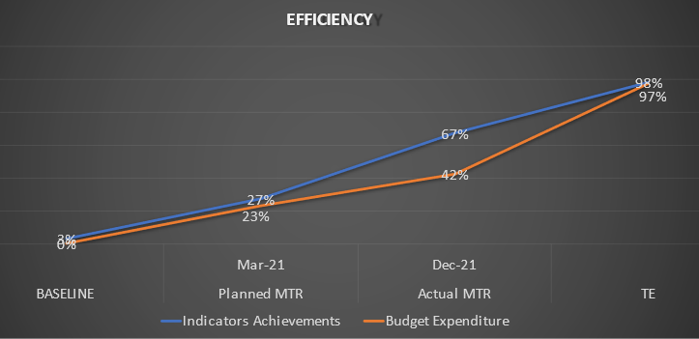
- The evaluators sought to validate progress by analyzing milestones achieved in relation to expenditures. The figure displays scheduled and actual Mid-Term Review (MTR) dates. Conducting MTRs, even with limited results, identifies issues, refines the Results Framework, and highlights management concerns. Effective management practices were evident.
Figure 10. Project Efficiency

- The project's ability to effectively utilize its budget, achieve its expected outputs, and adapt to challenges justifies a "Satisfactory" rating. The project's performance in terms of budget execution and output achievement aligns with a satisfactory level of project management and outcome delivery.

3.2.7 M&E Design & Implementation /Adaptive Management & Capacity
- This section evaluates the Monitoring and Evaluation design and implementation. The M&E tracking system is considered adequate. The quality of the information and reporting provided in implementation meets expectations and facilitated decision-making and evaluations garnering a Highly Satisfactory (HS) ranking. The composite ranking is Satisfactory (HS).
M&E Design | HS
M&E Implementation | S
Adaptive Management & Capacity | HS
Overall Ranking | HS
Table 18: Summary M&E Ranking
Highly Satisfactory (HS); Satisfactory (S); Moderately Satisfactory (MS); Moderately unsatisfactory (MU); Unsatisfactory (U)

- The Monitoring and Evaluation (M&E) Design for the project has been assessed as highly satisfactory. This design effectively facilitates the collection of essential information and tracking of indicator targets throughout the project's lifecycle. The cornerstone of this M&E framework is the Results Framework, which has proven to be an efficient tool in monitoring progress and evaluating outcomes.
- One notable strength of the M&E system is the availability of baseline data for most of the indicators, ensuring a solid foundation for performance measurement. Additionally, the indicators in use are not only suitable but also well-defined, although there's room for improvement through SMART analysis to make them even more specific, measurable, achievable, relevant, and time bound.
- In terms of resources allocated to M&E, Communication and Knowledge Management, the system is adequately supported, with human resources and a budget allocation equivalent to 14% of the overall project budget.
- The implementation of the M&E system is satisfactory. The initial communication challenges between the Executing and Implementing Agencies, partly due to high expectations based on WWF's extensive project execution experience, were overcome thanks to adaptive management practices. When the institutions decided to address the issues, personnel changes were made and a new commitment to success, from that point forward, things rallied.
- Adaptive management is the process whereby the partners set the Project on the right track. For that reason, the Project is a model of adaptive management. The project's success hinges on stakeholder engagement, collaboration with CCAD, capacity strengthening, and the pivotal role of ISNCs in enhancing governance. Additionally, the project's adaptability allowed it to overcome initial hurdles and achieve positive results.
- The executing agency (EA) and implementing agency (IA) collaborated to redefine indicators 2.3 and 3.2 within the adaptive management framework, focusing on certification standards. Following a joint analysis, adjustments were made to create more realistic and attainable indicators, which were subsequently approved by the steering committee. Also, for outcome 2.3 in component 2, concerning oil palm producers, the number of RSPO certified producers was replaced with the count of small producers implementing simplified RSPO certification, alongside an action plan developed with the AIPAH. Regarding sugar producers, the project replaced the number of BONSUCRO-certified sugar mills with the number of mills implementing sustainable practices within the BONSUCRO framework, with APAH receiving support to design a baseline emphasizing sustainability and innovation. To fulfill output 3.2, collaboration with WWF Honduras and the IADB led to hiring Control Unión Perú to audit eight shrimp farms in Belize, assisting the Belize Shrimp Growers Association (BSGA) under the MAR2R and IADB initiatives. Control Unión Perú devised a detailed schedule for auditing each farm, enabling action plans for certification preparation. It was noted that each farm's certification process depended on their individual circumstances, effort, investment, and willingness to implement changes. As such, the project recognized that it couldn't enforce the process and hence reconsidered its indicators related to company certification commitments, learning that such issues within private companies are typically addressed privately, especially concerning investments.
- The project's M&E system has demonstrated reliability through the consistent submission of reports and the delivery of tangible benefits to the project's overall management and decision-making processes. Overall, the project's approach to monitoring and evaluation has proven to be robust and highly effective in supporting its objectives and outcomes.

3.3 Assessment of Risks to the Sustainability of Project Outcomes

3.3.1 Financial Risks: Potential Identified Risks
- The risk assessment for financial sustainability of the project benefits reveals several risks:
- Economic Changes and Market Shifts: Potential economic changes or shifts in commodities markets for shrimp, lobster, coffee and palm oil could pose a risk to the project's revenue generation. These uncertainties could affect land use and cover.
- Resource Limitations: Limited financial resources, manpower, and technological infrastructure can hinder the execution of the project's Strategic Plan. This is most evident in the availability of capital for credit to finance improved technology or retrofit old technology, such as wastewater treatment plants.
- Global economic performance can affect the availability of capital for green investments. Changes in global economics should form part of the assumptions of the documents. This limitation may also lead to operational challenges and impact the overall sustainability of the SAP if SICA member states cannot provide consistent levels of support.
- To address these risks and ensure financial sustainability, the project incorporated adaptive measures:
- The SAP outlines approaches to leverage technical and financial support from a range of bilateral and multilateral sources. Key partners include Germany, GIZ, UICN, MarFund, EU, GEF, and DEFRA. This diversification of funding sources helps reduce dependency on a single entity and enhances financial stability. New follow-on projects are under development.
- The project's focus on "Ridge to Reef" actions for climate change mitigation and adaptation creates opportunities for increased financial support and capacity building. These activities align with global priorities and attract additional funding options.
- Emphasizing the implementation of proposed activities and optimizing resource utilization demonstrates a proactive approach to sustainability. Efficient resource management can mitigate financial risks associated with resource limitations.
- Aligning the project with the National Determined Contributions (NDC) ensures political, institutional, and financial sustainability. It enhances the project's legitimacy and access to government resources.
- The SAP underscores the need to leverage different sources of financing, including innovative mechanisms and financial instruments.
- The strategies outlined in the SAP, such as diversifying funding sources, aligning with national priorities, and optimizing resource usage, demonstrate a comprehensive approach to mitigate these risks and ensure the long-term success of the project. Financial Sustainability Assessment: Likely (L)

Sociopolitical Risks: Potential Identified Risks
- The socio-political risks identified are:
- Diminishing Community Support: Community support for the project may decline over time due to changes in community priorities, leadership, or economic conditions. This can pose challenges in maintaining local engagement and participation.
- Potential Conflicts and Alienation: When conflicts arise or significant changes occur, communities often find themselves facing a challenging choice between economic interests and environmental concerns. This predicament can create difficulties in boosting community members' willingness to invest in environmentally friendly solutions. Such conflicts have the potential to disrupt community cohesion and diminish the support for environmental initiatives over time.
- Gender-Based Disparities: Gender-based disparities are identified as a potential concern that may require ongoing efforts to address. Achieving gender equality and inclusivity may be a slow and continuous process.
- To mitigate these risks, the project has incorporated several strategies into its plan:
- The Strategic Action Plan emphasizes community engagement and inclusiveness. It aims to involve local actors, indigenous communities, government authorities, civil society, and the private sector in project activities, promoting collective knowledge and equitable participation.
- The plan aligns with the Regional Policy for Gender Equality (PRIEG) 2014-2025, indicating a commitment to addressing gender-based disparities. This commitment includes ongoing efforts to promote gender equality and inclusivity.
- Ensure transparency and information management through the operation of the Regional Environmental Observatory and participation in existing governance platforms to build trust and maintain community support.
- The SAP includes measures to mitigate sociopolitical risks related to community dynamics, gender disparities, and inclusiveness. Regardless, there remains moderate risks associated with the potential for diminishing community support over time and the emergence of conflicts. The emphasis on community engagement, gender equality, and transparency should contribute to overall sociopolitical sustainability. Ongoing monitoring and adaptability will be essential to address and mitigate these risks effectively. The Sustainability Assessment: Moderately Likely (ML)

3.3.3 Institutional Framework & Governance Risks: Potential Identified Risks
- Several critical institutional and governance factors that could impact its long-term success of the SAP:
National Elections and Political Instability: Rapid changes in leadership, political instability, and shifts in government priorities can disrupt the continuity of implementing the Strategic Plan. These factors, including nationalism, could introduce a significant risk to transboundary cooperation.
Consistency in Policy Implementation: The SAP success relies on the consistent capacity of governments to place quality leadership within CCAD and implement policies aligned with the SAP. Inconsistencies in policy implementation can hinder progress and sustainability. Changes in administration can influence the project's direction and priorities.
Adaptability to Changing Circumstances: The SAP needs to improve its adaptability to changing circumstances, including technological advancements, economic shifts, and social changes. Failure to do so may lead to the project becoming outdated or less effective.
- To address these risks, the project took several measures that support sustainability:

- High-Level Political Endorsement of the SAP
- CCAD is mandated to promote and finance the Ridge-to-Reef concept to all states.
- Collaboration and Data Exchange through the REO will promote collaboration among stakeholders at various political, technical, and civil society levels, enhancing governance and data exchange fostering coordination and knowledge sharing.
- Thematic and Territorial Initiatives: Institutional and political sustainability is strengthened through concrete actions within thematic and territorial initiatives, such as AFOLU 204010, Grandes Bosques, and the Corredor Seco Centroamericano. The SAP provides a structured framework for project activities.
- Intersectoral Collaboration: Intersectoral sustainability and a holistic approach is reinforced through the development of agendas involving multiple ministerial councils, addressing integral topics like environment-agriculture and environment-tourism.
- Strategic Prioritization: The prioritization of landscape restoration, standardized discharge quality, and blue economy development contributes to strategic and intersectoral sustainability. These priorities align with long-term goals.
- Regional Environmental Framework Strategy: The Regional Environmental Framework Strategy organizes the regional environmental agenda and supports institutional arrangements, policy instruments, programs, and projects. This helps achieve proposed goals in various thematic areas.
- Despite these efforts, the potential for rapid leadership changes, shifts in government priorities and an unequal capacity for executing SAP actions introduces moderate risks to sustainability. The CCAD should remain vigilant, adaptable, and politically engaged to navigate these challenges successfully and maintain its institutional and governance sustainability. Sustainability Assessment: Moderately Likely (ML)

3.3.4 Environmental Risks: Potential Identified Risks
- Several factors that could impact its compliance with environmentally sustainable standards:
Changes in Environmental Conditions and Regulations: The project acknowledges the importance of complying with environmentally sustainable standards and has incorporated various regional strategies and initiatives to address environmental challenges. However, it recognizes that changes in environmental conditions and regulations could pose moderate risks to sustainability. These changes may require adjustments to the SAP strategies and practices to remain compliant. Conversely, this could be an opportunity to share good practice in policy.
National Policy Shifts: A policy shift, especially incentives to productive sectors at the national level in one of the member countries can have significant implications for environmental sustainability. Such shifts can introduce uncertainty and potential challenges in aligning the project with new national policies and priorities.
Resource Diversion and Priority Shifting Events: Events, such as pandemics or large climatic events that divert resources and shift priorities are potential risks to environmental sustainability and can disrupt the project's ability to allocate resources and maintain its focus on environmentally sustainable practices.
- Experience with insuring coral reefs could be studied for application to other fields, such as de-risking improvements in Shrimp farming.
- Publicly reward companies that invest in environmental sustainability, such as the sugar mill wastewater cooling plant on the New River in Belize.
- There are no strategies in place for a collapse scenario. There are technologies under development, such as 3D printing of coral in Mexico, that could be used to repopulate coral reefs in the event of a catastrophic event. These types of contingency plans can include identifying genetic material of sea grass species, mangroves, fishes, etc. A fish mortality event in Belize’s New River provides an example of the difficulties that arise when events occur without contingency plans. The SAP does not include these types of basic scenarios.
- Despite the SAP’s regional environmental strategies and initiatives, the potential risks associated with changes in environmental conditions, regulations, policy shifts, and resource diversion are considered moderate. The probability of climatic or environmental shocks is moderate to high. It is essential for the SAP implementation to remain adaptable and responsive to these potential challenges to ensure the overall sustainability of its environmental outcomes. Sustainability Assessment: Moderately Likely (ML)

3.3.5 Overall Likelihood of Sustainability
- The Risk Assessment for the Overall Sustainability of the Project demonstrates a robust approach to ensuring the project's long-term viability and positive outcomes:
Proactive Measures and Strategic Planning: The project's sustainability is grounded in proactive measures and strategic planning. It recognizes the importance of anticipating and addressing potential risks to sustainability in various dimensions.
Identification of Moderate Sustainability Risks: The project has identified and classified moderate sustainability risks across financial, sociopolitical, environmental, institutional, and governance dimensions. This comprehensive assessment allows for a clear understanding of potential challenges.
Comprehensive Strategies in the Strategic Plan: The project's strategic plan includes a wide range of strategies designed to tackle these identified risks. These strategies are carefully crafted to ensure the project's resilience and ability to adapt to changing circumstances.
Long-Term Focus: The strategic plan emphasizes securing positive outcomes over the long term. This commitment to sustained impact underscores the project's dedication to achieving lasting results.
- In addition to these aspects, the project also recognizes the importance of monitoring and evaluation through sustainability indicators. These indicators serve as tools to measure the project's capacity for long-term sustainability in various areas, including institutional capacity, community involvement, financial self-sufficiency, policy and regulatory support, environmental responsibility, and socio-cultural sustainability.
- By using sustainability indicators, the project can continuously assess its progress, identify areas where improvements are needed, and ensure that resources are invested wisely in initiatives that have a strong likelihood of creating a lasting impact. Overall, the project's approach to sustainability assessment and planning demonstrates a commitment to achieving enduring positive outcomes.

Sustainability | Rating
Financial resources | Likely (L)
Socio-political | Moderately Likely (ML)
Institutional framework and governance | Moderately Likely (ML)
Environmental | Moderately Likely (ML)
Overall Likelihood of Sustainability | Moderately Likely (ML)
Table 19: Sustainability Ranking

3.3.6 Sustainability Exit Strategy
- The PMU in their Project Closure Report indicates an exit strategy based on the formulation and endorsement of the TDA and the SAP which includes the following:
Participative Environmental Assessment: A participative process identified environmental problems, opportunities, and proposed solutions. This process ensures that local communities are actively engaged in addressing environmental issues, fostering ownership and sustainability.
Alignment with Regional Protocols: The strategy leverages regional protocols endorsed by countries, providing a solid foundation for implementing the Ridge-to-Reef (R2R) approach. This alignment helps ensure the sustainability of project initiatives at a broader regional level, scaling to all countries in the MAR region.
Governmental Support: National policies such as the Water Resources Policy, Wastewater Quality Standards, and NOM001 demonstrate governmental support for MAR2R initiatives. This support is crucial for long-term sustainability.
Political Backing and Future Initiatives: The outcomes of MAR2R have the potential to influence future initiatives like the R2R regional initiative, thanks to political backing. This ensures that the project's impact extends beyond its current scope.
Institutional Support: Key organizations and environmental ministries, such as the CCAD council, Mexico-SEMARNAT, and others, provide institutional support, reinforcing the project's sustainability.
Multi-Stakeholder Engagement: Multi-stakeholder platforms are actively involved in the sustainability strategy. These platforms play a crucial role in fostering collaboration and commitment among various stakeholders.
Capacity Building: Capacity building efforts among producers and processors have reduced water pollution and improved agricultural practices. This not only addresses immediate issues but also ensures sustainable practices in the long run.
Infrastructure and Skill Enhancement: MAR2R has enhanced the capacities of water treatment plant operators, benefiting over 1 million people in the Yucatan Peninsula. This infrastructure and skill development contribute to long-term water resource management.
Ecosystem Preservation: Coral restoration efforts not only restore sensitive ecosystems but also contribute valuable skills and techniques for their preservation. This ensures the long-term health of these ecosystems.
Institutional and Governance Support: Importantly, every action implemented by MAR2R has institutional and governance support. This promotes replicability and scalability, allowing successful initiatives to be expanded to other regions or contexts.
- Evaluators conclude that the SAP is in effect the exit strategy because it establishes the pathway for development of the MAR. Given the previous sections of this report, evaluators suggest that CCAD consider the following actions:
- Target financial sources for the strategic lines in the SAP and establish strategic partnerships. Consider a GEF Capacity Building Mid-sized project or work this into a MAR2R Fase II project.
- Consider institutionalizing the dialogue for Transboundary Water Management by creating a structure within CCAD with functions similar to that of UNECE and establishing principles for sound dialogue and resolution of water conflicts e.g. early warning, prior consent, etc.
- Consider a donor roundtable to define the suite of actions in an expanded TOC can be addressed. This could be a SICA or CCAD hosted event at a COP or hosted by another organization. The Sustainability Strategy with Exit Plan for the MAR2R Project is a holistic approach that integrates community engagement, regional alignment, government support, multi-stakeholder collaboration, capacity building, and institutional backing. This comprehensive strategy is designed to ensure that the project's positive environmental impacts are sustained well into the future.
- Upgrade the TOC to include intermediate actions and define step changes and transformational scaling as described herein.
- Focus on policy coherence, identify policies with perverse incentives and develop plans to influence those policies.
- Consider increasing the capacity of national and municipal government agencies to promote and execute the SAP. This would require strategic communication and brokering diploma and study opportunities.
- Work in establishing productive linkages. Only 25% of sugar producers in latin America are members of the sugar industry sustainability round table. Promote productive linkages for sustainability for each productive sector and connections with the new GEF-8 Integrated Programs.

3.4 Gender Equality and Mainstreaming
- GEF 5 did not require a Gender Action Plan. The project did have a gender strategy within a gender mainstreaming approach. Gender is recognized as a significant aspect within the project's framework. The Project Document (PRODOC) provides guidelines for Gender Mainstreaming, which were further elaborated in the Environmental and Social Management Framework (ESMF) regarding specific project activities.
- An analysis of the project's approach to gender mainstreaming and monitoring suggests certain limitations. While the project includes gender-sensitive indicators related to attendance, the overall strategy appears to lack comprehensiveness. The absence of qualitative indicators to explore the qualitative dimensions of the project and attitudes that may support unproductive practices suggests a potential gap in gender-sensitive monitoring. The project primarily focuses on measuring the attendance of men and women in workshops and trainings, involving only two out of 16 indicators.
- The composition of the project management unit and the Steering Committee shows a gender imbalance in the selection processes, one for watershed specialists and another for the coastal marine sector. Women were initially chosen but ultimately declined their positions, causing a repetition of both processes. The same situation occurred in the selection of the administrative and financial leadership.
- On the other hand, there were instances where the representation of women on the PSC reached 75%.
- The project showed commitment in promoting equal participation of both men and women in capacity development activities related to watershed planning, climate change adaptation, and IWRM and ICMM.

72% of participants in the evaluation survey agreed that both women and men had equal access to project benefits.

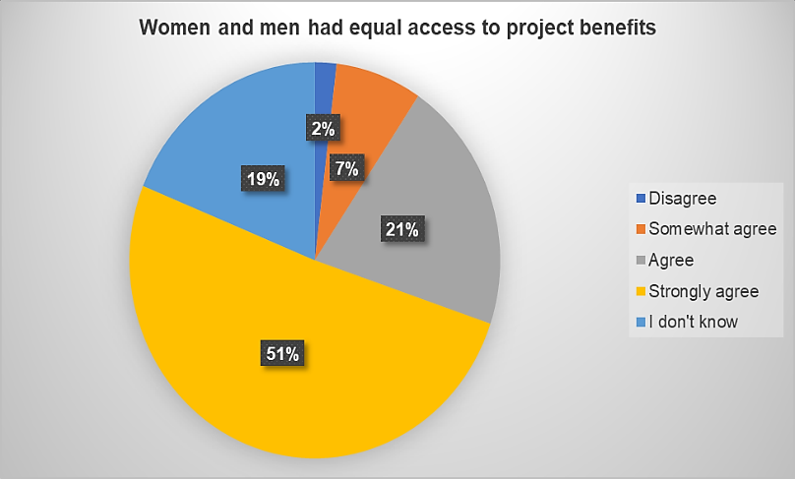
Figure 10: Beneficiary perception of access to project benefits by men and women

- The project's demonstration projects were designed ensured that women had equitable access to, participation in, and benefits from these initiatives. Training and activities within these projects emphasize equal opportunities for both genders, encompassing their involvement in decision-making, planning, and management processes. Notably, capacity-building activities within components 2 and 3 have successfully engaged women, with 51% actively participating in marine-coastal issues and 34% in agriculture, water management, and entrepreneurship-related activities. Safeguards have facilitated women's participation in these projects, promoting gender inclusiveness and empowerment.
- For instance, in the Merendón Region of Honduras, women coffee growers have received substantial support, including equipment and training, aimed at enhancing their productivity and time management. Similarly, in Rio Hondo, Mexico, both male and female entrepreneurs have received project support, with a particular emphasis on women's active involvement in training, product development, manufacturing, and sales, contributing to a more inclusive and equitable project impact.
- While gender inclusion was evident in the project's implementation in Honduras and Mexico, with clear interventions by women and youth in prioritized activities, there is no specific evidence of gender mainstreaming in the other projects in Guatemala and Belize, apart from the segregation of training attendance by gender. Project outcomes show that a total of 4,881 individuals were trained through project IWRM and ICMM activities, with an imbalance of 1,141 more men (62%) than women (38%). This suggests that gender and equality considerations may not have been as prominent as initially planned.
- Recommendations for future projects include efforts to promote gender diversity and balance in leadership roles within the project to enhance its commitment to gender equality. Additionally, incorporating process indicators will be essential for understanding cultural or gender-based perceptions about local practices, providing a more comprehensive understanding of the project's impact on gender dynamics.
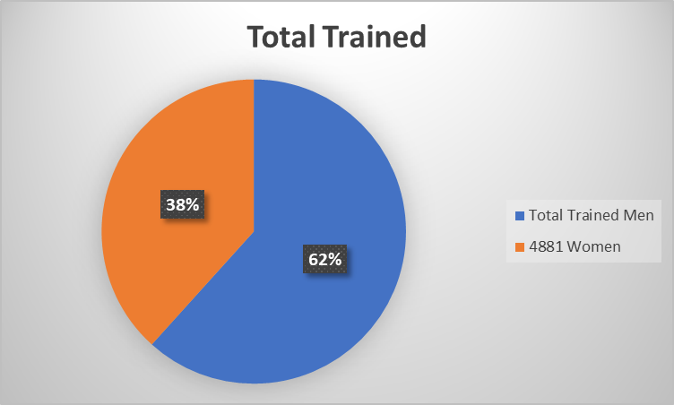
Figure 11: Beneficiaries of Training disaggregated by Gender.

3.5 Stakeholder Engagement
- Stakeholders in the MAR2R included national and local NGOs, private sector organizations, civil society groups including women’s groups, producer associations, local watershed committees/associations, fishing organizations, and others actively participating in various initiatives relevant to integrated watershed and coastal and marine management in the MAR.
- The local communities living and working in the watersheds, coastal and marine zones that depend on the natural resources and associated environmental services were engaged throughout project execution. This group included: farmer and agricultural associations, community organizations, committees of indigenous inhabitants, women's community groups, water associations and committees, fishers and fishers’ associations. Local communities were key players in various activities including demonstration projects.
- The objective of the Stakeholder Engagement Plan was to strengthen regional governance and collaboration through extensive stakeholder involvement, which was pivotal in achieving the project's goals. The strategy involved a stakeholder engagement stratified by geographic levels, namely: Regional, National, Sub-national, Local levels.
- At the Regional Level:
- Involved CCAD Council of Ministers and SEMARNAT of Mexico.
- Ensured collaboration with other Central American ministerial councils (tourism, agriculture, fisheries).
- Facilitated the creation of significant regional products, including the CCAD Regional Environmental Framework Strategy (ERAM) and various regional protocols.
- Achieved intersectoral collaborations, e.g., between agriculture-environment and tourism-environment.
- Endorsed the Strategic Action Plan for the Mesoamerican Reef Ecoregion, ensuring sustainability.
- At the National Level:
- Centered on the environmental ministries of Belize, Guatemala, Honduras, and Mexico, and the CCAD countries.
- Focused on policy development, regulations, and planning for integrated water and natural resource management.
- At the Sub-national Level:
- Incorporated stakeholders around watershed governance, private sector organizations, and platforms for dialogue on ecosystems like coral reefs and mangroves.
- Facilitated the creation of watershed management plans, financial strategies, and technical instruments.
- Emphasized capacity building of stakeholders through courses, guides, advocacy activities, and participation.
- At the Local Level:
- Involved civil society, communities, indigenous groups, producer groups, and local organizations, such as water boards. In Mexico, honey and chocolate production was strengthened through the demonstration project under “Amigos de Sian Ka’an”. Coffee producers benefit from improving coffee quality through the demonstration project in Honduras by Fundacion Merendon.
- Executed demonstration projects, technical training, and water management strategies.
- Promoted political advocacy for water management and knowledge-sharing through congresses and communities of practice.
- The evaluators identified several critical success factors that greatly contributed to these outcomes. The leadership displayed by CCAD, combined with its strong relationship with Mexico, played a pivotal role in instilling trust and encouraging active participation from various stakeholders. Furthermore, the project's technical and strategic approach was tailored in such a way that it resonated with the priorities and needs of the involved parties, ensuring their buy-in and commitment. A notable strength was the project's ability to effectively coordinate across technical, political, and strategic levels. This upstreaming and down streaming ensured that decisions and actions were harmonized, leading to efficient execution and realization of the project's objectives.
Key Developments:

- Adaptation of Intersectoral National Committee (ISNC) Concept: The ISNC concept was tailored to the unique national contexts of the countries involved. Examples of key developments include:
- Mexico established the Yucatan Peninsula Watershed Council.
- Honduras initiated dialogue through platforms like the San Pedro Sula Water Security Alliance.
- Guatemala formed the Marine Coastal round table.
- Belize introduced a National Working Group and Task Force.
Enhanced Stakeholder Engagement: Every country showcased commitment to the Ridge-to-Reef (R2R) concept. Engagement led to political, strategic, and technical discussions, with concepts such as spatial marine planning and blue economy coming to the fore. The R2R approach was integrated into top-tier regional instruments like the Regional Environmental Framework Strategy (ERAM) and other political-level organizations within SICA.
Expansion and Quality of Stakeholder Participation: The MAR2R project saw increased stakeholder numbers, encompassing private sectors, academia, and the scientific community. The quality of participation also improved, enhancing advocacy in policy development at local and national scales.
Strengthening Local Governance: Local platforms for water and coastal-marine resource management were fortified. The project backed community-based enterprises and partners, encouraging better practices and standards. The application of social and environmental safeguards was crucial, fostering new skills in partner organizations.
- Other Noteworthy Achievements include:

- Policy and Institutional Framework: Enhanced policy instruments, national plans, strategies, regulations, and institutional frameworks have been established to support integrated R2R management.
- Stakeholder Participation and Collaboration: Stakeholder involvement led to improved governance and public participation. Alliances with strategic regional partners were created to ensure the continuation of conservation activities in the MAR Ecoregion.
- Knowledge and Understanding: A deeper comprehension of the R2R approach was achieved, both linguistically and conceptually. The approach was applied to strategies, public policies, planning documents, and practical field actions.
- Facilitating Political Dialogue: Having MAR2R anchored within the Central American Commission on Environment and Development (CCAD) facilitated high-level political dialogue. This setting enabled the formulation of public policies, strategies, and agreements with official endorsements.
- Conclusions drawn from the Project’s stakeholder engagement include the following:
- The project successfully engaged stakeholders at various geographical levels to achieve its goals, demonstrating the efficacy of the engagement strategy in fostering collaboration and progress in regional governance and collaboration.
- The stakeholder engagement in the MAR2R project yielded significant advancements in regional collaboration, policy development, and R2R management. The tailored approach to each country's unique circumstances coupled with the broader regional perspective made the outcomes more effective and influential.
- The stakeholder engagement experience in the MAR2R project underscores the importance of laying a strong foundation, clear communication, continuous engagement, breaking down silos, and planning for future continuity and expansion. These lessons can guide similar initiatives to foster collaboration and achieve their objectives.

- The following lessons were learned from stakeholder engagement process:

Importance of Initial Foundation: Proper groundwork is essential for a successful long-term project. The project’s initial phase, while time-consuming, provided the necessary foundation for stakeholder collaboration. Time invested in building strong relationships, understanding partner perspectives, and aligning visions is crucial. Patience and persistence in the face of obstacles (like COVID mobility restrictions) can lead to productive outcomes.
Clarity in Commitments & Responsibilities: Transparent articulation of roles and expectations, especially between public and private sectors, is essential for cooperation. It's important to transform stakeholders' limited self-perceptions from mere executors to active partners. This can amplify investment and international cooperation.
Institutionalization and Collaboration: Achieving standards and best practices necessitates ongoing reinforcement and collaboration among diverse entities. For lasting results, continuous engagement and strengthening of academic, civil, private, and community partners at all levels is necessary.
Addressing Financial Gaps: Despite advancements in understanding the project's concepts, financial challenges remain. Active strategic management and targeted communication are needed to persuade the financial sector about the long-term benefits of investing in sustainable projects. Collaboration with key financial institutions and ministries can be instrumental in increasing private sector engagement.
Cross-sectoral Collaboration: Breaking down silos between different stakeholder groups, such as coastal-marine stakeholders and watershed stakeholders, is a challenge. Future initiatives should prioritize fostering communication and understanding between groups that traditionally work in isolation, emphasizing the interconnectedness of their roles.
Ensuring Continuity and Expansion: Achievements from projects like MAR2R need to be sustained and expanded upon. To retain the benefits and extend them further, there's a need to continuously broaden stakeholder engagement and consider expanding successful models to new regions.

3.6 Safeguards Review
- The Project was classified as Category B for safeguard purposes indicating any adverse environmental and social impacts were unlikely. All risks were considered minimal, obviating the need for an environmental and social impact assessment. The project was essentially a conservation initiative, expected to generate positive and long-lasting social, economic, and environmental benefits.
- The MAR2R Project strongly focused on adhering to WWF's environmental and social standards right from the beginning. It emphasized capacity development for implementing partners, particularly in local communities. Gender and social inclusion were key priorities, and the project involved creating documents, training local partners, and fostering knowledge sharing and monitoring throughout its duration.
- The primary objective of the project was to achieve integrated management of freshwater, coastal, and marine resources in the Mesoamerican Reef Ecoregion (MAR), addressing both environmental and social challenges. To accomplish this, WWF's safeguard standards were rigorously applied during the design, construction, implementation, and monitoring of demonstrative projects in eight priority basins across four countries in the region. The project aimed to enhance regional governance and local capacities for ecoregion management, ultimately ensuring sustainable economic benefits and livelihoods for local communities.
- The MAR2R Project was carried out, in part, through demonstrative projects in prioritized regions, strictly adhering to WWF's environmental and social safeguard policies, as well as relevant national laws and regulations. An Environmental and Social Management Framework (ESMF) was developed during the design phase for the MAR2R Project to guide the design of the demonstrative projects and to evaluate their potential impacts. Right from the outset, WWF and the CCAD Executive Agency collaborated to establish and employ a "screening tool" as part of the due diligence process to ensure that safeguards were correctly applied in each demonstrative project.
- An Indigenous Peoples Planning Framework (IPPF) was prepared as part of the ESMF to address potential impacts on indigenous peoples, ensuring culturally appropriate participation and benefits. While the project was not expected to cause resettlement or land-taking, procedures for addressing such impacts were also outlined in the ESMF. Agricultural and agroforestry activities are included in the demonstration projects, with strict guidelines against financing chemical pesticides unless accompanied by an Integrated Pest Management Plan (IPMP).
- A grievance redress mechanism was developed for the project and incorporated the demonstration projects within a common framework. In April 2023, among all the projects, only the "Comprehensive Water Resource Management with an R2R Approach in the Tulum Watershed" project in Mexico received a grievance. A beneficiary raised a complaint because the composting latrine, which was part of the pilot project, had not been fully completed, with pending issues related to the door and paint. The complaint was submitted in writing and placed in a community complaint box. SEMARNAT (the Mexican Ministry of Environment and Natural Resources) and the PMU (Project Management Unit) received and addressed the complaint. They resolved it by installing the missing door and making the necessary adjustments to ensure satisfactory delivery to the beneficiary.
- The application of environmental and social safeguards effectively achieved its primary goal of enhancing technical capacities through both tool-based and process-based learning. It also facilitated regional knowledge exchange, significantly strengthening the technical capabilities of implementing partners in policy application, which is now institutionalized for future projects. The project thoughtfully designed the demonstrative projects with a comprehensive cycle approach encompassing planning, implementation, and monitoring at the national level.

71% of participants in the survey agreed that the social risks of the project were addressed.
78% of participants in the survey agreed that women were provided with the opportunity to participate in decision-making and be informed about the project.

- CCAD had no prior internal process for managing safeguards. CCAD benefitted from WWFs safeguards and administrative procedures that have contributed to increasing CCAD’s capacity as a GEF executing agency.
- Key lessons learned in gender mainstreaming indicate that Identifying risks during the formulation phase and implementing well-structured mitigation plans by designated focal points were instrumental in safeguarding the project's integrity and objectives such as in the following examples:
In Honduras, the significance of incorporating safeguard elements from the project's outset was underscored, enabling design from a local perspective and early engagement with beneficiaries. The gender focus was seamlessly integrated, actively involving women and youth in priority activities. The Merendón Foundation's institutional image flourished due to its transparent approach to conserving natural resources, and the project generated economic benefits for participating families. Also, a successful Safeguard Week was conducted, providing a platform to raise awareness and deepen understanding of safeguard principles and practices. Furthermore, the project successfully attracted private sector allies through the Water Resources Alliance.
In Guatemala, the demonstrative project adeptly repositioned FDN's presence in the geographic area and earned social recognition within beneficiary communities. Municipalities became strategic partners in the basin management plan, exemplifying effective engagement of local partners with local authorities. The concept of basin-to-reef was embraced, and food security components were incorporated. Potential investments from USAID provide support for the project's sustainability. Also, efforts were made to bridge linguistic gaps by providing project materials in indigenous languages, fostering greater accessibility and inclusivity.
In Mexico, the construction of demonstrative projects encountered delays beyond expectations. However, the process was bolstered by socialization and consultation with basin councils, which played a pivotal role in supporting implementation. Basin management plans formed the cornerstone for basin-to-reef projects. It was imperative to strengthen institutions like CONANP, CDA, and ASK, and transparency during the design process attracted partners to validate the implementation.
In Belize, a long-term commitment to continue actions beyond MAR2R was made, leaving a positive impression on society due to the concrete actions taken in a significant river. Key stakeholders from various sectors, including the sugar industry, joined the project, offering both technical and financial support. Partners now collaborate and seek joint solutions to identified problems.
- It's crucial to acknowledge that a protracted approval process for environmental and social safeguard instruments and other subcontracting requirements at the project's outset resulted in deficiencies that caused delays in the work plans of the demonstration projects. This experience highlights the lesson learned that organizations engaged in environmental work should not be assumed to possess inherent completeness in their capabilities. Instead, any knowledge or capacity gaps should be viewed as opportunities for strengthening partner capacities to achieve project goals effectively and efficiently.
- Environmental and social safeguards played a central role in the project, receiving recognition from all stakeholders and being meticulously implemented during field activities. They were considered valuable assets in ensuring the absence of any environmental or social incidents throughout the project's lifecycle.
- Overall, the implementation of safeguards was highly satisfactory, reinforcing the project's commitment to responsible and sustainable practices. It's important to note that some beneficiaries expressed a need for support in safeguard development, underscoring the importance of an inclusive approach. The safeguard process also contributed to building capacity within partner organizations, ensuring that safeguard guidelines established during the design phase were consistently adhered to. Furthermore, safeguards facilitated women's participation in demonstration projects, promoting gender inclusiveness and empowerment.

3.7 Finance and Co-finance review
GEF Financing
- The overall deployment of project financing to the end of June 2023 is estimated at $8,719,762 U.S. or 97% of the total project budget of $9,018,349 U. S. (GEF Grant).

Component | Approved Budget | Expenditures to June 2023 | Balance | % Execution (Expenditure/ap proved budget)
Component 1 | 858,890 | 848,342 | 10,548 | 99%
Component 2 | 4,294,453 | 4,247,648 | 46,805 | 99%
Component 3 | 2,576,671 | 2,483,711 | 92,960 | 96%
Component 4 | 858,890 | 758,769 | 100,121 | 88%
Project Management Costs | 429,445 | 381,292 | 48,153 | 89%
Total | 9,018,349 | 8,719,762 | 298,587 | 97%
Table20: MAR2R Budget Execution
Source: MAR2R Project Closeout REPORT 31072023
- Figure No. 10 below demonstrates accumulated budget execution by quarter and by component. The solid lines present moving averages for the total expenditures. A flat trend line such as PMC in light blue demonstrates a consistent level of budget execution. This is typical of a dedicated staff with consistent fixed costs. A trend line such as C1 in orange and C4 in yellow, indicates that the total budget deployment increased consistently quarter over quarter. This usually indicates a healthy and progressive budget execution scenario. When the slope of the line is very steep, such as above 100% or 45 degrees, it generally indicates a period of low performance with several quarters of accelerated performance towards the end of the project, either a “catch-up” scenario or risky behavior. In this case, the project suffered from delays and later from COVID-related interruptions in the value chain. All components ticked-up from October 2021.
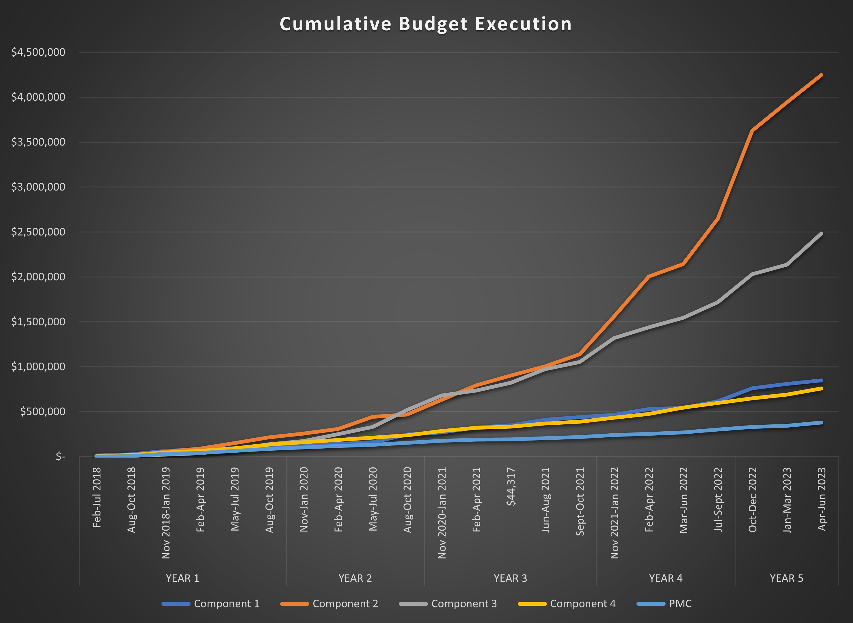
Figure No. 12. Cumulative Budget Execution
- Despite Covid-19 and its poor performance during the first 2 years, the project is cost-effective with an overall budget execution of 97% by June 2023. With the remaining 3% budgeted for the project closure with full execution by December 2023.
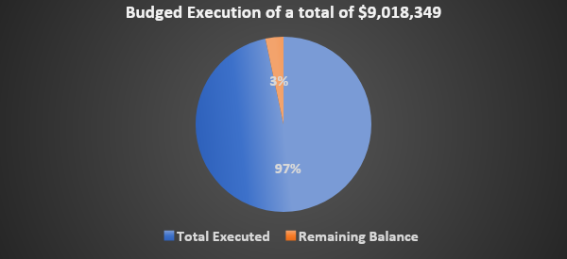
Figure No. 13. Total Budget Execution

Cofinancing:
- Of $51,277,908 U.S. in co-financing pledged, $29,801,594 U.S. (58%) was mobilized at the time of the MTR. An additional $ $24,150,630 U.S materialized by the end of year 5 for a total of $53,952,224 U.S

From Prodoc |  |  | AT MTR | AT TE
Sources of Co-financing | Name of Co-financier | Amount Anticipated Overall | Amount Contributed To Date | Amount Contributed To Date (B) | Balance
Regional Organization | CCAD | 10,665,000 | 4,266,000 | 11,265,500 | 600,500
Government | Ministry of Forestry, Fisheries, and Sustainable Development of Belize | 7,691,250 | 1,157,576 | 4,746,798 | -2,944,452
Government | Coastal Zone Management Authority and Institute of Belize (CZMAI) | 310,000 | 62,000 | 62,000 | -248,000
Government | National Commission for Natural Protected Areas of Mexico (CONANP) | 3,734,685 | 3,451,464 | 5,157,051 | 1,422,366
Government | Ministry of the Environment and Natural Resources of Guatemala | 4,000,348 | 709,492 | 4,007,860 | 7,512
Government | Secretary of Energy, Natural Resources, Environment and Mines of Honduras | 9,100,000 | 867,527 | 3,487,131 | -5,612,869
International NGO | Healthy Reefs Initiative | 740,000 | 0 | 0 | -740,000
International NGO | MAR Fund | 1,764,292 | 1,833,530 | 2,351,718 | 587,426
International NGO | Wetlands International | 160,500 | 0 | 0 | -160,500
International NGO | WWF-MAR | 2,000,000 | 0 | 2,115,535 | 115,535
International NGO | WWF-US | 1,137,540 | 0 | 207,991 | -929,549
National NGO | Fundacion Defensores de la Naturaleza | 2,154,294 | 312,505 | 1,626,631 | -527,663
National NGO | FUNDAECO | 5,670,000 | 0 | 155,500 | -5,514,500
Private Sector | The Coca-Cola Company | 2,150,000 | 0 | 0 | -2,150,000
Government | Secretaría de Ecología y Medio Ambiente - Chetumal, Quintana Roo, México | 0 | 16,405,911 | 16,405,911 | 16,405,911
International NGO | Asociación Mundial para el Agua (GWP) en Centroamérica - Honduras | 0 | 172,390 | 172,390 | 172,390
National NGO | SUSTENTUR | 0 | 310,000 | 763,584 | 763,584
National NGO | Amigos de Sian Ka’an, México | 0 | 253,199 | 1,211,012 | 1,211,012
National NGO | Asociacion de productores de azucar de Honduras(APAH) | 0 | 0 | 55,052 | 55,052
National NGO | Asociacion Industrial de palma aceitera de Honduras(AIPAH) | 0 | 0 | 21,358 | 21,358
National NGO | Asociación Centinelas del agua, México | 0 | 0 | 107,202 | 107,202
National NGO | Fundación Merendon (Honduras) | 0 | 0 | 32,000 | 32,000
Total |  | 51,277,908 | 29,801,594 | 53,952,224 | 2,674,316

Table 21: Cofinancing by source
- Co-financing valued at TE was $53,952,224 U.S. or 105% of the pledged amount at CEO endorsement.

Figure 14. Co-Financing at Terminal Evaluation

3.8. Knowledge Management Assessment
- The MAR2R Project, under GEF International Waters, relies on knowledge sharing for lasting impacts in conserving transboundary freshwater and marine resources. The results of knowledge management is rated highly satisfactory, as the project effectively achieved its objectives and successfully disseminated knowledge to diverse audiences.
- Even though a dedicated Knowledge Management (KM) section is not included in the Project Document (PRODOC), it is integral to Component 4. The Project developed and executed a Knowledge Management & Communications Strategy as part of the project’s strategy under Outcome 4.2 seeking that the advantages of the ridge to reef approach shared with local and international audiences, including the GEF IW:LEARN community. The component focused on knowledge sharing and knowledge management between the participating countries and partners to maximize the impacts achieved as well as for replication and scaling-up purposes. The project designed an information dissemination strategy under this outcome described further below.
- Monitoring via Project Progress Reports (PPRs), involving Monitoring and Evaluation Officer, MTWG, and ISNC, was key to this process. The Communication Strategy played a pivotal role in enhancing integrated ridge-to-reef management in the MAR ecoregion, engaging stakeholders, and sharing information. Effective communication was fundamental for project success.
- Components 2 and 3 worked with local stakeholders, covering agriculture, aquaculture, tourism, NGOs, and more, providing training and tools for resource management. Component 4 developed communication and knowledge products that were also shared via the CCAD-Regional Environment Observatory (REO) and used for seminars and webinars, such as the following:
- On best practices: https://www.sica.int/noticias/comparten-buenas-practicas-y-estandares-de-pesca-en-la-ecorregion-del-arrecife-mesoamericano_1_132104.html
- Strengthening livelihoods in Mexico via IWRM: https://www.sica.int/noticias/fortalecimiento-de-la-gestion-integral-del-recurso-hidrico-y-mejoramiento-de-los-medios-de-vida-comunitarios-en-la-cuenca-del-rio-hondo-mexico_1_131870.html
- Video Los Manglares: https://drive.google.com/drive/u/1/folders/11XnqD7fGM-ufPrH-70ygDh2oRfjIYV4c
- The project promoted knowledge at all levels, including government, local communities, NGOs, and international forums through IW-LEARN. MAR2R actively educated and trained 4,881 participants, 38% being women (1,870 women). Capacity-building grew as planned and with demonstration projects, reaching individuals from 34 countries around the world. Activities were both in-person (3,590 persons) and virtual (1,291 persons).

Systematizing experiences led to key findings

Capacity building is crucial for adopting and implementing integrated water management practices.
Capacity building is crucial for adopting and implementing integrated water management practices.
Geography matters: lower watershed zones demonstrate improved practices effectively.

Geography matters: lower watershed zones demonstrate improved practices effectively.

Website: 11,807 visits from 6,138 users since Feb 2021.
115 news items, 38 videos, and 29 bilingual infographics.
58 documents on diverse topics.
9,336 REO section visits from 3,897 users.

Knowledge management challenges

R2R concept integration is still nascent despite political and strategic alignment.
Communication products like infographics, videos, and publications were developed to bridge understanding across diverse audiences involved in MAR2R's work.
Figure 15: Knowledge Management Products

- MAR2R emphasized a communications approach in promoting the R2R concept practically. It crafted infographics and corresponding explanatory videos to simplify technical aspects. Abundant publications were shared. Knowledge management ensures project sustainability, with capacity and information continuing to be applied. The objective was to foster understanding and positivity around MAR2R's 5-year execution in the Mesoamerican Reef Ecoregion (MAR). This included socializing the "Ridge to Reef" approach, influencing political will, sharing best practices, and creating multimedia content. The knowledge management translated into learning through face-to-face encounters brought similar stakeholders together for B2B and thematic site-visits, discussions, and knowledge sharing. Participants interviewed during the TE site visits all stressed the importance of the combined approach. The TDA and SAP documents and results are also knowledge products. Dissemination of the MAR2R approach, the results of the TDA and the SAP should be a continuous endeavor not only by CCAD for future projects, but as a core activity for the participating ministries, NGOs, and academics. Mainstreaming these documents should be a core activity in future SAP implementation and associated IWRM and ICMM projects in the MAR.

- The strategy unfolded in four phases:

Preparation, involving branding, graphics, database surveys, and a communicator network.

Production of promotional materials like brochures and posters.

Creation of communication tools—documents, reports, social media, etc.

Specific actions showcased results, ensured accountability, and shared lessons learned until project closure.
Figure 14: Knowledge Management and Communication Strategy

- The strategy's four-phase approach, from preparation to specific actions, demonstrates a well-structured and organized approach to knowledge management. Moreover, the project's objectives, including fostering understanding and positivity around its approach and influencing regional agreements, were evidently met.
- The project successfully employed a comprehensive strategy that involved the creation of various materials, such as infographics, explanatory videos, publications, and communication tools, which were disseminated widely. These efforts aimed at promoting the "Ridge to Reef" approach, influencing political will, sharing best practices, and creating multimedia content for successful dissemination. Additionally, the inclusion of capacity-building activities, engagement with diverse audiences, and the development of practical materials like infographics and videos further contributed to the project's effectiveness in knowledge dissemination and management.

4. Conclusions, Recommendations & Lessons Learned

4.1. Conclusions

Relevance and Coherence
The MAR2R Project demonstrates strong coherence and relevance with International Waters concerns and aligns well with GEF-5 Focal Areas IW-1, IW-2, and IW-3. It fosters multi-state cooperation, addresses critical water-related issues, considers climate change, promotes sustainable transboundary water management, and emphasizes an ecosystem-based approach. The project effectively addresses transboundary pollution, contributes to sustainable water management, reduces conflicts, improves groundwater, rebuilds fisheries, supports coastal management, and promotes cooperation, aligning with regional and national policies. Survey results show strong agreement on the project's relevance to conservation and sustainable use of shared resources and alignment with national priorities, policies, and goals for environmental conservation.
Effectiveness
The implementation of the project was Highly Satisfactory. Regional policy instruments developed (7); national policy instruments developed (4); All countries (4) in the MAR endorsed the Transboundary Diagnostic Analysis and the Strategic Action Program; number of visitors consulting the Regional Environmental Observatory (3,897); 3,695 Stakeholders trained in IWRM; Strengthened public-private mechanisms to increase (USD) in funding available for public private mechanisms in BZ, GT and HN ($579,479); Stakeholders engaged to reach Voluntary Standards in sugar and palm oil (4); support to sanitary and improved production practices in coffee; and Number of tourism and tourism development sector actors adopting better management practices (BMP) to protect aquifers and freshwater critical habitats under project activities (36). The results of the project exceeded expectations.
Efficiency
The execution of the project was satisfactory. 98% of the outputs were produced on 97% of the budget. Regardless of COVID, the PMU maintained a flow of project activities. In response to slow performance, the principal partners took corrective action that increased the efficiency and overall delivery of the annual work plans. In terms of the time-to-delivery, there was no delegation of authority to the PMU to approve basic amounts of expenditures. SICA administrative approval procedures were in force and required SICA sign-off which created drags in delivery.
Results/ Impact
The Project was Highly Successful in producing the Results to Impact per GEF IW Core indicators by increasing the number of regional policy instruments that promote ridge to reef management of the MAR ecoregion approved due to project activities (7); increase in the area (ha) of watersheds under IWRM project activities (3,402,101 ha.); and the area of coastal and marine ecosystems under ICMM (323,600 ha.) and an endorsed Transboundary Diagnostic Analysis and Strategic Action Program.

Sustainability
Sustainability is “Moderately Likely.” Financial risks for future SAP implementation are related to commodity prices, difficulty in de-risking small and mid-sized producers, and credit availability. Socio-political risks are in distrust by stakeholders, difficulty in willingness to pay for environmental services. Institutional risks in frequent changes in leadership, nationalism, capacity to act on improved policies, and perverse incentives, and low capacity to adapt to changing circumstances. Environmental risks associated with climate change and no plans in place for ecosystem restoration following a catastrophic collapse. The CCAD has mandated the PMU to develop MAR2R Fase II and extend the Ridge to Reef concept to all SICA nations.
Adaptive Management
The project was highly successful in adaptive management. All parties (WWF, CCAD, and the PMU) realized personnel changes, adjusted the Results Framework, and increased the effectiveness of the M&E function. This brought the project back from a relatively slow start and from interruptions from COVID and post-COVID related interruptions in the value chain.
Equality and Gender Mainstreaming
CCAD had no prior established Equality and Gender mechanisms or safeguards. The project used the approved WWF-GEF Environment and Social Management Framework. Equality and Gender were effectively mainstreamed. Compliance with safeguards was not built into the process for approving demonstration projects, which subsequently took longer to approve. The sub-executing agencies for those projects had histories of mainstreaming gender and equality. Gender and Equality were mainstreamed into the budget and reporting process. However, approximately 70% of respondents indicated that men and women had equal access to project benefits.
Table 21: Conclusions

4.2. Recommendations

Finding 1: Effectiveness
Recommendations: Create a Monitoring and Evaluation section in the REO that tracks a scorecard on SAP progress. Use this as a basis for formulating new projects and setting targets for new projects. Systematize the SAP indicators including sustainability. The SAP is a Program and requires mid-term and long-term indicators that capture information from many future projects. Use process indicators to capture qualitative gains to capture resilience health and wellbeing of vulnerable populations that rely on transboundary environmental services | Responsible Entity  CCAD
Finding 2: Efficiency -The project was implemented efficiently but with time lags.
Recommendations Future processes can be streamlined through the establishment of CCAD Standard Operating Procedures for all aspects of project management (financial, M&E, safeguards, gender, etc.) to GEF & GCF standards. This could be done through a capacity development project in tandem with a MAR2r Fase II initiative or before. Take advantage of the GEF and WWF Policies and guidance and training materials available through GEF. Once established, establish the framework for delegation of authority for the fiduciary management of projects to CCAD. SICA can retain spot or annual auditing, etc. as a safety measure. At the onset of projects, develop a project manual that defines for all stakeholders the SOPs and project data and indicators in-force for each project and procedures to follow. | Responsible Entity  CCAD
Finding 3: Results to Impact
Recommendations: Expand the scope of the TOC. It needs to be further revised by CCAD to outline the future of the MAR region and to guide SAP implementation and the development of other future initiatives supporting the SAP. That process should incorporate step-changes and a transformational process and scaling out of effects, such as the results from demonstration projects to higher levels, scaling-up of effects through policies that create incentives or eliminate perverse incentives, and scaling-deep of changes in attitudes and reversing inappropriate production practices. Evaluators recommend that CCAD and focal points consult the GEF-STAP guidance on Transformation, Policy Coherence, and other new STAP resources. Work towards a transformational scaling of Global Environmental Benefits by expanding scaling out (replication, financing), scaling deep (advocacy for change, policy), and Scaling-up (policies enabling private sector, green infrastructure and eliminate perverse incentives). All new projects for SAP implementation would fit within a common expanded and directional TOC.  Consider increasing the capacity of national and municipal government agencies to promote and execute the SAP. This would require strategic communication and brokering diploma and study opportunities. There is now a Massive Online Course on Transboundary Freshwater Security available through the SDG Academy that can be promoted. Follow-on Projects could cover the small certification costs for key authorities and stakeholders as part of a capacity building process. | Responsible Entity  CCAD, National governments, bilateral and multi-lateral institutions.
Finding 4: Sustainability
Recommendations: Develop a MAR2R Fase II project that makes operational the Strategic Action Program (SAP). Update the NDCs of each nation to include strategic projects under the SAP. Increase communications on the benefits of MAR2R and hazards of poor wastewater. Seek alternatives to lack of financing institutions to support businesses to install water treatment and reuse systems.  Develop concept notes for all projects alluded to in the SAP and develop similar projects for the remaining SICA nations in support of CCADs mandate to extend the Ridge’to’Reef Concept. Consider a targeted capacity building project for CCAD and state and local governments to improve systems and capacity to support SAP implementation at much higher levels of financing and to execute multiple, large projects simultaneously through national partner organizations and through the promotion of public-private governance structures, such as the Alianza in San Pedro Sula.  For environmental sustainability, create restoration plans to respond to the risk of catastrophic collapses. Promote productive linkages for sustainability for each productive sector and connections with the new GEF-8 Integrated Programs and other fora, such as Mangrove Alliance, Coral Reef Alliance, Coffee roundtables, etc.  Sustainable financing is a Lever-of-Change for Transformational scaling. For financial sustainability, create a public-private financing roundtable to define actions for and expanded TOC supporting SAP implementation to scale global environmental benefits and to provide co-financing SAP aligned projects. This could be a SICA or CCAD hosted event at a COP or hosted by a third-party organization. Focus on raising awareness of the value of water to increase the “willingness to pay” for water provisioning services, wastewater treatment, ecosystem restoration, etc.  Continue the Private Sector Focus. Target financial sources for the strategic lines in the SAP and establish strategic partnerships. Consider a GEF Capacity Building Mid-sized project or work this into a MAR2R Fase II project. Work in establishing productive linkages with and for the private sector. Only 25% of sugar producers in Latin America are members of the sugar industries sustainability round table.  Consider institutionalizing the dialogue for Transboundary Water Management by creating a structure within SICA or CCAD with functions like that of UNECE and establishing principles for sound dialogue and resolution of water conflicts e.g., early warning, prior consent, etc. A Central American Water Commission or Authority or similar structure could address water issues and conflicts. Presently, these are simply relegated to CCAD without establishing the principles or rules for dialogue on transboundary water issues. Many of the elements of principles, e.g., right to timely consultation, free and full informed consent, etc. are present in global baseline transboundary projects.  Focus on policy coherence, identify policies with perverse incentives and develop plans to influence those policies. | Responsible Entity  CCAD, National Focal Points, support from INGOs
Finding 5: The Adaptive Management of the project was “highly effective”
Recommendations: An MAR2R Board is recommended. Rather than a project-specific PSC, CCAD is now in the position to define multiple projects. A board structure that guides the SAP process, and possibly all individual projects from different donors, might prove advantageous. It is further recommended to integrate Private Sector and Academic institutions into the board that can provide continuity through political changes. This would also be a critical structure in extending the MAR2R influence as recently mandated. Note: this type of structure is not a water commission as presented in the previous section. | Responsible Entity  SICA  CCAD
Equality and Mainstreaming
Finding 6: Gender and Equality were effectively mainstreamed into the project. Systematize within CCAD
Recommendations: For SAP implementation, the process can be further mainstreamed by developing a CCAD Environment and Social Management Framework (ESMF) applicable to all future projects and GEF compliant that can be applied during the development phase of all new projects and help to streamline project and sub-grant delivery, monitoring and evaluation. | Responsible Entity  CCAD
Table 23: Recommendations

4.3. Lessons Learned Clave
- In the context of the MAR2R project, several valuable lessons emerged, shedding light on crucial aspects to consider in future international waters initiatives. These lessons, drawn from the project's experiences, provide important insights:
- Governance's Central Role: Effective project governance was paramount to MAR2R's eventual success. In contrast to the early phase of the Project, collaborative engagement between MAR country government representatives and the implementation team, characterized by transparent communication, was foundational to the Project outcome. The key takeaway is that sound project governance is indispensable for solving problems, changing direction and achieving predetermined objectives outcomes, and outputs.
- Bridging Terrestrial and Coastal-Marine Zones: MAR2R made significant progress in Integrated Water Resources Management (IWRM) and Integrated Coastal Management and Marine (ICMM) planning in priority watersheds and coastal-marine zones. However, seamless integration of these planning spheres and processes proved challenging. The lesson underscores the need for sustained efforts in realizing the ridge-to-reef approach, necessitating policy integration and the active involvement of stakeholders from both land and sea.
- Leveraging Regional Governance: A notable strength of MAR2R was its execution by a regional governance body within CCAD, enabling the approval of regional policies and agreements with the support of regional governments. This experience illustrates the significance of enhancing the depth of the execution capacity of regional organizations like CCAD, which can facilitate political agreements on shared resources and regional policy instrument implementation.
- Empowering Partners: The success of MAR2R was closely tied to the capabilities of local organizations engaged in various thematic areas. The assumption of their complete operational and technical proficiency can lead to design errors and suboptimal solutions. Therefore, investing in strengthening their operational processes and technical knowledge is imperative. This reinforces the importance of technical and operational capacity building in GEF projects.
- Acknowledging Capacity Gaps: It is erroneous to presume that organizations engaged in environmental work possess comprehensive capabilities. This highlights the need to bolster technical knowledge in areas such as safeguards, reporting, communication skills, administration among others. In the MAR2R context, capacity and knowledge gaps led to delays in the execution of sub-grants. The lesson is that capacity gaps should be viewed as opportunities for partner capacity enhancement.
- Collaborative Relationships: Successful GEF projects hinge on harmonious relationships between Implementing and Executing Agencies. Mutual respect and collaboration are essential, especially when unforeseen challenges threaten project outcomes. The lesson is clear: the implementing agency should provide guidance, coaching, and unwavering support to the executing agency, prioritizing the achievement of planned outcomes. The executing agency should likewise be forthcoming about their internal gaps and include provisions for internal technical assistance in the annual work planning process.
- Engaging with the Private Sector: MAR2R demonstrated the feasibility of collaboration with private sector entities, provided the project refrained from assuming responsibilities that fall within the voluntary domain of the companies. The project's experience with Belize shrimp companies during the COVID-19 pandemic underscores the role of projects in facilitating environmental and profit improvements while respecting corporate responsibility boundaries.

5. ANNEXES

Annex 5.1: TOR of Terminal Evaluation (without annexes)
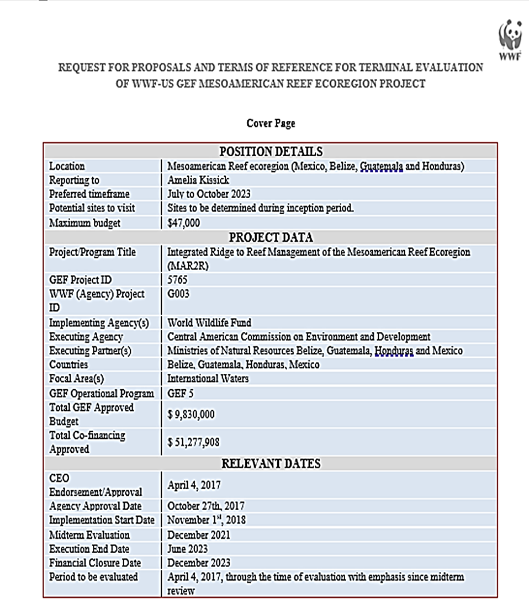

INTRODUCTION and Project overview

World Wildlife Fund, Inc. (WWF) policies and procedures for all GEF financed full and medium-sized projects require a terminal evaluation (TE) upon completion of project implementation. The following terms of reference (TOR) set out the expectations for the TE for the project “Integrated Ridge to Reef Management of the Mesoamerican Reef Ecoregion (MAR2R)” hereafter referred to as the “Project”. The technical consultant selected to conduct this evaluation will be referred to as “evaluator” throughout this TOR.

The Project seeks to support regional collaboration for integrated ridge to reef management of the MAR ecoregion by demonstrating its advantages and improving regional, national, and local capacities for integrated management and governance of its freshwater, coastal, and marine resources. The project has four interrelated components designed to scale up existing baseline programs to address key threats and barriers to the integrated management and conservation of the MAR::

- Strengthen resource governance and regional collaboration for integrated ridge to reef management.
- Integrated ridge to reef management of watersheds and freshwater resources.
- Integrated ridge to reef management of coastal and marine resources; and
- Project monitoring and evaluation, and knowledge sharing.

See the WWF GEF project website for additional details and project documents.
SCOPE AND Objectives for the evaluation
WWF is seeking an independent consultant to undertake a Terminal Evaluation of the Project. The scope of the TE will cover the GEF financed components.
The objectives of this evaluation are to examine the extent, magnitude and sustainability of any project impacts to date; identify concerns as well as best practices; assess progress towards project outcomes and outputs; and draw lessons learned that can both improve the sustainability of benefits from this project and aid in the enhancement of future related projects. The evaluator is expected to frame the evaluation effort using the seven (7) core criteria of relevance, coherence, effectiveness, efficiency, results/impact, sustainability and adaptive capacity. Emphasis will be placed on effectiveness, efficiency, results/impact and sustainability. Definitions of each of these criteria will be provided as well as summary table templates and a report outline (See annexes A - C).
Evaluation approach and method
The evaluation will adhere to the guidance, rules and procedures established by WWF and the GEF Terminal Evaluation and Ethical Guidelines. The evaluation must provide evidence‐based information that is independent, participatory, transparent, and ethical. The evaluator(s) must be unbiased and free of any conflicts of interest with the project. The evaluator(s) is expected to reflect all stakeholder views and follow a participatory, inclusive and consultative approach. There should be close engagement with WWF GEF Implementing Agency (IA), government counterparts, the GEF operational focal points in each country, CCAD as the Executing Agency (EA) / project management unit (PMU), partners and key stakeholders. Contact information will be provided.
The Evaluation process will include the following, with deliverables marked by “*”:
- Inception meeting with WWF, CCAD, and Project Steering Committee to gather input from select project stakeholders on evaluation approach, to agree on methodology, and to inform the inception report;
- Desk review including, but not limited to:
  - Project Document and CEO Endorsement Letter;
  - Project governance documents (agreements between WWF-US and CCAD, CCAD and executing partners, etc.)
  - Midterm Review Report;
  - Relevant safeguards documents, including WWF GEF Agency Categorization and Compliance memo, Environmental and Social Management Framework, Process Framework, Grievance Redress Mechanism, sub-project safeguards screens, if applicable;
  - Gender-responsive approaches used in the project, as applicable;
  - Annual Work Plan and Budget (AWP&B) documents;
  - Project Progress Reports (PPR) including Results Framework and AWP Tracking;
  - Project Closure Report (PCR) (if available);
  - GEF Agency reports, including Project Implementation Reports (PIRs) and Supervision Mission Reports;
  - GEF IW Tracking Tools
  - Relevant financial documents, including financial progress reports; co-financing monitoring tables and letters, and audits;
  - Meeting minutes (Project Steering Committee (PSC)) and relevant virtual meetings with the WWF- GEF AMU and support team; and
  - Other relevant documents provided by the Executing Agency and partners.
- Inception report* that outlines evaluation methodology, including how ratings/findings will be assessed (indicators to be used, key questions, etc.);
- Site visits to be determined, but may be across the four project countries;
- Interviews, discussions and consultations with executing partners, GEF Operational Focal Points (OFP), Project Steering Committee (PSC) members, beneficiaries, WWF-GEF Agency and support team; Project Management Unit, and others;
- Debrief and presentation* of initial findings to select project stakeholders (e.g. the EA, PMU, PSC and GEF Agency) for feedback and final data collection. Feedback log requested to record responses to comments received;
- Draft report* not to exceed 50 pages (excluding annexes) shared with GEF AMU, PMU and PSC for review and approval. Draft report shall include both a tracked changes and clean version of the report and should be presented in both English and Spanish. Additionally, this package will include all data collected in a shared drive. A sample outline will be provided; and

- Final TE report* (50 page limit excluding annexes) that has addressed any inaccuracies, responded to requests for additional means of verification and taken into consideration any feedback. Report should be in both English and Spanish. Final report package shall include a tracked changes and clean version of the report and should annex a feedback log showing actions taken/responses to all reviewer comments.
Expected Content of Evaluation Report
The Terminal Evaluation report should include:
- Information on the evaluation process, including when the evaluation took place, sites visited, participants, key questions, summary of methodology and rating rubric, and feedback log showing how comments on draft were incorporated;
- Assessment of Relevance (project design , theory of change) and Coherence;
- Assessment of project Results Framework plus rating of project objective and outcomes (individual and overall);
- Assessment of Effectiveness and ratings of Implementation and Execution;
- Assessment and rating of Risks to the Sustainability of project outcomes;
- Assessment and rating of Monitoring and Evaluation Design and Implementation;
- Assessment of knowledge management approach, including activities and products;
- Assessment of replication and catalytic effects of the project;
- Assessment of stakeholder engagement and gender-responsive measures;
- Assessment of any environmental and social impacts and safeguards used for the project. A review of risk category classification and mitigation measures;
- Assessment of Efficiency, financial management and summary of co-financing delivered;
- Summary table of key findings by core criteria and GEF ratings, including justification and/or indicators for their determination;
- Key lessons tied to identified strengths, best practices or issues;
  - Conclusions and recommendations that would be useful for project close and sustainability, and for other similar projects in order to improve on identified issues, replicate best practices or achieve better results.
Evaluation Team Qualifications
Required Qualifications and Experience
- Minimum 10 years of relevant professional experience (e.g. leading evaluations)
- Noted experience with evaluation methodologies
- Excellent written and oral communication in English and Spanish
Preferred Qualifications and Experience
- Experience with GEF financed projects and knowledge of GEF Monitoring and Evaluation;
- Experience with participatory evaluation, social assessments, and both quantitative and qualitative evaluation methods;
- Experience in the region and familiarity with intergovernmental organizations, particularly CCAD / SICA.
- Technical knowledge related to the project (e.g. integrated watershed management, International Waters GEF Focal Area, etc.);
- Familiarity with Conservation Standards or WWF Project and Programme Management Standards, including emphasis on theory of change;
- Knowledge and experience implementing or reviewing application of social and environmental safeguards policies in GEF (or similar) projects; and
- Fluent in written and spoken English and Spanish.
Payment modalities and specifications
Payment, expense reimbursement, and other contractual terms and conditions will be outlined in the consultant agreement made between WWF and the evaluator(s). Payments will be made following submitted and approved deliverables. Twenty-five percent of payment will correspond with completion and approval of the Inception Report. Fifty percent of the payment will correspond with submission and approval of the debrief presentation and the Draft Report. The final twenty-five percent will be delivered with the submission and approval of the Final Report.
Application process
Interested consultants are invited to submit a technical and financial proposal in English with their curriculum vitae, a relevant writing sample and three professional references. The financial proposal should include fees and reimbursable expenses, such as travel costs, if applicable. The budget shall not exceed $47,000. Individual or team applications are welcome. Applicants are requested to apply by sending their applications to amelia.kissick@wwfus.org by March 24th, 2023.
The selection of candidates and contractual agreements will be in compliance with WWF procurement policies and subject to GEF requirements. In addition to accounting for financial proposals, references and writing sample, a selection committee will rate technical proposals based on quality of the proposal, understanding of the terms of reference and meeting required and desired qualifications. Women and members of social minorities are encouraged to apply.

Annex. 5.2: Field visit itinerary (including photographs)
MAR2R Mission Itinerary & Agenda
Tuesday, August 15th
09:09 am Depart SDQ-PY Copa Airlines CM 267
10:43 am Arrive in Panama

12:24 pm Depart PY-CUN Copa Airlines CM 270
03.08 pm Arrive in Cancun

03:30 pm Meet Mario Escobedo in the Airport (TBD) +503-7844-9997
04:00 pm Hotel Adhara

Wednesday, August 16th
AM CONANP (Comisión Nacional de Areas Naturales Protegidas México): Meeting with Focal Point & Steering Committee Fernando Orozco and Christian Alva
PM Centinelas del Agua, Oficina Quintana Roo: Meeting with Alejandro Lopez Tamayo, Director General
Dinner Gonzalo Merediz, Presidente del Consejo de Cuenca de la Península de Yucatán

Thursday, August 17th
AM Depart with Mario Escobedo and Christian Alva to Chetumal
PM Visit to Centro Ecologico Akumal (https://ceakumal.org)
Arrive at HOTEL: Fiesta Inn Chetumal

Friday, August 18th
AM Rio Hondo Watershed field visit - Meet Amigos de Sian Kan, Christian Alva
PM Return to Cancun. Hotel Adhara

Saturday, August 19th (Travel to Belize)
14:00 Depart CUN FBO Terminal (next to terminal 3)-BZE Tropic Air 9N6611
14:30 Arrive BZE P.S.W. Goldson Intl. (Belize City)
15:00 Go to Hotel: Golden Bay Belize Hotel

Sunday, August 20th – Paperwork
Monday, August 21st
AM Meet Edgar Ek at the Hotel to go to New River Watershed, Belize
PM Meet Jorge Garza at the Hotel, Belize.

Tuesday, August 22nd
Meeting in Belmopan, BZ with:
      - Kenrick Williams, CEO. Ministry of Sustainable Development, Climate Change and Risk Management Belize. MAR2R Bz Manager
      - Nayari Diaz, PACT. Execuctive Director
      - Tenielle Williams, CEO. National Hydrology Service, Belize
      - Carlos Moreno, Punto Focal CCAD
      - Edgar Ek. Focal point to MTWG/Steering Committee
      - Wilber Sabido, CEO. Forestry Department. Ministry of Sustainable Development, Climate Change and Risk Management Belize.
      - Jorge Garza

Wednesday, August 23rd
AM Meeting with Arlene Jones and Chantalle Clarke Samuels, Coastal Zone Management Authority and Institute – BZ
PM Meeting with Jorge Garza at the Hotel

Thursday, August 24th (Travel to San Pedro Sula)

7:00 am Depart Belize (terminal 10)- STP Tropic Air Limited 9N2200
8:00 am Arrives San Pedro Sula (Ramon V. Morales Intl)
9:00 am Go to Hotel: Villa Sarela and meet Ricardo Calles
Visit the Project “Gestión integral del recurso hídrico en la subcuenca del río Manchaguala para la reducción de amenazas a la Ecorregión del MAR”. Meet Graciela Martínez y Jonas Madrid, Fundación Merendon

Friday, August 25th
Meeting at: Alianza para la Seguridad Hídrica de San Pedro Sula/ Centro de Producción Más Limpia de Honduras
Saturday, August 26th (Travel SPS-PY-SDQ)
13:52 Depart San Pedro Sula, (Ramon V. Morales Intl) -PY Copa Airlines CM 287
17:03 Arrives in Panama City, (Tocumen Intl)
18:20 Depart PY to SDQ Copa Airlines CM 107
21.49 Arrives in SDQ

Annex 5.3: Geo-referenced maps

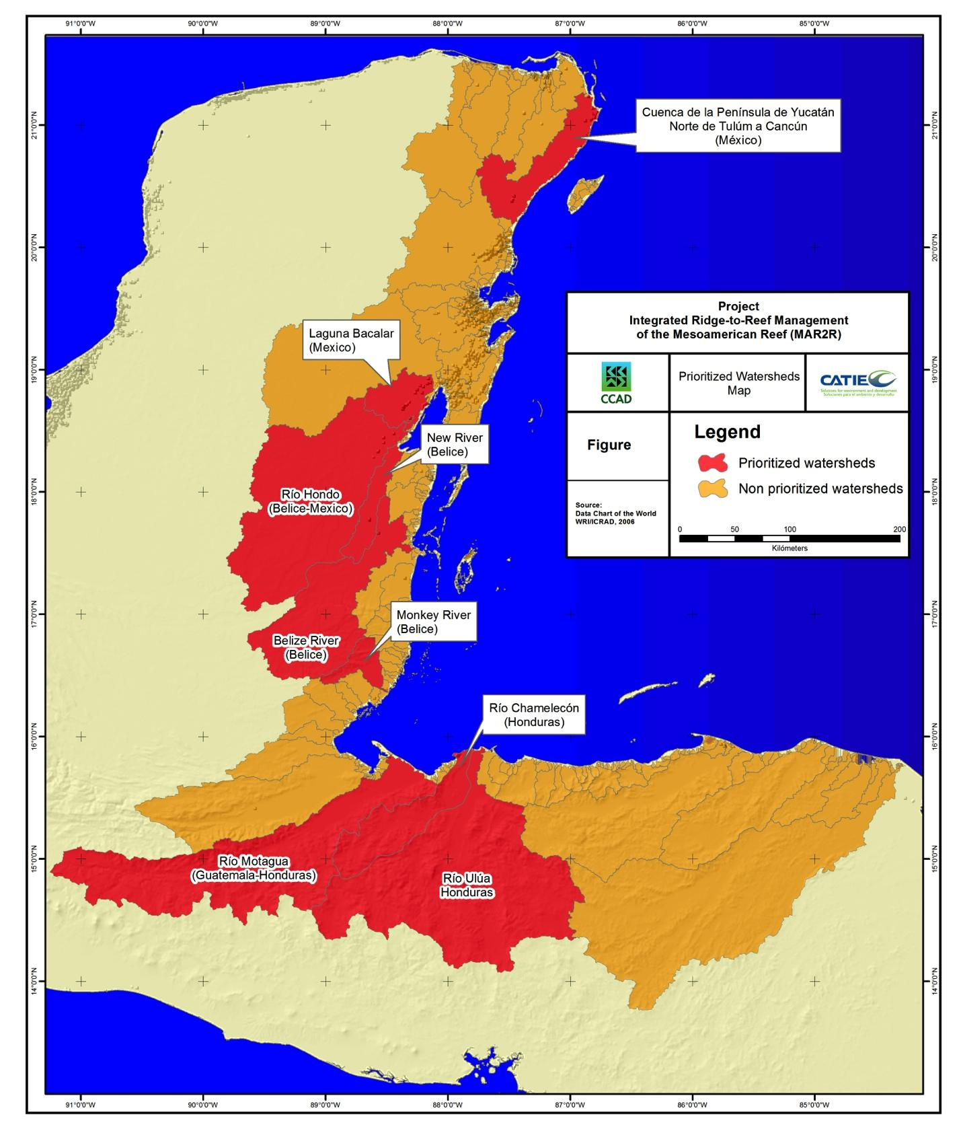
Figure 1: Priority Watersheds for the MAR2R Project Map
*The map was prepared for the project’s purposes depicting the ecoregion’s watersheds and other key features and is not representative of political boundaries between the countries.

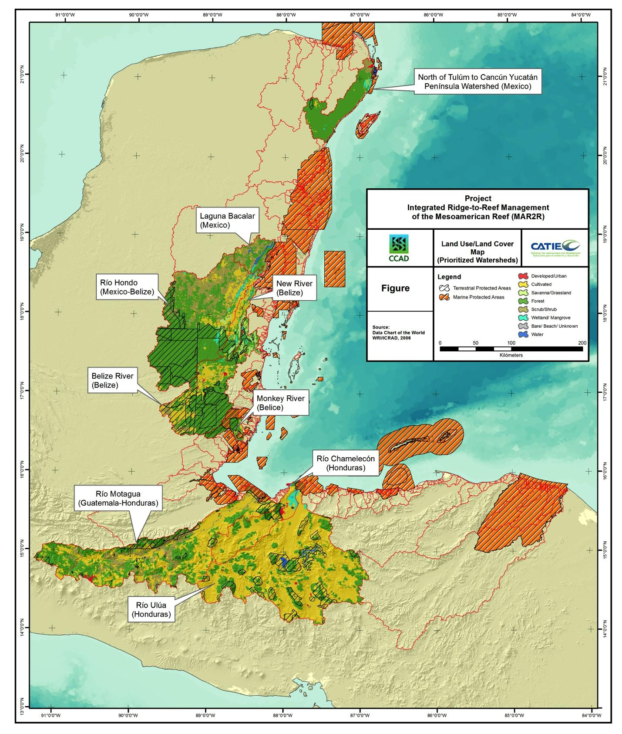
Figure 2: Land Cover in priority watersheds and marine and terrestrial Protected Area Map
*The map was prepared for the project’s purposes depicting the ecoregion’s watersheds and other key features and is not representative of political boundaries between the countries.

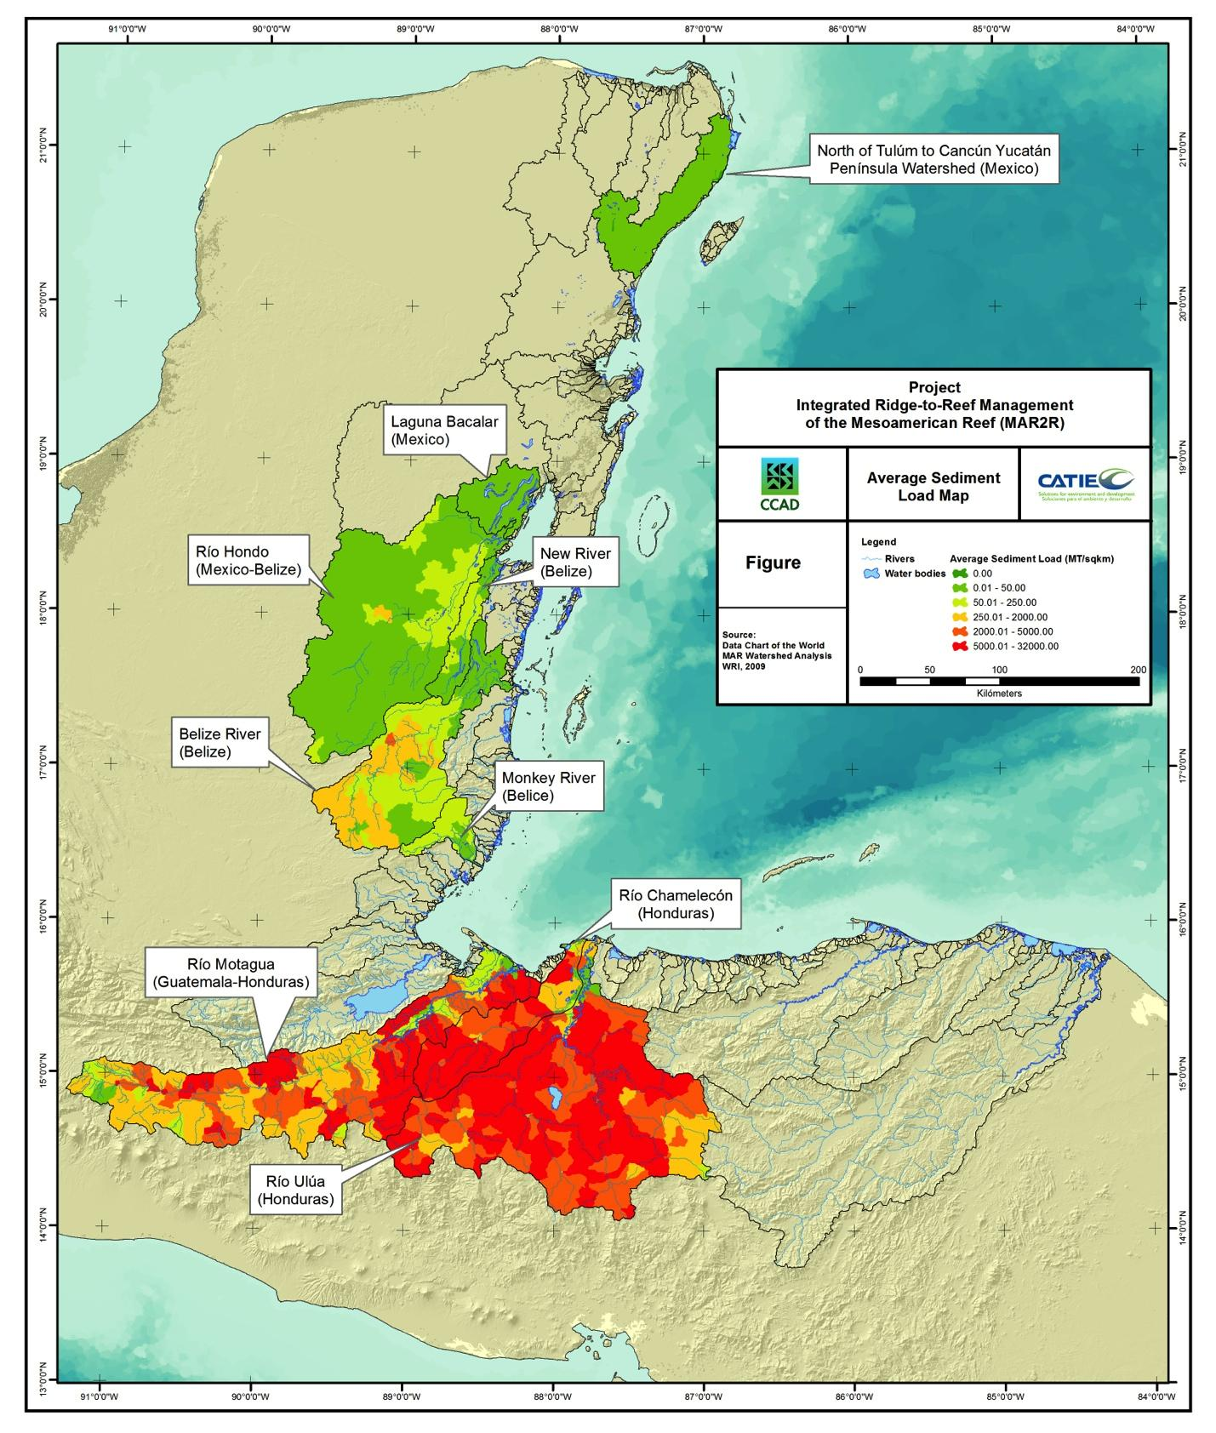
Figure 3 Average Sediment load in prioritized watersheds in the MAR Region Map
*The map was prepared for the project’s purposes depicting the ecoregion’s watersheds and other key features and is not representative of political boundaries between the countries.
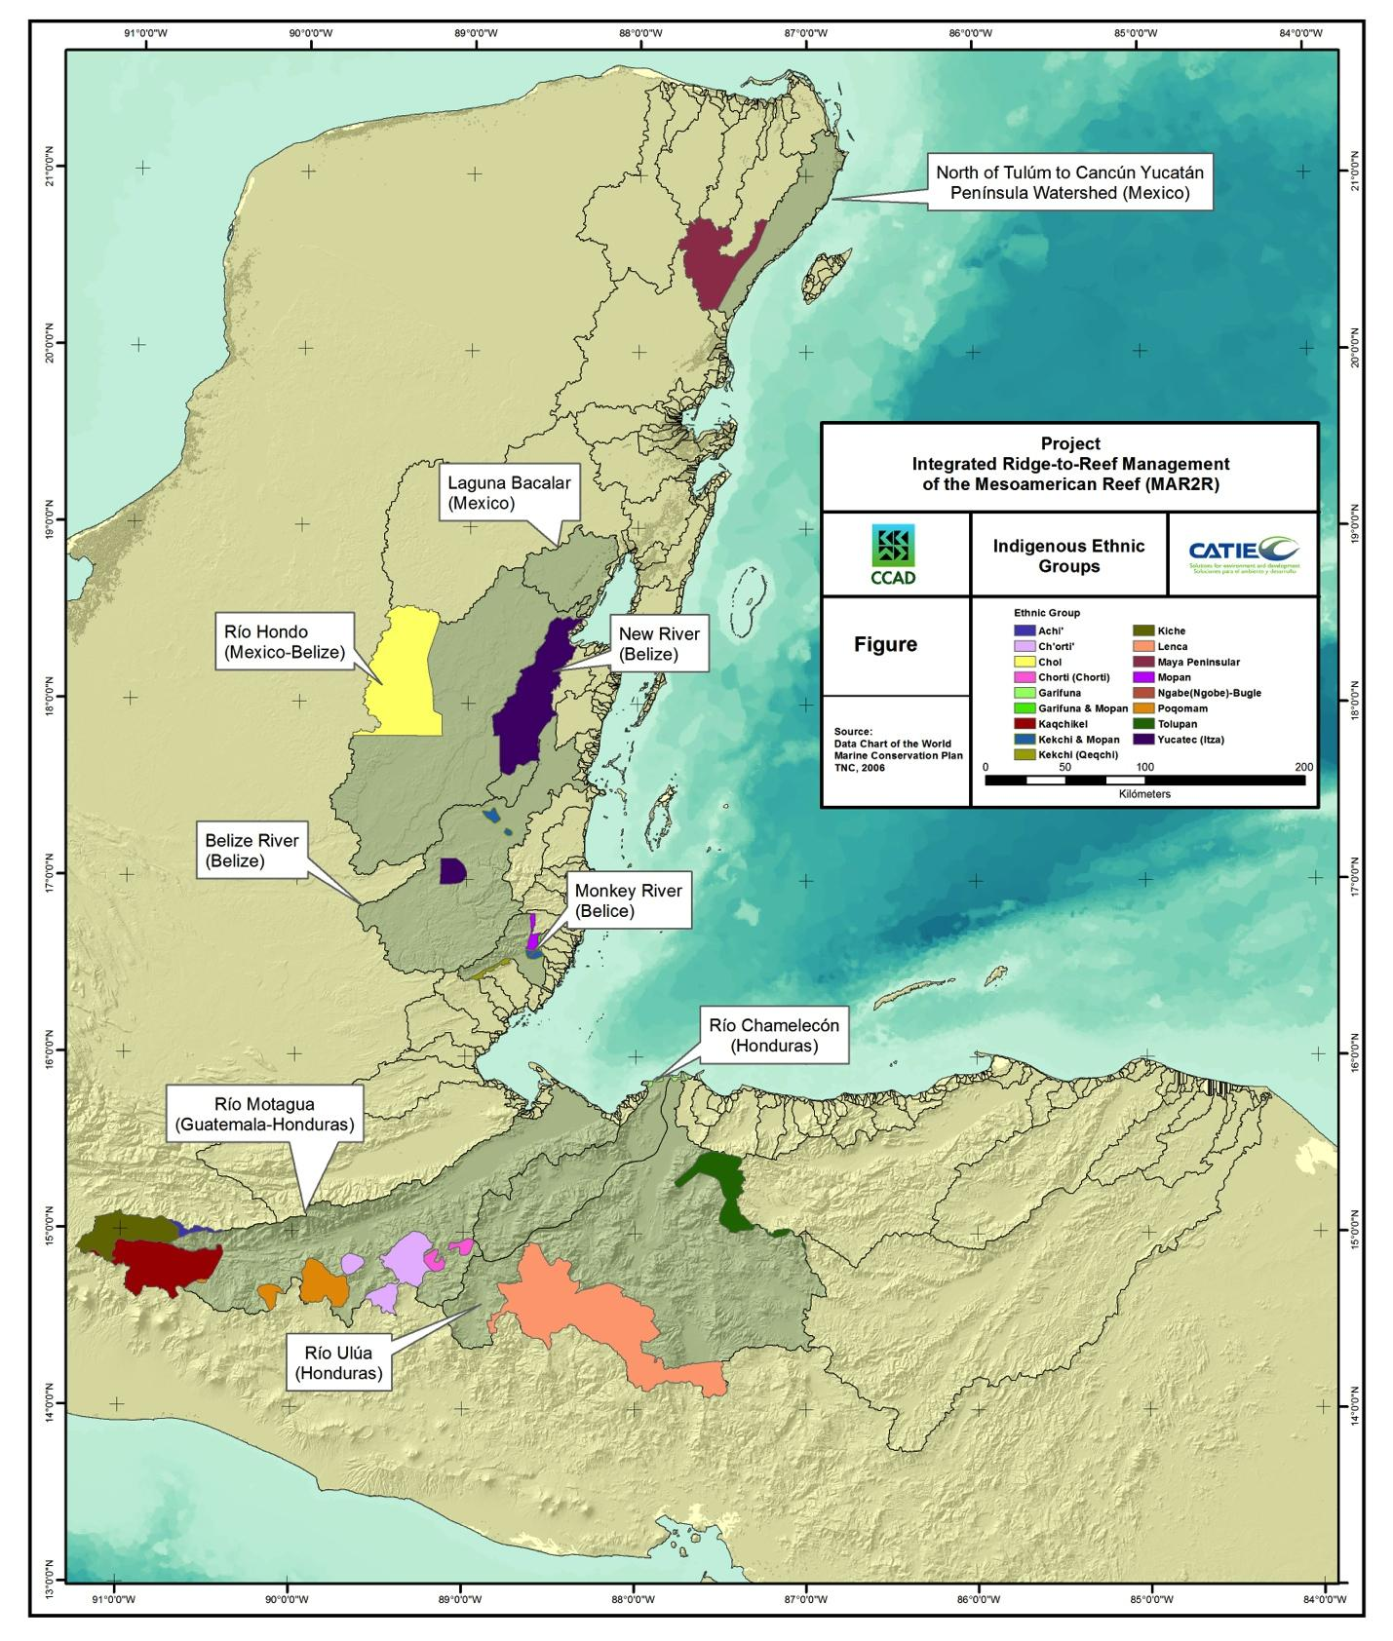
Figure 4: Indigenous Ethnic Groups in prioritized watersheds in the MAR Region Map
*The map was prepared for the project’s purposes depicting the ecoregion’s watersheds and other key features and is not representative of political boundaries between the countries.

Annex 5.4: List of Persons Interviewed

Name | Rol/Organization
Alejandro Lopez Tamayo | Centinelas del Agua, MX
Alvin Henderson | Belize Shrimp Growers Association
Arlene Jones | Coastal Zone Management Authority and Institute, BZ
Bryan Nino | Alianza para la Seguridad Hídrica de San Pedro Sula/Centro de Producción Mas Limpia de Honduras
Carlos Moreno | Punto Focal CCAD
Carlos Rodriguez Olivet | PMU-ICM Specialist/Safeguards Specialist
Chantale Clarke Samuels | Coastal Zone Management Authority and Institute, BZ
Claudia Ruiz | RRA SAM, MARFUND
Cristian Alva | CONANP. Mexico
Daniel Ayes | Alianza para la Seguridad Hídrica de San Pedro Sula/Centro de Producción Mas Limpia de Honduras
Edgar Ek | Department of Environment, Ministry of Sustainable Development, Climate Change, Risk Management Belize and Focal Point to MTWG/Steering Committee – BZ
Enriqueta Ramirez | PMU – M&E, KM, Gender Support
Eris Portella | Alianza para la Seguridad Hídrica de San Pedro Sula/Centro de Producción Mas Limpia de Honduras
Evalyn Mateo | Fundacion Defensores de la Naturaleza, GT. Especialista Salvaguardas
Fabiola Tabora | GWP
Fernando Orozco | Comision Nacional de Areas Naturales Protegidas Mexico. CONANP, Focal Point to MTWG/Steering Committee, MX
Gabriela Alfaro | Universidad del Valle de Guatemala
Genoveva Martinez | Mission Lead, Implementing Agency/WWF-GEF
Gerardo Guillen | Asociación de Productores de Azúcar de Honduras
Gonzalo Merediz | Amigos de Sian Ka’an/Consejo de cuenca de la Peninsula de Yucatán, MX
Graciela Martinez | Fundacion Merendon
Heather McIntosh | Belice Caribbean Shrimp Company
Hector Castro | Asociación Industrial de Productores de Aceite de Honduras
Ingrid Arias | Enlace Tecnico Directora de Desarrollo Institucional, FUNDAECO
Isabel Filiberto | WWF GEF Project Support at WWF-US
Jair Urriola Quiroz | Executive Secretary CCAD, Project Steering Committee-CCAD
Javier Marquez | Director, Defensores de la Naturaleza, GT
Jonas Madrid | Alianza para la Seguridad Hídrica de San Pedro Sula/Fundacion Merendon
Jorge Garza | PMU-M&E Officer
Jorge Fernandez | Ministerio Ambiente y Recursos Naturales, GT; Focal Point to MTWG/Steering Committee, GT
Jose Infante | OSPESCA, Executive Director
Jose Ricardo Calles | PMU-IWR Specialist
Julio Lazo | PMU-F&A Manager
Julio Lemus Godoy | DIPESCA MAGA Guatemala. Director. Ministerio de Agricultura
Kenrick Williams | CEO. Ministry of Sustainable Development, Climate Change and Risk Management Belize. MAR2R Bz Manager
Maria Jose Gonzalez | MARFUND
Marielos Villatoro | Asociación de Productores de Azúcar de Honduras
Mario Escobedo | PMU Director
Mauricio Mejia | WWF Guatemala/Mesoamérica Agriculture Officer
Milton Solis | Fundacion Defensores de la Naturaleza, GT. Coord. Proyecto Demostrativo
Nayari Diaz | PACT. Executive Director
Regina Sanchez | Ministerio Ambiente y Recursos Naturales, GT
Ricardo Sierra | Asociación de Productores de Azúcar de Honduras
Rocio Moreno | Amigos de Sian Ka’an/MX
Rosa Loreto | Amigos de Sian Ka’an/MX
Sandy Pereira | Secretaria de Recursos Naturales y Ambiente. Focal Point to MTWG/Steering Committee, HN
Skarlet Pineda | Direccion de Biodiversidad, Honduras
Stacey Alpuche | Department of Environment, Ministry of Sustainable Development, Climate Change and Risk Management Belize. MAR2R Bz Manager
Tenielle Williams | CEO. National Hydrology Service, Belize
Thalia Coria | SUSTENTUR
Vicente Ferreyra | SUSTENTUR
Wilber Sabido | CEO. Forestry Department. Ministry of Sustainable Development, Climate Change and Risk Management Belize
Anonymous | 6 Interviewees requested anonymity

Annex 5.5: List of Documents Reviewed

Project Document and CEO Endorsement
Project Inception Documents
Results Framework
Technical PPR Reports
Committee Meeting Minutes
GEF Core Indicators Tracking Tool
Financial and Co-financing Reports
Audit Reports
Attendance List for Meetings, Workshops, and Training
List of Parallel Projects Contributing to Project Objectives
List and Maps of Project Sites
Safeguard Reports
Annual Work Plans
Communication and Knowledge Products
Monitoring Strategy
Deliverables

Annex 5.6: Evaluation Questions/ Matrix

Final Evaluation Matrix
(evaluation criteria with key questions, indicators, sources of information, and methodology)
Integrated Ridge to Reef Management of the Mesoamerican Reef Ecoregion (MAR2R)

Key questions | Indicators | Sources |  | Methodology
Relevance: To what extent do the design, outcomes, indicators, and goals of the Project remain valid and consistent with development priorities and local and national organizational policies, including the context of changing country circumstances (e.g., political context)?
Was the project strategy relevant to international and national priorities and policies?
Were the project's objectives and outcomes consistent with the focal areas and strategies of the GEF Operational Programs? | The contribution of impact results to the objectives of the GEF-5 International Waters focal area. | - GEF-5 International Waters focal area indicators  - Results of the Progress toward Impact Analysis  - Project Monitoring and Evaluation (M&E) documents and Project Implementation Reports (PIRs) |  | - Desk review  - Evaluation of Impact Results and their contribution to GEF-5 Indicators
How have the impacts of the Project contributed to the priorities of each country and their national objectives in International Waters? Have the necessary capacities been developed to better contribute to their regional agendas? | Contribution of the Project's results to each country's national priorities and capacities. | - CEO endorsement documents, National Communications to the UNCCD, NDC, and analysis of national capacities in International Waters.  - Interviews with key informants, the GEF Focal Point, and sector representatives (REDD+, IOs) |  | - Desk review  - Validation of alignment between impacts related to Nationally Determined Contributions (NDC), International Waters, and ministerial (governmental) priorities.
How have the Project's impacts contributed to the Central American Commission for Environment and Development (CCAD) Regional Environmental Framework Strategy 2021-2025 and OSPESCA's policy for regional fisheries management? how have they aligned with the strategic action plans (SAPs) developed by the Caribbean and Northwest Atlantic Large Marine Ecosystem (CLME+) Project, the Gulf of Honduras projects, and with both the previous WWF-MAR Conservation Strategic Planning for 2010-2015 and the current strategy? How have they intersected with the Regional Strategy for Integrated Water Resources Management and the Central American Plan for Comprehensive Water Resources Management)? | Alignment and agreement between the Results and the Strategies. | - Presentations at regional meetings  - Mid-Term Review (MTR), Project Implementation Reports (PIR) |  | - Desk review  - Interviews
How do the demonstration projects relate to the identified causes and barriers? | Evidence of the relationship in project documents | - Key informants  - PRODOC  - PPRs, PIRs |  | - Desk review  - Interviews
How has the project strengthened alignment and built capacity for International Waters (IW) and National Environmental Agencies (AE) to align with their priorities and promote their International Waters (IW) agendas? | Contribution of project results to national priorities and the presence of national analytical documents incorporated into the PRODOC analysis section that are included in this analysis. | - CEO Endorsement documents, National Communications to the UNCCD, NDC.  - Interviews with implementing agency authorities and executing agency representatives. |  | - Desk review.  - Interviews with key individuals, research, information triangulation.
Relevance: Did the Project's Theory of Change adequately address the causal pathways for long-term impacts?
Were the issues addressed by the project the right ones? | Presence/absence of unforeseen, unidentified, or ignored issues that influenced the project's theory and project impacts | - Interviews with project authorities and/or stakeholders involved in project design.  - Project Documents (CEO Endorsement).  - Review documents and STAP responses |  | - Desk review  - Comparative analysis of Progress to Impact vs. Theory of Change
Did the project's impacts validate the Theory of Change? | Presence/absence of alternative strategies towards desired impacts.  Key individuals to validate the results vs. the Theory of Change. | - Interviews |  | - Alignment between the project's problems, goal(s), and project results
Were the set of project objectives sufficient to address the problem? | Indicators of progress towards impact by outcome. | - CEO Endorsement documents  - Mid-Term Evaluation Report  - PIRs, PPRs  - Interviews with key individuals |  | - Analyze the linkage between the Project's impacts and the project objectives.
Is the project architecture (results, products, indicators) aligned with the project's Theory of Change (ToC)? | Degree of integrity between the project's internal logic and the Theory of Change (ToC). | - Approved project document by the GEF, Results Framework  - Modified Results Framework  - Focus Group Discussions (FGD) with project authorities  - Interviews with key individuals |  | - Desk review  - Alignment of evidence between the Theory of Change (ToC) and the results, products, and indicators in the logical framework
Relevance: Did the project strategy produce the expected results/impacts?
Were the assumptions (implicit and explicit) evaluated correctly? | Number of validated hypotheses  Presence/absence of unforeseen assumptions | - PRODOC  - PIRs  - Focus groups with project officials |  | - Desk Review  - Triangulation between approved project documents and progress toward impact.
Does the Project's strategy reflect a thorough identification of environmental and social risks? Are there adequate mitigation measures in place? | ESMF | - PRODOC  - ESMF  - Focus groups with Executing Agency (EA) and Implementing Agency (IA) officials. |  | - Desk review  - Compare the risk assessment at the time of the final evaluation with the risk assessments at the beginning and in the annual reports.
What opportunities or relationships were established in the Project with interventions such as the GEF/IDB/UNEP Regional Fund for Wastewater Management in the Caribbean (CReW), the GEF's Caribbean and North Brazil Shelf Large Marine Ecosystem (CLME+) Project, or any other mentioned in the project document? | The number of partnerships that supported the project.  New partnerships developed during implementation. | - CEO endorsement documents  - Interviews |  | - Analysis of the effects of the proposed partnerships for the project and the actual partnerships at the time of the Final Evaluation.
Do the results developed during project formulation still represent the best strategy for achieving the project objectives? | - Acceptance of the project strategy by key stakeholders. | - Interviews with key informants |  | - Analyze the degree of acceptance of the strategy among different stakeholder groups.
¿ What was the progress of the project towards the expected impacts? Has the project enabled or enhanced regional collaboration for integrated watershed management in the transboundary MAR ecoregion? Has the project improved local capacities for integrated management and governance of their freshwater, coastal, and marine resources? | - Number of regional policy instruments promoting watershed-to-reef management in the MAR ecoregion approved as a result of project activities. | - PIR  - Technical reports  - Policy instrument documents |  | - Technical assessment  - Interviews with CCAD and the PMU
 | - Area (ha) of watershed areas under Integrated Water Resources Management (IWRM) activities | - GIS analysis, contractor reports, project records |  | Analysis of the presence or absence of operational elements.  Interview with an Integrated Water Resources Management (IWRM) specialist.
 | Surface area (ha) of coastal and marine ecosystems under Integrated Coastal and Marine Resources Management (ICMM) project activities. | - GIS analysis, contractor reports, project records |  | - ICMM Specialist Interview
Coherence
The compatibility of a project intervention with other interventions (particularly policies) in a country, sector, or institution. This can include internal coherence and external coherence. Internal coherence addresses the synergies and interrelationships between project interventions and those carried out by the same sector or institution in the country. External coherence measures the consistency and compatibility of interventions across different sectors but within the same context.
To what extent is the project aligned with other interventions in the same focal area? | Alignment of the project with other interventions.. | - PRODOC  - Strategies, actors, and national/local institutions involved in the same area.  - Greater Caribbean and beyond the region | - Desk review  - Interviews
Do the Project's interventions provide added value and complement/coordinate with interventions from other sectors in the same context? | - Partnerships and associations established.  - Additional project impact not listed. | - Local and national government, institutional actors.  - Progress reports, PIRs (Project Implementation Reports).  - Steering Committee minutes. | - Desk review  - Interviews
Effectiveness
The extent to which the project's products, results, and objectives have been achieved or are likely to be achieved, taking into account their relative importance. Identify the main factors that have facilitated or hindered this achievement. Review the project's management structure and determine whether the project's organizational structure, resources, allocation of responsibilities, and coordination mechanisms were appropriate for achieving progress towards the project's results.
Effectiveness: Was the project design appropriate for achieving the expected results?
Do the countries have the necessary conditions to enable integrated management of the Mesoamerican Reef System (MAR) with a "ridge to reef" approach? | - At least 2 regional policy instruments developed. | - Policy instrument documents. |  | - Presence or absence of policy instrument documents.  - Interviews with CCAD, PMU.  - Field visits.
Have the national policy frameworks for R2R in MAR (IWRM and ICMM) been strengthened [in relation to components 2 and 3]? | At least 2 national policy instruments developed per country | Policy instrument documents. |  | - Presence or absence of policy instrument documents.  - Interviews with PMU specialists, Intersectoral National Committee (ISNC), Integrated Water Resources Management (IWRM), and Integrated Coastal and Marine Resources Management (ICMM).
Does the MAR have an ADT and a Strategic Action Plan (SAP) that will guide the ecoregional "From Ridge to Reef" (R2R) management? | All (4) MAR countries supporting the ADT and SAP.  Evidence of the scientific basis of the TDA | - Current transboundary diagnostic analysis (TDA) analysis  - Current or draft Strategic Action Plan (SAP).  - Endorsement/support from Ministries of Environment approving the TDA.  - Cover letters or approval documents for SAP submission to the Ministry of Environment.  - Key individuals |  | - Review the Transboundary Diagnostic Analysis (TDA) and supporting documents.  - Review the Strategic Action Plan (SAP).  - Presence or absence of endorsement letters and submission letters.  - Interviews.
Is MAR's strategic planning, policy formulation, management, and monitoring supported by reliable up-to-date information accessed through REO? | REO (Regional Environmental Observatory) in a full year. | - Website of the Regional Environmental Observatory.  - PIRs, PPRs |  | - Verification of information in the REO.  - Interview with the REO specialist.
Has IWRM increased in priority watersheds? | Number of stakeholders trained in IWRM through project activities (at least 350 men and 350 women).  Evidence of training that produces IWRM outcomes. | Attendance lists for workshops (including at least name, gender, organization, title, email, country). |  | - Review of attendance lists.  - Interviews with IWRM Specialist.  - Online survey of stakeholders.  - Field visits.
Are public-private mechanisms for integrated watershed management strengthened and supported by stakeholders? | Increase (USD) of at least $175,000 in available funds for public-private mechanisms in BZ, GT, and HN. | - Letters of promised contributions or receipts for paid contributions.  - PIRs |  | - Accounting of the promised or paid amount in USD.  - Interviews with IWRM Specialist.  - Online survey of stakeholders.
How involved are stakeholders in IWRM in priority watersheds? | Percentage of sugar (BONSUCRO) and oil palm (RSPO) producers in the project area who are achieving and/or maintaining compliance with Voluntary Standards. | - BONSUCRO website listing certified producers.  - RSPO certified, RSPO website listing certified producers. |  | - Interviews with producers and IWRM specialists.  - Online survey.  - Documentation review.
 | Number of tourism sector actors and tourism development actors adopting best management practices (BMP) to protect aquifers and critical freshwater habitats as part of project activities. | - Baseline developed by the contractor or consultant before technical assistance.  - Contractor and progress reports after technical assistance. |  | - Interviews with contractors and IWRM specialists.  - Documentation review.
Is ICMM strengthened through capacity development and strategic planning? | Number of stakeholders trained in ICMM through project activities, broken down by gender. | - Attendance lists for training workshops. |  | - Document review (attendance list).  Online survey.
How committed are the stakeholders involved in ICMM in the prioritized marine coastal areas? | Number of shrimp farms and fisheries in the project area that are achieving and/or maintaining compliance with Voluntary Standards (Marine Stewardship Council - MSC and Aquaculture Stewardship Council - ASC). | - Certificates for voluntary standards, ASC website records listing certified producers.  - FIP Action Plan and Comparative Assessment and Tracking Tool. |  | - Document review (certificates, website, action plans, tracking tool).  - Interviews (shrimp farms, fisheries, ICMM Specialist).  - Online survey.  - Field visits.
Does the project's monitoring and evaluation system employ inclusive and participatory methods throughout the project's life? | Number of MAR2R progress reports completed (including midterm and final evaluations and the GEF IW tracking tool). | - Evaluation report documents: PPR, MTR, tracking tool. |  | - Desk review  - Interviews
Are the advantages of the watershed-to-reef approach shared with local and international audiences, including the GEF IW:LEARN community (funded with at least 1% of the project budget)? | Number of communication and knowledge management products disseminated. | - Website statistics  - Social media statistics  - Publications produced  - Videos/animations produced  - Webinars organized  - Attendance lists for organized workshops  - Presentations given at the IW conference. |  | - Desk review  - Interviews  - Online survey
Regarding the definition of the Theory of Change, how were gender factors and inclusive participation (youth, elderly, disabled, indigenous communities, minorities, etc.) considered? | • Levels of gender-based data breakdown recorded.  • Degree to which the Program invested in specialized technical assistance in these areas. | - PRODOC  - Progress reports (submitted to donors).AWPs  - Key Informants |  | Analysis of documents, interviews with project staff.
Does the project budget include funding for gender-relevant results, products, and activities? | Amount of money allocated to gender-relevant results, products, and activities. | Prodoc budget; AWP; Substantial review. |  | Document review and semi-structured interviews.
Does the project budget include funding for results, products, and activities with inclusive participation and safeguards-related activities? | . Amount of money allocated to gender-relevant results, products, and activities. | Prodoc budget; AWP; Substantial review. |  | Document review and semi-structured interviews.
Were gender and safeguards specialists consulted or contracted during the project preparation phase? During implementation? | Number of meetings; Number of workshops | Interviews with key actors |  | Desk review and interviews
Are the results consistent and reflective of the theory of change that the Program aims to contribute to? | Adequacy in the description of the different components of the results framework and appropriate hierarchy among them. | Prodoc |  | Document review and semi-structured interviews.
Are the indicators SMART? Are the goals for mid-term implementation and the final ones measurable? | Degree of measurable goals | Results framework; Monitoring and Evaluation matrix; |  | Desk review
Are the results and product indicators well-designed to support their monitoring? Are they measurable? | Degree to which the indicators can be considered SMART | Results framework; Monitoring and Evaluation matrix;. |  | Desk review
How would you assess the project's organizational structure in terms of its effectiveness in achieving the desired results? | Level of compliance with the structure | Key informants |  | Interviews  Survey
Do you consider that the resources allocated to the project were adequate in terms of personnel, financing, and equipment? | Fluctuations in the analysis of financial reports. | Key informants  Financial reports |  | Interviews  Analysis of accounting movements over the course of the project's implementation period
What was your experience regarding the distribution of responsibilities within the project? Were tasks and roles clearly assigned? | Level of satisfaction | Key informants |  | Interviews  Survey
How were coordination mechanisms established among the different teams and stakeholders involved in the project? | Level of satisfaction | Key informants |  | Interviews  Surveys
Were efficient communication and collaboration strategies implemented between the different levels of project management and execution? | Level of knowledge about the project among the actors. | Key informants, Technical Reports, Evidence of communication mechanisms. |  | Interviews  Surveys  Desk review
What recommendations or improvements would you suggest strengthening the project management structure in future similar initiatives? | Satisfaction level | Key informants |  | Interviews and survey
Progress in achieving results: What is the degree of compliance with the expected results and objectives?
Have the products been achieved according to expectations? | Reported progress level in the GEF monitoring instruments | GEF Tracking Tool; PIR; Progress Reports (PPRs). |  | Desk review  Document review and semi-structured interviews.
Have the end-of-project objectives been achieved as expected? | Reported progress level in the GEF monitoring instruments | GEF Tracking Tool; PIR; Progress Reports (PPRs). |  | Desk review  Document review and semi-structured interviews.
What have been the main obstacles, as well as the facilitating factors that have limited and/or improved the achievement of the expected results? | Extent to which external factors/risks were considered in defining the lines of work. | Safeguards of the stakeholder engagement plan; Prodoc; AWP (Annual Work Plan); PPRs (Progress Reports); PIRs (Project Implementation Reports). |  | Desk review  Document review and semi-structured interviews.
To what extent has the project ensured compliance with safeguard provisions, particularly those related to involuntary resettlement and the rights and concerns of indigenous communities? | Evidence of implemented measures. | Reports  Key informants |  | Desk review  Document review and semi-structured interviews.
Is the partner strategy suitable, effective, and viable for achieving the products? | • Effective level of co-financing.  • Percentage of results achieved. | Safeguards of the stakeholder engagement plan; Prodoc; AWP (Annual Work Plan); PPRs (Progress Reports). |  | Desk review  Document review and semi-structured interviews.
Efficiency
The extent to which results have been achieved with the least costly resources possible. This includes efficiency in fund availability, project management and human resources, coordination, and information flow among project partners.
Did the project utilize the least-cost options? If not, did they choose the most cost-efficient options available? | Efficiency of budget execution and its relationship with product/results indicators.  Budget deviations.  Timeline of cash disbursements. | • Project framework.  • Financial progress reports.  • Annual work plans. | • Desk review  • Budget execution assessment  • Interviews
Did implementation delays affect profitability? | Analysis of the achievement of results in relation to budgeted amounts.  Comparison between effectiveness and efficiency in execution.  Compliance with established deadlines.  Changes in the timeline of the work plan. | Financial reports.  • PRODOC (Project Document).  • Work plans.  • Progress reports.  • Results framework. | • Analysis of incurred costs and the time required to achieve results.  • Document review.  • Interviews.
Project Execution and Adaptive Management: Has the project been implemented efficiently, cost-effectively, and adapted to changing conditions? To what extent do monitoring and evaluation systems, information, and communication contribute to its execution?
¿Se aplicaron adecuadamente los recursos humanos, técnicos y financieros disponibles para el logro de las actividades y productos? Y en este sentido, ¿se respetaron los tiempos y montos previstos? | • Level of budget execution in relation to what was programmed, in proportion to the activities carried out.  • Extent to which substantive reviews have applied the criterion of optimizing investments/funds allocation.  • National counterpart funds are disbursed in a timely manner as stipulated in the Project Annual Work Plan  • Level at which implementing partners actively participate in the planning of committed activities. | • PRODOC (Project Document)  • Progress Reports  •AWP (Annual Work Plan)  • Financial Reports  • Substantive Reviews  • Key Informants |  | - Desk Review  - Semi-structured interviews with key informants
Has there been effective coordination among the different actors in the project implementation? What have been their specific roles and responsibilities? | Existence of a stakeholder engagement strategy;  Involvement of other actors in the Project Steering Committee. | Review of the PRODOC (Project Document) and minutes of the Project Steering Committee meetings. |  | • Desk review  • Semi-structured interviews with beneficiaries and government representatives.  • Online survey.
Has there been duplication of efforts between the MAR2R interventions and those carried out by other projects? | Perception of the actors involved regarding the level of efficiency in relation to the different projects. | Minutes of the Project Steering Committee meetings. Interviews with beneficiaries. |  | • Desk review  • Semi-structured interviews with beneficiaries and government representatives.  • Online survey.
What is the analysis of the capacity and institutional arrangements for project implementation? | Capacity of the executing entity and national counterparts to implement the project. | - PRODOC  PPRs  AWPs  Reports generated for financial tracking.  - • Substantive reviews.  - • Informants. |  | Documentary analysis, interviews with beneficiaries, and government representatives.
Has the technical assistance provided by WWF through human resources (offices, external consultants) been sufficient and of the necessary quality to meet the execution commitments? | • Level of turnover/substitution of staff in WWF country offices.  • Favorable/unfavorable perception of national partners regarding the roles played by WWF experts and contracted consultants. | PRODOC (Project Document)  Progress Reports, PIR (Project Progress Report)  AWP (Annual Work Plan)  Financial Monitoring Reports  Substantive Reviews  Informants |  | Documentary Analysis; Interviews with Beneficiaries and Government Representatives; Online Survey.
Was the co-financing received as planned? | Level of co-finance | Prodoc, PIRs |  | Desk review & interviews
To what extent has the context generated by COVID-19 affected the project's execution in terms of planned activities? | • Unforeseen additional project impacts.  • Planned and current timeframes. | • PIRs, PPRs  • Project Team  • Monitoring and Evaluation Reports  • Financial Reports/Budget Execution. |  | - Desk review  - Interviews and survey
Were measures taken to mitigate the risk posed by COVID-19 in project implementation? | • Decisions made due to the COVID-19 pandemic.  • Existence of a COVID-19 mitigation plan. | - PIRs, PPRs  - Project Team  - Monitoring and Evaluation Reports  - Financial Reports/Budget Execution. |  | - Desk review  Interviews and survey
Results/Impact
The scope of the expected or unexpected effects that the project's interventions or strategies will have on the project's goal, conservation objectives, and Global Environmental Benefits (GEBs), whether positive or negative. Assess the project's logic or theory of change and the potential to expand or replicate the project's results and impacts.
Is it likely that the expected results and impacts at the impact level will be achieved? Are they likely to be at a scale sufficient to generate the expected Global Environmental Benefits? | Achieved results.  Project indicators and objectives.  Project impact. | - PRODOC  - PPRs and PIRs  - Theory of Change | - Desk review  - Interviews  - Field visits
Is it likely that the results will contribute to achieving the project's goal? | Achieved results.  Project indicators and objectives. | - PRODOC  - PPRs and PIRs  - Theory of Change | - Desk review  - Interviews  - Field visits
To what extent has the project achieved its stated vision and goals in terms of results that generate positive changes in biodiversity quality, ecosystem services, and, if relevant, human well-being? | Achieved results.  Project indicators and objectives. | • PRODOC  • PPRs and PIRs  • Theory of Change | - Desk review  - Interviews  - Field visits  - Survey
Were there any unexpected results/impacts (either positive or negative)? | Additional results/impacts not anticipated in the project's results framework. | - PRODOC  • PPRs  • PIRs  - Websites, social media | - Desk review  - Interviews  - Field visits  - Survey
Sustainability
The likely capacity of an intervention to continue providing benefits, progress, and impact after external support ends. Determine the degree of national and local support and acceptance given to the project.
To what extent are there financial, institutional, socio-economic, and/or environmental risks to the long-term sustainability of the project's results?
What are the trends beyond the project's control that influence the products (including opportunities and risks affecting the achievement of the products)? | Degree of inclusion of these trends in the analysis of environmental and social risks. | Prodoc and Project safeguards documentation |  | Desk review and interviews
To what extent can it be asserted that the adoption of the program at the regional and national levels can ensure the continuity of the services achieved in the field of watershed management with the program's support? | • Strategic Action Plan (SAP)  • National Legislation/Regulations. | National Plans with clear evidence of an emphasis on watershed management.  - National Legislation/Regulations.  - Key Informants |  | Desk review, interviews, survey.
What external factors could have a high or moderate probability of undoing or undermining the future sustainability of the project's positive impacts? | Risks to the sustainability of the activities. |  |  | Desk review, interviews, survey.
To what extent do the project's benefits depend on unsustainable political, financial, or technical resources? | • Local level of investments.  • National partners' perception of short and medium-term financing gaps. |  |  | Desk review, interviews, survey.
Do the relevant actors have the necessary political, financial, and technical capacity to ensure that the project's benefits are sustained? | Existence of necessary mechanisms for accountability, transparency, and the transfer of technical knowledge. | Legal frameworks  • Public policies  • Exit strategy  • Key informants |  | Document analysis, interviews with government representatives and beneficiaries, surveys.
To what extent do the project results depend on changing sociopolitical factors? | • Changes in national and local governments that could affect project results.  • Modifications to public policy agendas. | Legal frameworks  • Public policies  • Exit strategy  • Key informants |  | Document analysis, interviews with government representatives and beneficiaries, surveys.
Are there environmental and social risks that could undermine the future flow of project impacts and Global Environmental Benefits, including potential armed conflicts or other sociopolitical challenges? | - Environmental risks to the sustainability of the activities. | - Project Team  - Local, national, and regional institutions.  Interviewed stakeholders. |  | Desk review, interviews, survey
Is the project adequately anticipating and taking measures to ensure resilience against these external factors? | - Identification of key risks.  - Planning. | - PRODOC  - Risk analysis and document management.  - Project Team.  - WWF/GEF representatives |  | Desk review, interviews, survey
Are the project benefits scalable? | - Scaling (Policy)  - Expansion (Replicability) (Financial)  - Deepening (Water Culture) | Status of the Strategic Action Plan (SAP).  • Conceptual notes for future projects.  • National investment plans, policies supporting SAP priorities.  • Status of the watershed governance structure and process.  • Key interviews, especially in Watershed Councils. |  | Desk review, interviews
Adaptation Capacity
To what extent is monitoring and evaluation (M&E), lessons learned, and adaptive management used to achieve indicator objectives and mitigate project issues (such as design flaws or any adverse project impacts)?
Did the team utilize lessons from best practices in other conservation/development experiences and consider these experiences in the project design? | . Integration of lessons/best practices from other experiences into the project design. | - ADT Documentation  - SAP  - Training Records  - Interviews with key individuals | Document analysis, semi-structured interviews  Analyze the adoption and coverage of ADT/SAP training  Test the incorporation of lessons from IWLEARN sources, other GEF projects.
To what extent is monitoring information, including risk assessment, being properly recorded, disseminated, and used to inform future plans? | Effectiveness and frequency of use of monitoring tools.  Dissemination mechanisms. | - M&E reports  - M&E actors | Desk review and interviews
Did the project establish a baseline reference for conservation objectives and key contextual factors? Is there ongoing systematic monitoring of these? | - Progress indicators.  - Baseline | - PPRs, PIRs  - PRODOC  - Project Results Framework | Desk review and interviews.
Is there ongoing, systematic, and rigorous monitoring of results delivery, achievement of outcomes, and impact measurement, with plausible attribution to WWF's actions? | • Effectiveness and frequency of use of monitoring tools.  • Achieved results.  • Effects of project interventions. | ● M&E reports  ● M&E actors | Desk review and interviews
To what extent are lessons documented and shared in a way that promotes learning by the project management team and key stakeholders? | • Documentation and management of lessons.  • Dissemination mechanisms.  • Level of awareness among key stakeholders. | - Key informants  - Survey results  - Reports  Knowledge products & communications | - Desk review  - Interviews  Survey
What are the lessons learned from the project, the failures/opportunities, and losses to date? What could have been done better or differently? | Leassons learned identified to date. | - Key informants  - Survey results  - Reports  - Knowledge products & communications | - Desk review  - Interviews  - Survey
Safeguards
Were social and environmental safeguards adequately considered in the design and implementation? | WWF & GEF safeguards reports. | - PRODOC  - WWF Environmental and Social Safeguards Compliance Report.  - Key informants | - Desk review  - Interviews
To what extent are stakeholders, including the Project Management Unit (PMU), aware of the existence and accessibility of the grievance mechanism? Additionally, how effectively has the PMU addressed complaints and managed issues throughout the project implementation? | Presence or absence | - Published grievance mechanism.  - Interviews with key actors | - Interviews  - Internet research
Were there any additional adverse or unforeseen environmental or social impacts, and were mitigation measures taken to address them? | • WWF and GEF safeguards.  • Key environmental or social risks.  • Additional unmentioned environmental or social impacts/risks. | - PRODOC  - WWF Environmental and Social Safeguards Compliance Report.  - Key actors | - Desk review  - Interviews  - Survey
Gender Equity
To what extent were gender issues addressed in the project design? Could you provide information on how gender-related concerns were addressed within the PMU during project implementation? Specifically, was a gender specialist designated, or was gender considered a shared responsibility among team members? | - Gender Strategy | - PRODOC  - Key informants | - Desk Review  - Interviews  - Survey
How has the project incorporated monitoring mechanisms to ensure the effective integration of gender perspective and social inclusion? | Information about specific indicators or metrics used to assess progress in these areas would be helpful. | - Project reports  - PRODOC  - Project members | Desk review  Interviews
How has the project contributed to improving the status and position of women? | Gender strategy  • Participatory planning by women.  • Gender progress indicators.  • Opinions on the improvement of women's status | - PRODOC  - Gender experts  - PIRs  - PSC minutes | Desk review  • Interviews  Survey
Are financial resources/project activities explicitly allocated to enable women to benefit from project interventions? | • Actors and roles chart.  • Participatory planning by women.  • Percentage of funds allocated for women's participation. | - PRODOC  - Manuales de la Organización  - Documentos presupuestarios  - Minutas del Comité Directivo | Desk review  Interviews  Survey
How did the gender results of the project advance or contribute to the Integrated Water Resources Management (IWRM) outcomes and the Gender-Responsive Approach (GRA) outcomes of the project? | - Gender indicators  - Progress gender indicators | - PRODOC  - Project Results Framework  - Theory of Change  - M&E reports | Desk review  Interviews  Survey

Annex 5.7: Questionnaire used

Information Gathering Tool No. 1
Interview Guide

Proyecto: “Manejo Integrado de la Cuenca al Arrecife en la Ecorregión del Arrecife Mesoamericano (MAR2R)”- GEF ID 5765

Semi-Structured Interview Guide for Stakeholders (interviews with government partners, NGOs, civil society, private sector, communities)

The following form is configured with questions derived from the Pre-Assessment Matrix for each interview and focus group. Thus, the questions vary by groups of actors. The following form serves as an illustration of this process
Date
Name
Organization
Position
Country
Project Role

Introduction:

- Thank the interviewee/participant for their willingness to participate in the interview.
- Briefly introduce yourself.
- Provide a brief overview of the main objective of the evaluation and how we will collect information.
- Ask if the participant/interviewee has any specific questions or concerns before starting the interview.
- Emphasize that all collected information will be strictly confidential and non-traceable.
- Inquire if the interviewee prefers to remain anonymous.
- Ask if the interviewee consents to recording the conversation; Make it clear that recording will be done solely to capture information accurately – If the interviewee is not comfortable with recording, it will not be done.

Part I: General Information

Please briefly explain your organization's work and its relationship with the Integrated Ridge to Reef Management of the Mesoamerican Reef Ecoregion (MAR2R).
Note: It is important to know exactly who we are speaking with here: Are you a government representative directly involved in the project's implementation? A representative from another project collaborating with MAR2R? A member of an NGO? Depending on the nature of the collaboration, the questions should be adapted to make them more specific.
Important Information:
- How long have you been involved in the project?
- What type of relationship do you have with the project?
- Is there any evidence of this relationship, such as a memorandum of understanding or agreement?
Part II: Relevance and Coherence
- Do you consider that the project was well designed when establishing its four components? (Strengthening resource governance and regional collaboration for integrated ridge-to-reef management in the Mesoamerican Reef Ecoregion; Integrated management of watersheds and freshwater resources; Integrated management of coastal and marine resources; Project monitoring and evaluation and knowledge exchange). Please explain.
- Did you or anyone from your unit/organization participate in the project formulation process? Please describe the process (not applicable to some stakeholders or actors).
- Do you believe that the project has considered possible externalities (environmental, economic, social, or political) in the project's design?
- How have the project's impacts contributed to Mexico's country priorities and the national objectives of International Waters (IW)? Has the country developed capabilities to promote its program? What about Guatemala, Honduras, and Belize?
- What control and mitigation measures were implemented to address potential risks during the project, and what is the assessment of residual risk? How does this residual risk relate to the planning of a second phase and the long-term sustainability of the project?
- The following risks were identified at the beginning of the project. Do you believe that all of these were possible risks? Have new risks emerged?
- Low capacity or interest from the regional government to engage in regional and cross-border collaboration for integrated ridge-to-reef management in the MAR by the four participating countries.
- Low national capacity or interest to engage in integrated ridge-to-reef management in the MAR in the four participating countries.
- Inability to sign, ratify, or reach agreements between countries.
- Political tension between Guatemala and Belize affecting collaboration.
- Capacity built is lost due to high turnover of personnel in the public sector.
- Limited participation of private sector stakeholders in the integrated management of the MAR ridge-to-reef and the adoption of voluntary practices.
- The increasing frequency of extreme weather events, rising sea levels, and ocean acidification can lead to harmful socio-economic and environmental impacts.
- In your opinion, do the results framework or the budget include relevant gender and environmental and social safeguards products and activities? Please provide details.
- Did the project effectively track and accommodate changing safeguard needs as the project progressed? How were these changing needs absorbed within the capacity of the PMU and the allocated budget?
- Do you believe that the results and product indicators are well designed? Are they measurable?
- Do you think the project has generated or can generate beneficial effects for the country's development or could catalyze them in the future? (e.g., contribute to the conservation and sustainable use of shared freshwater, coastal, and marine resources in the transboundary MAR ecoregion through the implementation of the ridge-to-reef approach, thereby ensuring sustainable economic benefits and livelihoods for countries and their communities)?
- What is your perspective on whether the project's theory of change remains relevant? Provide information on any aspects you believe could be reviewed or updated to enhance project effectiveness and results.
- Did the Opportunities and Linkages (GEF and non-GEF interventions) established in the PRODOC support the achieved results? For example: the GEF/UNDP Honduras AMP Project, the Caribbean Regional Fund for Wastewater Management (CReW) of the GEF/IDB/UNEP, the Management and Protection of Key Biodiversity Areas in Belize Project, the GEF/UNDP Guatemala Coastal-Marine Project in the Pacific (specifically regarding integrated coastal management policy instruments), and the Large Marine Ecosystem (LME) AMF Project of the Greater Caribbean.
- How did the Project contributed to strengthen the alignment and capacities for the Implementing Agency and the Executing Agency to agree with their priorities and promote their IW agendas?

Part III: Effectiveness and Efficiency
- To what extent does the Project support your organization in achieving its results? Please explain briefly.
- Have the project's objectives for each result or product been achieved? What do you believe is working exceptionally well and why?
- What do you believe have been the main obstacles and facilitating factors in achieving results? Please explain.
- Has the project managed to have an adequate strategy for stakeholders? Please explain.
- Has the project allowed or improved regional collaboration for integrated ridge-to-reef management in the transboundary MAR ecoregion?
- How do you evaluate regional and international cooperation and knowledge management at the national, regional, and international levels? Could you provide some recommendations for improvement?
- How committed are the actors involved in Integrated Coastal Marine Resource Management in the prioritized marine coastal areas?
- How committed are the actors involved in Integrated Water Resources Management in the prioritized watersheds?
- Was there a multilateral agreement to carry out the Transboundary Diagnostic Analysis (TDA) process based on scientific evidence?
- Were stakeholders trained in the Transboundary Diagnostic Analysis (TDA) process? And for the Strategic Action Plan (SAP)?
- How were multilateral communications managed to facilitate the TDA process, such as an exchange portal?
- How are information/lessons from demonstration projects scaled up?
- How have demonstration projects alleviated identified barriers?
- Has the project allowed or improved regional collaboration for integrated ridge-to-reef management in the transboundaryMAR ecoregion? Has the project enhanced local capacities for integrated management and governance of freshwater, coastal, and marine resources?
- To what extent is the project aligned with other interventions in the same focal area?
- Have the national policy frameworks for MAR's R2R (IWRM and ICMM) been strengthened [in relation to components 2 and 3]? ● For interviews with PMU specialists, Intersectoral National Committee (ISNC), Integrated Water Resources Management (IWRM), and Integrated Coastal Marine Resource Management (ICMM).
- Have public-private mechanisms for integrated watershed management been strengthened? Have they received support from project actors? Interviews with Integrated Water Resources Management (IWRM) Specialist.
- How involved are stakeholders in Integrated Water Resources Management (IWRM) in the prioritized watersheds? Interviews with producers and IWRM specialists.

Part IV: Project Implementation and Adaptive Management
- Do you think the structure and organization of the Project are appropriate (WWF-US, WWF-MAR, steering committee, project management unit, CCAD)? Did the project have enough human and technical resources to achieve the results?
- Note: If the person doesn't know, ask if they have been informed about project changes and if they have been able to influence or express concerns at different coordination levels.
- Have there been any substantial changes in the project? Was the project able to adapt effectively and quickly to changing circumstances or needs, and did the implementation/execution demonstrate agility and responsiveness in this regard?
- Were you aware of the project's monitoring, evaluation, reporting, and data collection activities, and if so, how were these findings and information shared with you?
- Do you understand that Covid-19 affected the project overall? What measures were taken to adapt to the impact of the pandemic?
- How would you evaluate the project's organizational structure in terms of its effectiveness in achieving the desired results?
- Do you consider the resources allocated to the project to be adequate in terms of personnel, funding, and equipment?
- What was your experience regarding the distribution of responsibilities within the project? Were tasks and roles clearly assigned?
- How were coordination mechanisms carried out among different teams and stakeholders involved in the project?
- Were efficient communication and collaboration strategies implemented between different levels of project management and execution?
- What recommendations or improvements would you suggest strengthening the project management structure in future similar initiatives?
- Has the technical assistance provided by WWF through human resources (offices, external consultants) been sufficient and of the necessary quality to meet execution commitments?
Part V: Safeguards and Gender
- Does the project budget include funding for results, products, and activities relevant to gender, inclusive participation, and safeguards-related activities?
- Were gender and safeguards specialists consulted or hired during the project's preparation phase? How about during the implementation phase?
- To what extent has the project ensured compliance with safeguards provisions, particularly those related to involuntary resettlement and the rights and concerns of indigenous communities?
- Are you aware of the existence and accessibility of the grievance mechanism?
- What is your opinion on the effectiveness of the Project Management Unit (PMU) in addressing complaints and managing issues during project implementation?
- Could you provide information on how gender-related concerns were addressed within the PMU during project implementation? Specifically, was a gender specialist designated, or was gender considered a shared responsibility among team members?
- How has the project incorporated monitoring mechanisms to ensure the effective inclusion of gender perspective and social inclusion?

GOVERNMENT
- ¿ Do you believe there has been duplication of efforts with other projects?
- Do local governments support the project's objectives? Do they have an active role in decision-making?
- Have different partners contributed to co-financing? How is it being tracked?
- Do you think the project's structure and organization were adequate to facilitate project execution? What lessons have been learned?
- How have the project's impacts contributed to each country's priorities and national goals in International Waters? Have the necessary capacities been developed to better contribute to their regional agendas?
- How have the project's impacts contributed to the Central American Commission on Environment and Development's (CCAD) Regional Environmental Framework Strategy (ERAM) 2021-2025 and to the OSPESCA policy for regional fisheries management? What about the strategic action plans (SAPs) developed by the Caribbean and Northwest Atlantic Large Marine Ecosystem (CLME+) Project and the Gulf of Honduras projects, as well as with WWF-MAR's previous Strategic Conservation Planning for 2010 to 2015 and current strategy? How about the Regional Strategy for Integrated Water Resources Management (ECAGIRH) and the Central American Plan for Integrated Water Resources Management (PACAGIRH)?
- Has Integrated Coastal and Marine Resources Management (ICMM) been strengthened as a result of capacity development and strategic planning?

Part V: Sustainability

- Once the project and financial support from the GEF are concluded, will different countries be able to continue promoting this initiative focused on the transboundary management of international waters under the "ridge to reef" approach?
- Do you believe that the products generated by the project and the strengthened capacity of responsible parties are sufficient to continue supporting regional collaboration for integrated management from the basin to the reef in the transboundary MAR ecoregion?
- Are there any new risks to consider for the project's sustainability? What measures could be taken to mitigate these risks?
- Do relevant stakeholders have the necessary technical capacity to ensure that the project's benefits are maintained?
- To what extent can it be asserted that regional and national program ownership can ensure the continuity of the services achieved in watershed management with program support?
- Do you have any other comments you would like to add?

Thank you for your cooperation.

Annex 5.8: Summary of survey results

QUESTIONS | CRITERIA
What is your relationship with the Project? | Beneficiary | Government | International/ Regional Organization | Partner | Other | None
What is your relationship with the Project? | 10 | 11 | 12 | 14 | 8
Gender | Female | Male
Gender | 28 | 25
How do you classify your level of involvement or benefit in the project? Please indicate the most appropriate | Goods and services received | Received training | Technical/field personnel | Decision-making/ execution | Supervision | None of the above
 | 5 | 10 | 17 | 17 | 4 | 6
"The Project is highly aligned with the plans of my country regarding environmental conservation." | Strongly disagree | Disagree | Somewhat agree | Agree | Strongly agree
 | 4 | 0 | 3 | 19 | 27
Do you agree with the following statement? "The objectives and outcomes of the project were realistic and concrete." | Strongly disagree | Disagree | Somewhat agree | Agree | Strongly agree | I don't know
 | 0 | 2 | 6 | 22 | 18 | 5
The project is relevant for the conservation and sustainable use of the shared freshwater, coastal, and marine resources of the SAM transboundary ecoregion? | Strongly disagree | Disagree | Somewhat agree | Agree | Strongly agree | I don't know
 | 1 | 0 | 3 | 14 | 34 | 1
Do you agree with the following statement? "I have been adequately informed during the implementation of the project." | Strongly disagree | Disagree | Somewhat agree | Agree | Strongly agree | I don't know
 | 0 | 3 | 6 | 19 | 23 | 2
Coordination/communication has been effective within and between the execution team, stakeholders, partners, and participants." | Strongly disagree | Disagree | Somewhat agree | Agree | Strongly agree | I don't know
 | 1 | 3 | 10 | 19 | 19 | 1
Do you agree with the following statement? "The project generally completed its activities on time and without delays." | Strongly disagree | Disagree | Somewhat agree | Agree | Strongly agree | I don't know
 | 0 | 5 | 9 | 24 | 8 | 7
Do you agree with the following statement: "I support the creation of public-private mechanisms for integrated watershed management." | Strongly disagree | Disagree | Somewhat agree | Agree | Strongly agree | I don't know
 | 0 | 0 | 9 | 20 | 22 | 3
Do you agree with the following statement? "The project management team was efficient in the use and delivery of project resources." | Strongly disagree | Disagree | Somewhat agree | Agree | Strongly agree | I don't know
 | 1 | 2 | 6 | 18 | 21 | 5
The stakeholders involved in Integrated Coastal and Marine Resources Management are committed to the prioritized coastal marine areas. | Strongly disagree | Disagree | Somewhat agree | Agree | Strongly agree | I don't know
 | 0 | 0 | 8 | 22 | 15 | 8
Do you agree with the following statement? "Women and men had equal access to project benefits?" | Strongly disagree | Disagree | Somewhat agree | Agree | Strongly agree | I don't know
 | 0 | 1 | 4 | 11 | 27 | 10
Do you agree with the following statement? "Women were provided with the opportunity to participate in decision-making and be informed about the project"? | Strongly disagree | Disagree | Somewhat agree | Agree | Strongly agree | I don't know
 | 0 | 0 | 3 | 13 | 29 | 9
Do you agree with the following statement: "The social risks of the project were addressed"? | Strongly disagree | Disagree | Somewhat agree | Agree | Strongly agree | I don't know
 | 0 | 2 | 8 | 25 | 12 | 5
Do you agree with the following statement? "The project had sufficient technical and human resources to meet its objectives"? | Strongly disagree | Disagree | Somewhat agree | Agree | Strongly agree | I don't know
 | 0 | 1 | 9 | 19 | 21 | 3
Do you agree with the following statement? "The project has established the necessary mechanisms to ensure the continuity of the achieved results." | Strongly disagree | Disagree | Somewhat agree | Agree | Strongly agree | I don't know
 | 0 | 2 | 12 | 23 | 13 | 3
"The Project recorded, stored, and appropriately tracked information, including risk monitoring, with key partners and internal teams." | Strongly disagree | Disagree | Somewhat agree | Agree | Strongly agree | I don't know
 | 0 | 3 | 5 | 22 | 14 | 9
There is low national capacity or interest to engage in integrated watershed to reef management in the four participating countries. | Strongly disagree | Disagree | Somewhat agree | Agree | Strongly agree | I don't know
 | 1 | 14 | 12 | 19 | 3 | 4
Choose which of the following project achievements has been the most important to you? (Choose only one) | Improved regional collaboration | Training | Technical assistance | Equipment | Procedures and/or regulations
 | 23 | 20 | 14 | 6 | 7
The Project increased/improved local capacities for integrated management and governance of their water, coastal, and marine resources. | Strongly disagree | Disagree | Somewhat agree | Agree | Strongly agree | I don't know
 | 2 | 0 | 5 | 24 | 17 | 5
 | Strongly disagree | Disagree | Somewhat agree | Agree | Strongly agree | I don't know
Do you agree with the following statement? "Political tension between some of the countries affects collaboration." | 2 | 7 | 9 | 22 | 9 | 3
The project has improved regional collaboration for integrated watershed to reef management of the transboundary Mesoamerican Reef System (SAM) ecoregion? | Strongly disagree | Disagree | Somewhat agree | Agree | Strongly agree | I don't know
 | 0 | 1 | 6 | 25 | 16 | 5
Do you agree with the following statement? "The capacity created/developed is lost due to high staff turnover in the public sector." | Strongly disagree | Disagree | Somewhat agree | Agree | Strongly agree | I don't know
 | 0 | 5 | 16 | 19 | 10 | 2
How satisfied are you with the results of the project? | Very dissatisfied | Dissatisfied | Neutral | Satisfied | Very satisfied
How satisfied are you with the results of the project? | 0 | 4 | 7 | 26 | 15
The project actions have contributed to strengthening the national policy frameworks for Ridge-to-Reef (W2R) management of the SAM: IWRM and ICMRM | Strongly disagree | Disagree | Somewhat agree | Agree | Strongly agree | I don't know
 | 0 | 1 | 4 | 30 | 15 | 2
The Project is adequately anticipating and taking measures to ensure resilience against any environmental, socio-political, financial, institutional, and governance risks that could undermine the future flow of the Project's impact. | Strongly disagree | Disagree | Somewhat agree | Agree | Strongly agree | I don't know
 | 1 | 1 | 14 | 16 | 14 | 8

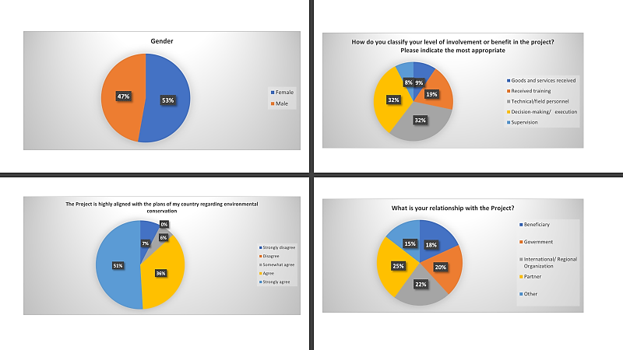

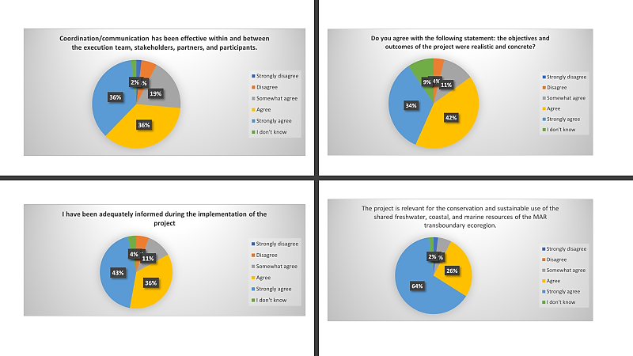

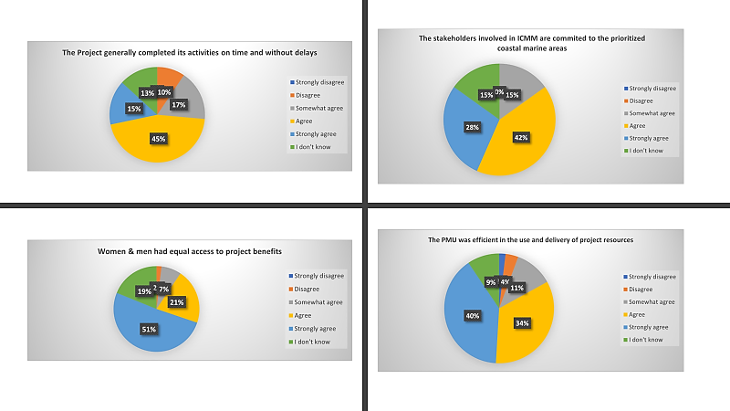

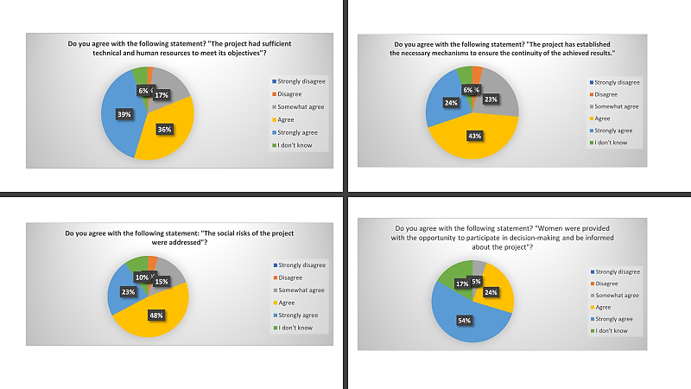

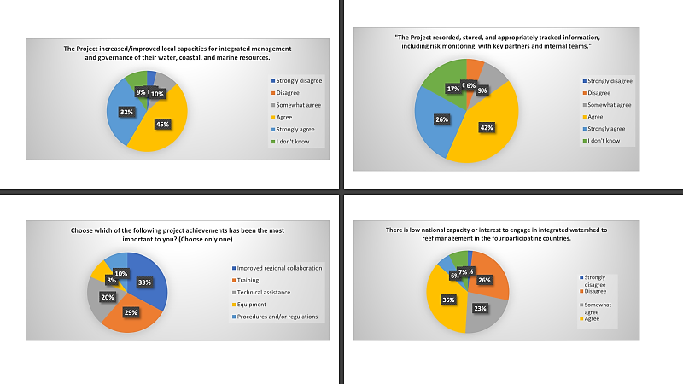

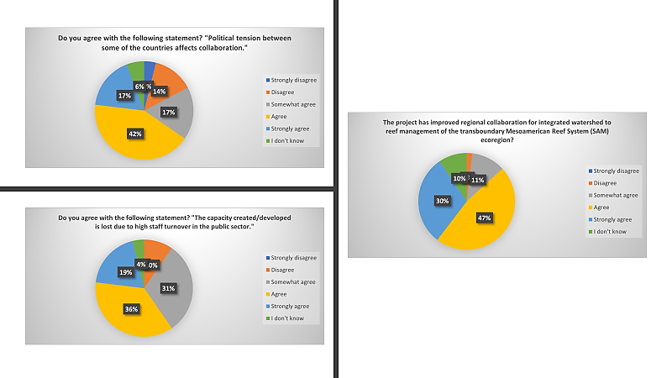

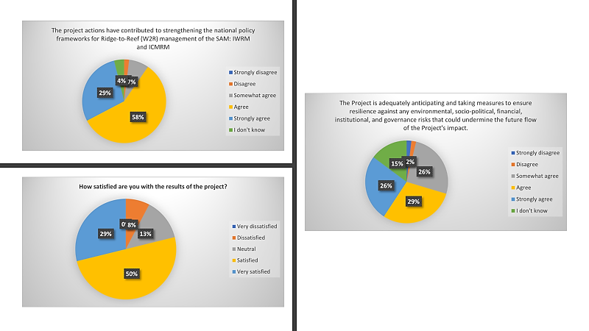

Annex 5.9: GEF Tracking Tool

GEF IW tracking tool WWF GEF PMIS 5765_MAR2R GEF5_IWTrackingTool 25 Jul 23.xlsx

Annex 5.10: Ratings Criteria

Outcomes Rating Criteria:
- Highly satisfactory (HS) – Level of outcomes achieved clearly exceeds expectations and/or there were not shortcomings.
- Satisfactory (S) – Level of outcomes achieved was as expected and/or there were no or minor shortcomings.
- Moderately satisfactory (MS) – Level of outcomes achieved more or less as expected and/or there were moderate shortcomings.
- Moderately unsatisfactory (MU) – Level of outcomes achieved somewhat lower than expected and/or there were significant shortcomings.
- Unsatisfactory (U) – Level of outcomes achieved substantially lower than expected and/or there were major shortcomings.
- Highly unsatisfactory (HU) – Only a negligible level of outcomes achieved and/or there were severe shortcomings.
- Unable to assess (UA) – The available information does not allow an assessment of the level of outcome achievements.

Sustainability/ Risk Rating Criteria:
- Likely (L) - There are little or no risks to sustainability.
- Moderately likely (ML) - There are moderate risks to sustainability.
- Moderately unlikely (MU) - There are significant risks to sustainability.
- Unlikely (U) - There are severe risks to sustainability.
- Unable to assess (UA) – Unable to assess the expected incidence and magnitude of risks to sustainability.

M&E Rating criteria:
- Highly satisfactory (HS) -- There were no shortcomings and quality of M&E design / implementation exceeded expectations.
- Satisfactory (S) -- There were no or minor shortcomings and quality of M&E design / implementation meets expectations.
- Moderately satisfactory (MS) -- There were some shortcomings and quality of M&E design / implementation more or less meets expectations.
- Moderately unsatisfactory (MU) -- There were significant shortcomings and quality of M&E design/ implementation somewhat lower than expected.
- Unsatisfactory (U) --There were major shortcomings and quality of M&E design/ implementation substantially lower than expected.
- Highly unsatisfactory (HU) -- There were severe shortcomings in M&E design / implementation.
- Unable to assess (UA) – The available information does not allow an assessment of the quality of M&E design /implementation.

Implementation and Execution Rating Criteria:
- Highly satisfactory (HS) -- There were no shortcomings and quality implementation / execution exceeded expectations.
- Satisfactory (S) -- There were no or minor shortcomings and quality implementation /execution meets expectations.
- Moderately satisfactory (MS) -- There were some shortcomings and quality of implementation /execution more or less meets expectations.
- Moderately unsatisfactory (MU) -- There were significant shortcomings and quality of implementation /execution somewhat lower than expected.
- Unsatisfactory (U) --There were major shortcomings and quality of implementation /execution substantially lower than expected.
- Highly unsatisfactory (HU) -- There were severe shortcomings in quality of implementation/ execution.
- Unable to assess (UA) – The available information does not allow an assessment of the quality of implementation / execution.

Additional guidance regarding the evaluation criteria and ratings for each dimension can be found in in the GEF Terminal Evaluation Guidelines.

The GEF Evaluation Policy (Prepared by the Independent Evaluation Office of the GEF), URL: https://www.thegef.org/sites/default/files/council-meeting-documents/EN_GEF.ME_C56_02_Rev01_GEF_Evaluation_Policy_June_2019_0.pdf
Please see the GEF Ethical Guidelines as published on GEF website.
LXIX Reunión Ordinaria del Consejo de Ministros de la Comisión Centroamericana de Ambiente y Desarrollo (CCAD), 7 de febrero de 2023, Isla San Pedro, Cayo Ambergris, Belice
Global Environment Facility. June 2019. Policy on Monitoring, GEF/C.56/03/Rev.01 URL: https://www.thegef.org/sites/default/files/council-meeting-documents/EN_GEF.C.56.03.Rev_.01_Policy_on_Monitoring.pdf ; accessed 23 September 2023
See the WWF Evaluation Guidelines, published on WWF Program Standards public website.
Effectiveness of gender mainstreaming, stakeholder engagement, scoping for environmental issues, etc.
Source: PRODOC
Specific, Measurable, Achievable, Relevant, and Time-bound
Stafford Smith, M., Ratner, B.D., Metternicht, G., Carr, E.R., Bierbaum, R., and Whaley, C. 2022. Achieving transformation through GEF investments. A STAP Advisory Document. Scientific and Technical Advisory Panel to the Global Environment Facility. Washington, DC.
Stafford Smith, M., Metternicht, G., and Bierbaum, R. 2022. Policy Coherence for the GEF. A STAP Information Brief. Scientific and Technical Advisory Panel to the Global Environment Facility. Washington, DC.
Course available at EdX: URL: https://learning.edx.org/course/course-v1:SDGAcademyX+TBW001+2T2020/home
https://www.thegef.org/sites/default/files/council-meeting-documents/EN_GEF.ME_C.55.inf_.01_Additionality_Framework_November_2018.pdf
CCAD, 2023 Acta, LXIX Reunión Ordinaria del Consejo De Ministros De La Comisión Centroamericano De Ambiente y Desarrollo (CCAD)
The “Mesoamerican Caribbean Reef Systems Initiative,” known as the “Tulum Declaration,” was signed on June 5, 1997, by the Presidents of the Republics of Guatemala and Honduras, the Prime Minister of Belize, and the President of the United Mexican States. On July 11, 2006, in Panama City, the leaders of these four countries ratified the Declaration of Tulum (Tulum+8), and thus the political commitment to strengthen the development and conservation of the second largest barrier reef in the world, the Mesoamerican Barrier Reef System. (MAR).
2017, April 17. WWF. GEF Agency Approval Letter. Internal Document
2017, April 24. WWF MAR. IPA MAR R2R Office.doc.x. Internal Memo
Ibid. attachment. WWF_MAR_IA_Roles_2_15_Final.docx.
WWF-GEF Project Document. Integrated Ridge to Reef Management of the Mesoamerican Reef Ecoregion (MAR2R) GEF ID 5765. Section 3: INSTITUTIONL FRAMEWORK AND IMPLEMENTATION ARRANGEMENTS. p. 72 URL: https://www.thegef.org/projects-operations/projects/5765
WWF-GEF Request for CEO Endorement. Part I: PROJECT INFORMATON. p. 1. URL: https://www.thegef.org/projects-operations/projects/5765
“Fortalecimiento de la gestión integral del recurso hídrico y mejoramiento de los medios de vida comunitarios en la Cuenca del Rio Hondo, México” https://drive.google.com/file/d/1B388g3KEAbijiS3WGSmw_3wg7JP7EgjJ/view?usp=sharing
Gestión Integral del recurso hídrico en la subcuenca del Río Manchaguala para la reducción de amenazas a la Ecorregión del Arrecife Mesoamericano https://drive.google.com/file/d/1JxH87k4gjZjok2i3L1nCDoOmbbvHwdsC/view?usp=sharing
Restauración de ecosistemas forestales de importancia hidrológica y fortalecimiento de la gobernanza hídrica en la Reserva de Biósfera Sierra de las Minas, Cuenca del Río Motagua, Guatemala. https://drive.google.com/file/d/1UxiHGGvmVU7CFBpIxEeR7_qoBCQGJWsH/view?usp=sharing
Systematization Process of the MAR2R Demonstration Project in the New River Watershed, Orange Walk District, Belize https://drive.google.com/file/d/1RiWo0zNKkbNBROxmXQPIAFDE7bkQ3PCv/view?usp=sharing Belize https://drive.google.com/file/d/1RiWo0zNKkbNBROxmXQPIAFDE7bkQ3PCv/view?usp=sharing
Gestión Integral del recurso hídrico en la subcuenca del Río Manchaguala para la reducción de amenazas a la Ecorregión del Arrecife Mesoamericano https://drive.google.com/file/d/1JxH87k4gjZjok2i3L1nCDoOmbbvHwdsC/view?usp=sharing
https://www.gefieo.org/sites/default/files/documents/ops4-m02-roti.pdf
MTR included since the project start up to December 2021 (the first quarter of Year 4)
https://www.sica.int/documentos/transboundary-diagnostic-analysis-tda-of-the-mesoamerican-reef-ecoregion-executive-summary_1_132282.html
https://www.sica.int/documentos/strategic-action-plan-for-integrated-ridge-to-reef-management-of-the-mesoamerican-reef-ecoregion_1_132305.html
Stafford Smith, M., Ratner, B.D., Metternicht, G., Carr, E.R., Bierbaum, R., and Whaley, C. 2022. Achieving transformation through GEF investments. A STAP Advisory Document. Scientific and Technical Advisory Panel to the Global Environment Facility. Washington, DC.
Stafford Smith, M., Metternicht, G., and Bierbaum, R. 2022. Policy Coherence for the GEF. A STAP Information Brief. Scientific and Technical Advisory Panel to the Global Environment Facility. Washington, DC.
Course available at EdX: URL: https://learning.edx.org/course/course-v1:SDGAcademyX+TBW001+2T2020/home
For additional information on evaluation methods adopted by WWF, see the WWF Evaluation Guidelines , published on our WWF Program Standards public website.
For additional information on the GEF Terminal Evaluation Guidelines, see the GEF Terminal Evaluation Guidelines.
Please see the GEF Ethical Guidelines as published on GEF website.
Deliverables submitted to GEF Secretariat will be in English, however, for full stakeholder participation, it is recommended that all deliverables under contract be in Spanish and English. At a minimum, the draft and final reports should be in both languages. Please account for translation services, if necessary, for both interviews and deliverables.
WWF Procurement Policy
Source: Project Document, page 138
Source: Project Document, Page 139
Source: Project Document, Page 140
Source: Project Document, page 141
GEF guidelines on Outcome rating: The calculation of overall outcomes rating of projects will consider all three criteria, of which relevance and effectiveness are critical. The rating on relevance will determine whether the overall rating will be in the unsatisfactory range (MU to HU). If the relevance rating is in the unsatisfactory range then the overall outcome will be in the unsatisfactory range as well. However, where the relevance rating is in the satisfactory range (HS to MS), the overall outcome rating could, depending on its effectiveness and efficiency rating, be either in the satisfactory range or in the unsatisfactory range. Overall Outcome achievement rating may not be higher than the effectiveness rating. For more details see GEF IEO TE Guidelines.

